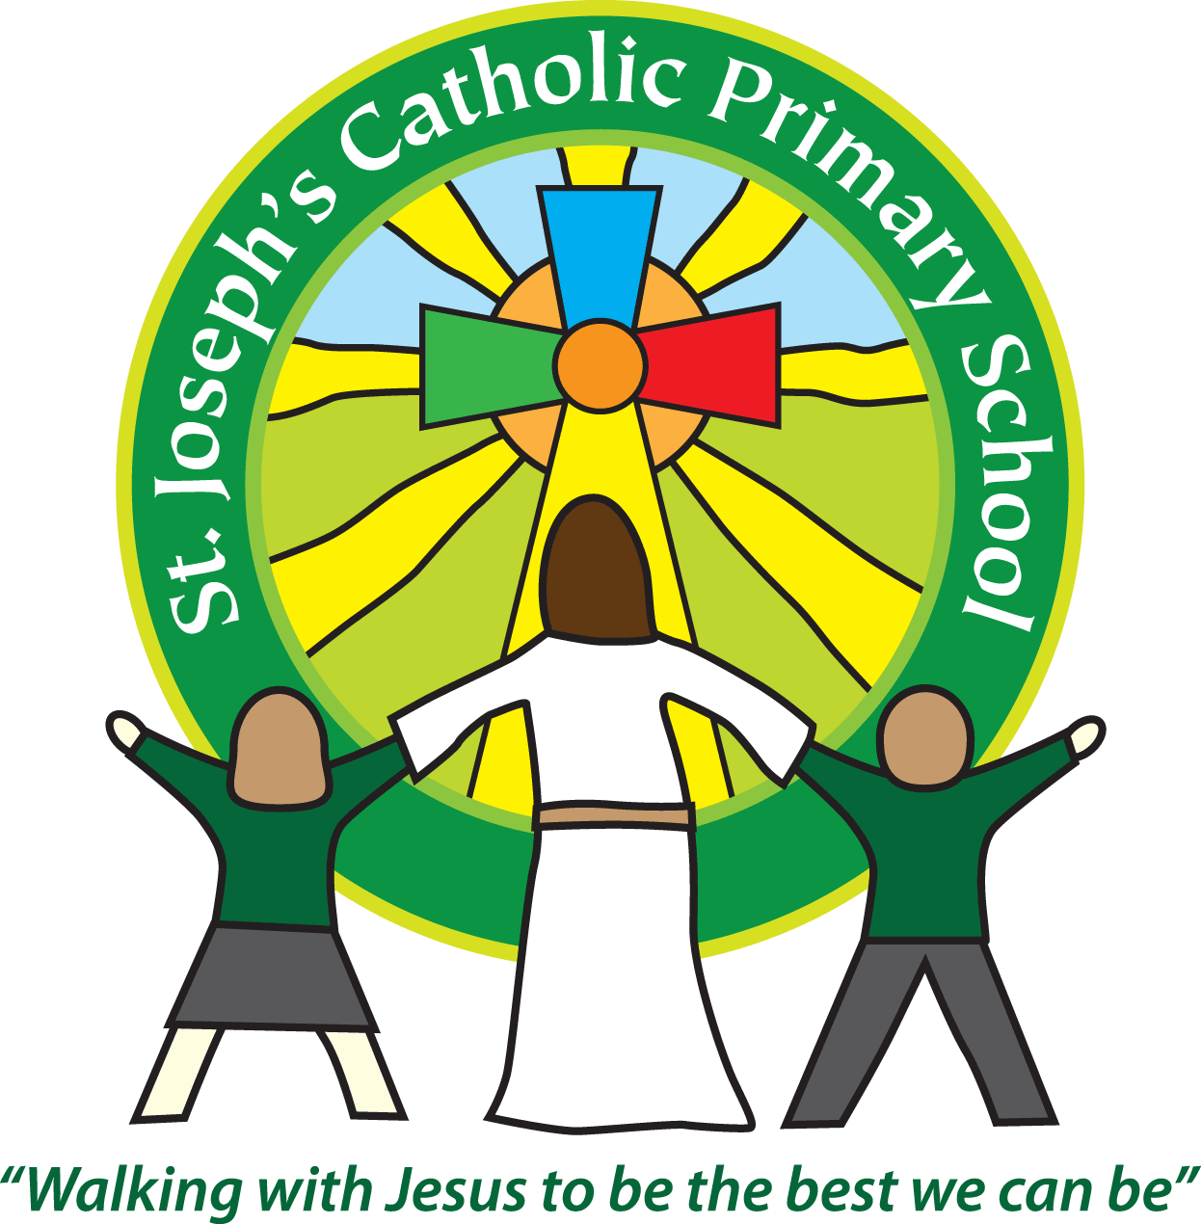

Equality Objectives

2022-2023

* Children of all groups to make at least good progress
* Support for children in school with emotional and mental health needs
* To develop awareness and understanding of speech and language difficulties throughout the school community