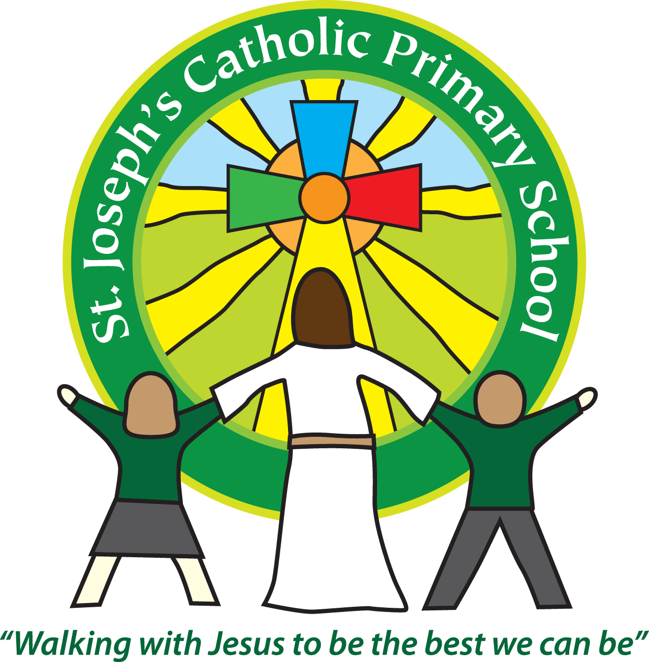**St Joseph’s Catholic Primary School parent questionnaire**

**Reflecting on the school as a Catholic community**

Your opinion is very important to us and we would be very grateful if you could complete this questionnaire and return it to the school office by Friday 10th May.

|  |  |  |  |  |  |
| --- | --- | --- | --- | --- | --- |
|  |  | **☺** | **2** | **3** | **☹** |
| 1 | My family and I are always made to feel welcome. |  |  |  |  |
| 2 | Staff are committed to creating supportive and effective relationships with parents. |  |  |  |  |
| 3 | Children are encouraged to be compassionate, respectful and understanding towards others. |  |  |  |  |
| 4 | Children are helped to appreciate and care for the environment. |  |  |  |  |
| 5 | Children are encouraged to work for, and give to, charities. |  |  |  |  |
| 6 | Children are taught to value other world faiths. |  |  |  |  |
| 7 | Children have a voice in the school with regard to decisions that will impact on their learning and well-being. |  |  |  |  |
| 8 | There is a sense of shared enjoyment and encouragement between adults and children in the school. |  |  |  |  |
| 9 | Children are involved in the school community, the parish community and the wider community of the school. |  |  |  |  |
| 10 | The school actively prepares its children for global citizenship activities through a range of national and international links. |  |  |  |  |
| 11 | Prayer is a regular part of school life. |  |  |  |  |
| 12 | As a parent/carer I welcome the open invitation to Mass and other acts of worship in the school. |  |  |  |  |
| 13 | A wide range of experiences contribute to my child’s spiritual development. |  |  |  |  |
| 14 | The RE curriculum has a high status in the school. |  |  |  |  |
| 15 | The school encourages individuals to develop high moral standards by following the example of Jesus Christ. |  |  |  |  |
| 16 | We prepare children to become considerate and caring members of the community and know their roles and responsibilities towards all members of today’s society. |  |  |  |  |
| 17 | The school demonstrates a strong commitment to supporting those who are most vulnerable in the school, community and the wider world. |  |  |  |  |
| 18 | The school environment is one where children feel confident, secure and able to express their opinions. |  |  |  |  |
| 19 | Our children take pride and celebrate in their own learning and the achievements of others. |  |  |  |  |
| 20 | The school embraces the love of Christ by promoting strong partnerships between home, school and parish. |  |  |  |  |