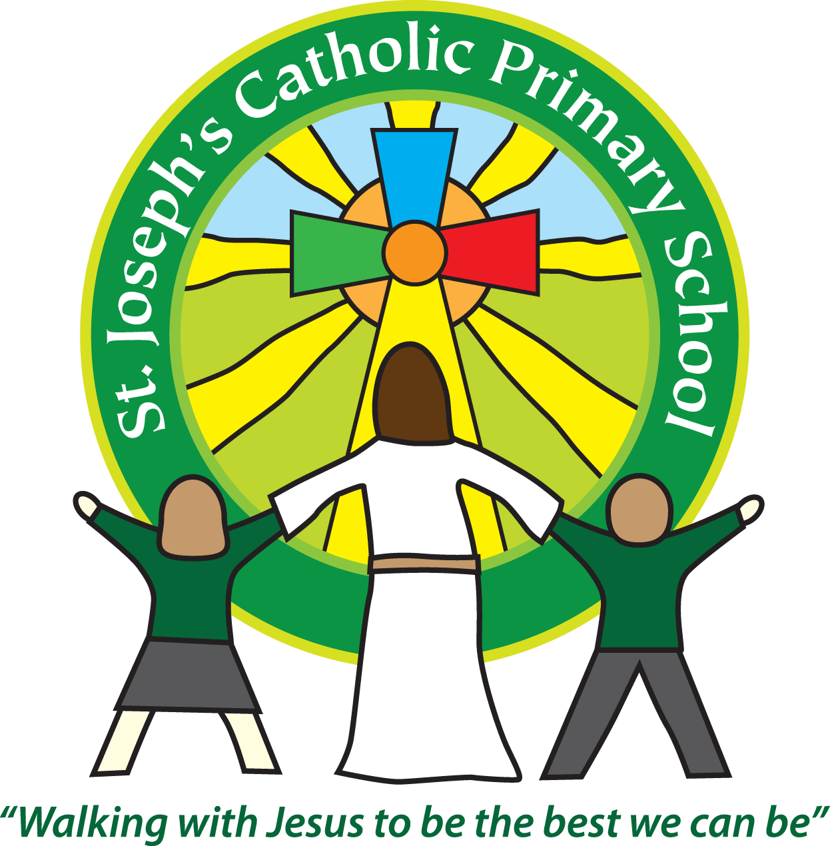

Equality Objectives

2020-2021

* Children of all groups to make at least good progress
* Support for children in school with emotional and mental health needs
* To develop awareness and understanding of Autism throughout the school community