St Joseph’s Catholic Primary School Home Learning Pack – 13.07.2020 and 20.07.2020
Willow Class
The way we are doing home learning is changing a little. We will be sending tasks home every two weeks and reducing the number of tasks to 3 maths, 3 English and 3 topics per week (so you will receive 6 maths, 6 topic and 6 English every other Monday).
Just to be clear, we are not expecting everyone to do all of the activities and these are only suggestions. We understand that our circumstances are all very different at the moment and that lots of you will be trying to juggle ‘home school’ and your own work as well as caring for elderly neighbours and family. Please only do what you feel you can. We do not want to set anything that causes any worry so please do what you feel. There are some references to resources but they do not need to be printed and can be viewed online and the work can be completed or copied onto paper. Please contact us at admin@stjo.uk and in the subject name it… For (Your Child’s teachers name and Class) if you need any further support. For example; For Mrs Spinks, Willow Class. This will help us to ensure your request is dealt with quickly.
All of the resources for the home learning below can be found at: https://www.stjosephsprimaryschool.com/website/home_learning_04052020/477542 on the Coronavirus information page – Home learning and then select the date and appropriate class.
Maths | Activities | Resources
Times tables | Please continue to practise your times tables everyday this can be done on TTRS or offline through a variety of games and activities. Here are a few ideas to help you:  - Use playing cards – Choose 2 cards at a time and multiply the numbers together and then discuss corresponding division facts.  - Exercise while reciting your times table facts e.g. skipping  - Play times table ping pong – in partners take it in turns to ask each other questions  - Times table bingo – draw a 3x3 grid and choose numbers from the tables – bingo caller to ask multiplication and division question.  - Why not invent your own times table game to play?
Week 1  Activity 1 | Can I divide 2-digit numbers by 1-digit numbers?  - Go through the power point or read the learning reminders to refresh your understanding.  - Complete the practice questions  - If you are finding it tricky complete the ‘A bit stuck sheet’.  - Have a go at the investigation to check understanding. | PDF document ‘Maths activity 1’ on the website  PPT Activity 1.
Activity 2 | Can I divide 2-digit numbers by 1-digit numbers?  - Read the learning reminders to refresh your understanding.  - Complete the practice questions  - If you are finding it tricky complete the ‘A bit stuck sheet’  - Have a go at the investigation to check understanding. | PDF document ‘Maths activity 2’ on the website
Activity 3 | Can I solve division problems?  - Read the learning reminders to refresh your understanding.  - Complete the practice questions  - If you are finding it tricky complete the ‘A bit stuck sheet’.  - Complete the questions to check your understanding. | PDF document ‘Maths activity 3’ on the website
Week 2  Activity 4 | Can I count on and back in steps of 25 and 1000?  - Go through the power point or read the learning reminders to refresh your understanding.  - Complete the practice questions  - Complete the questions to check your understanding.  - If you are finding it tricky complete the ‘A bit stuck sheet’.  - Have a go at the investigation to check understanding. | PDF document ‘Maths activity 4’ on the website  Maths activity 4 PPT.
Activity 5 | Can I use Roman numerals up to 100?  - Read the learning reminders to refresh your understanding  - Complete the practice questions  - If you are finding it tricky complete the ‘A bit stuck sheet’.  - Complete the questions to check your understanding. | PDF document ‘Maths activity 5’ on the website.
Activity 6 | Can I solve number problems?  - Read the learning reminders to refresh your understanding  - Complete the practice questions  - If you are finding it tricky complete the ‘A bit stuck sheet’.  - Complete the questions to check your understanding. | PDF document ‘Maths activity 6’ on the website.

Please continue to keep a written diary recording what you have done each day.
English | Activities | Resources
Week 1  Activity 1 | Can I write about a magical journey?  See English activity 1 on the website and complete the activities.. | PDF document ‘English activity 1’ on the website.
Activity 2 | Can I write a poem?  See English activity 2 on the website and complete the activities. | PDF document ‘English activity 2’ on the website.
Activity 3 | Can I use expanded noun phrases?  See English activity 3 on the website and complete the activities. | PDF document ‘English activity 3’ on the website.  Expanded noun phrase PPT
Week 2  Activity 4 | Can I write a recount?  See English activity 4 on the website and complete the activities. | PDF document ‘English activity 4’ on the website.  English activity 4 -Pobble
Activity 5 | Can I write a limerick?  See English activity 5 on the website and complete the activities. | PDF document ‘English activity 5’ on the website.
Activity 6 | Can I create a revolting recipe?  See English activity 6 on the website and complete the activities. | PDF document ‘English activity 6’ on the website.

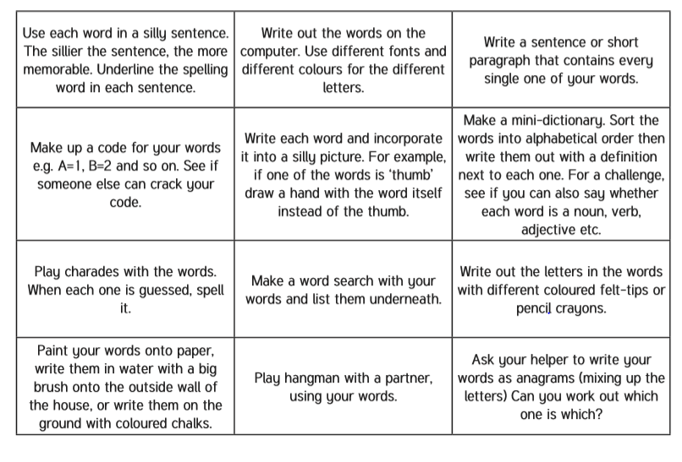
Spelling – Practise the year 4 spellings using a range of strategies. Below are some ideas that you can try.

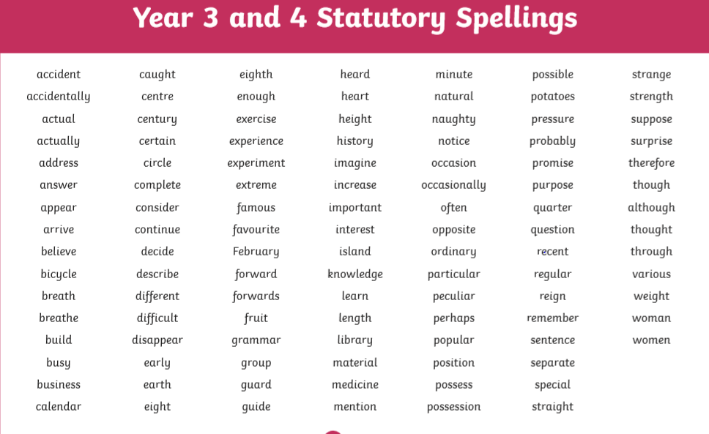
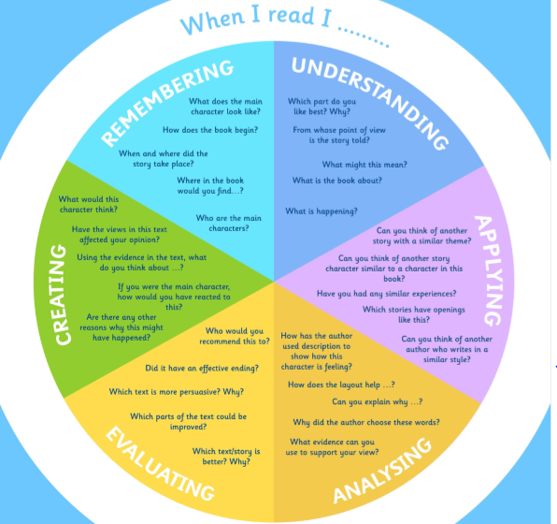
Suggested Reading Activities
This is an essential skill that the children need to continue to practise daily. It is recommended that the children read for at least 20 minutes each day. Continue to record all reading in the reading record books and remember to quiz on accelerated reader. You should have received an email with log in details. Please contact me if there is an issue with this. When listening to your chid read ask questions regularly to check and support understanding. Here is some example questions which would really support the children in their development.

Varied activities of Science, Music, Topic (History, Geography, Art) and R.E
 | Activities | Resources
Week 1  Activity 1 | Can I reflect on positive memories in year 4?  Complete the memories sheet reflecting on memories in year 4. I know that this has been a strange year and that we sadly have not had a full year together. However, I feel that it is important to reflect on the positives. | My favourite memories sheet on the website.
Activity 2 | Can I make a summer scrapbook?  A scrapbook is a way of preserving, presenting, and arranging things that are special to us in a book. Scrapbooks can also include notes and written details of the events that we have been on or thoughts that we have had and can act a bit like a pictorial diary. You cannot complete a scrapbook in one day. The items that you will put in them need to be collected over many days and weeks so this project is one that could keep you busy for the whole summer!  Getting started:  • Find a blank book that you could use to make your scrapbook. This could be a book that has plain pages (from a stationary shop) or a homemade book that could be constructed from blank pieces of paper or thin card  • Start the activity by decorating the front cover of the book. This could include a photo or a picture of you or some of the things that interest you  Inside your scrapbook:  • A page for every new day of the summer holidays that you show in your scrap book.  • Photos or pictures of the things that you see. These could also include things and events that you do at home too  • Tickets from the places that you visit  • Thoughts that you have on each day. Remember that the holiday may be a time to rest and reflect at home and these pictures and thoughts are just as important as visits that you may make  • Pictures of photographs of the people that you know and see  • Decorations or different borders around each page to make the scrapbook engage the reader  I really look forward to see your completed scrapbooks in September.
Activity 3 | These are the words of Oscar Romero. What can you find out about St Oscar Romero? Where did he come from and work? How did he live his life? You could use the internet to research or any books you have available. Why not design a poster with what you find out? Or make a photo slideshow to show someone else in your family?
Week 2  Activity 4 | Please complete activity 1. There are some other activities on the light up science document on the website if you would like to have a go at these.  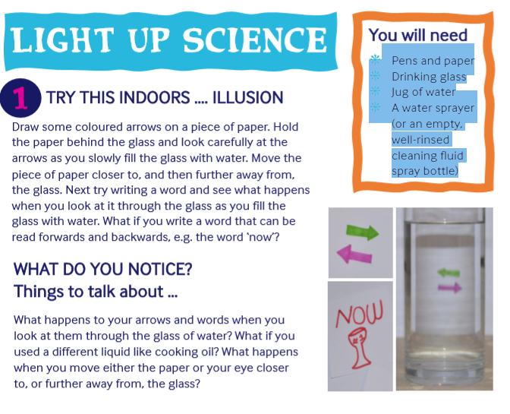 | Light up science – on the website  Pens and paper  Drinking glass  Jug of water  A water sprayer (or an empty, well-rinsed cleaning fluid spray bottle)
Activity 5 | I am really excited to be teaching you for another year!  Although we know each other very well, it is important to reflect on our aspirations for year 5. Please complete the transition booklet on the website. This does not need to be printed, you can write/draw your response on a piece of paper. | Transition booklet year 4 to year 5 on the website.

