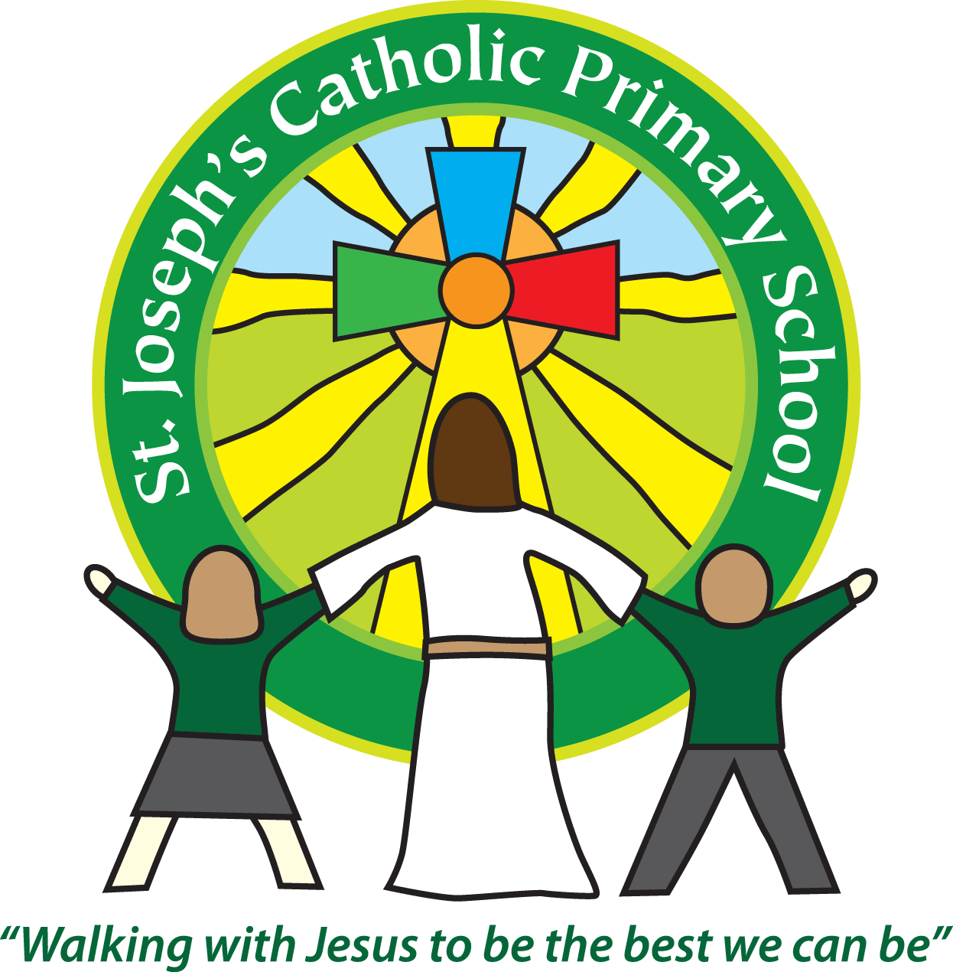
St Joseph’s Catholic Primary School
Year 2 – Sycamore Class
Mrs Owens and Mrs Monks
Spring Term 2022
Welcome back everyone,
This half term our topic is called – ‘pack a suite- case’ – please find a medium term overview on the website and Google classroom. There will also be a knowledge organiser for Geography for your reference.
Please note that the main change below is that PE kits will need to be worn on a Wednesday as before and a Tuesday.
A Polite reminder: Homework is posted on Google classroom every Friday. Please see the class teacher if you are having problems getting on.
Please could book bags come in daily – thank you.
Homework remains:
Subject | Sent home | Due in | Frequency
Spellings -  to be tested on a Friday | Friday | Thursday | Weekly
Times Tables  Times Table Rock Stars  Year 2 need to learn their 2, 5 and 10 times table as a minimum this year – please feel free to learn more if you would like. | Friday | Thursday | Weekly
Maths/Grammar | Friday | Thursday | Alternate Fortnightly
Topic | Friday | Thursday | Start of term
Reading | We expect the children to read at home daily. Please make sure that you regularly read with your child and discuss the books that they are reading.  Quizzing for children who are now on Accelerated reader can be done at home but the children must work on these independently.  Books will be changed on a Monday and Thursday. Some children may now be reading from longer texts so this may vary for them.  If children are reading on green or orange level they will be sent the text that they have read with an adult twice in the week in their ‘practice read’ groups on a Friday as the focus book to read at home.  There will also be a second class book in the book bag which is a book for ‘reading for pleasure’. This book is to share with an adult and the children are not expected to read it to the adult but to enjoy it with the adult.

General reminders:
School lunch and snacks | School lunch remains free for year 2 children and must be ordered via parent pay.  We promote healthy eating at school and so lunch boxes should not contain more than one chocolate snack and one packet of crisps.  Children are welcome to bring fresh fruit or vegetables for a snack at break time.  We are a nut free school. We have children with potentially fatal nut allergies in school, therefore no food containing nuts may be sent into school.
Drinks | Your child must have a named water bottle in school every day. Please only send in water, no juice or fizzy are allowed in the classroom: A small carton of juice can be sent with packed lunches. Please see the class teacher if there is a problem in this area.
Uniform | Please ensure all uniform is clearly named.  Grey trousers or shorts, grey skirt or pinafore dress, white or grey socks, grey tights, White polo shirt, Green logo school sweatshirt or cardigan. Warm weather option – green and white gingham dress (dress with shorts instead of skirt is acceptable).  Hair past shoulder length must be tied back – please use plain hairbands in green, black or white, not brightly coloured bows.  Nail varnish is not allowed. School shoes must be black and no heels, trainers or boots.
PE Kit | Green t-shirt with school logo, black shorts, navy or black jogging bottoms and trainers. All kit must be named and in a named bag.  Ear rings must be removed or covered with tape for PE lessons.  Watches must be removed for PE.  PE kit must be worn to school on a Wednesday and Tuesday please.
Bags/resources from home | Children must only bring in a book bag, water bottle, packed lunch and piece of fruit daily.
Mornings | Doors open to the classroom at 8.50am. Please do not come onto the Patio area as this remains continued Covid precaution (at the moment).  Your child will be greeted at the class door by an adult. Please only pass on quick messages at that point, for a longer meeting please make an appointment at the office or briefly with the teacher.  Children and parents arriving after 9.00am must go to the office to be signed in.
After school | School finishes at 3.30pm. If someone other than yourself is collecting your child please ensure the office has their details. We will not let the children leave unless we are sure they are safe and the designated adult has given the appropriate security word.
Contact details | Please ensure you contact details and those of other people who may collect your child are always kept up to date - see the office asap if you change your phone number or address.

Kind regards
Mrs Owens and Mrs Monks

