§
Parents: In year 2, the types of spellings and spelling patterns that children are expected to know continues to increase. As well as further ‘common exception words’ (words that don’t follow the usual rules but are used regularly), there is a whole series of spelling patterns and rules for children to learn. Teachers often find that getting children to learn spellings is one thing, but then getting them to use them in their everyday writing is another. All the more reason why children should practise their spellings in different ways and then be given the chance to use them in their writing. In addition, when a new spelling rule has been taught, children need to learn how to apply that rule to all words, not just a list they have been given to learn at home. If you wish to boost your child’s spelling ability even further, encourage them to read, as exposure to lots of words will lead to a better understanding of spelling.

Here are some ideas for different ways to learn your spellings at home. Try one or two different ones each week and see which ones work best for you.

Keep Copying | Make the Headlines  Cut letters out of newspapers or magazines and stick them onto paper to make the words in your list.  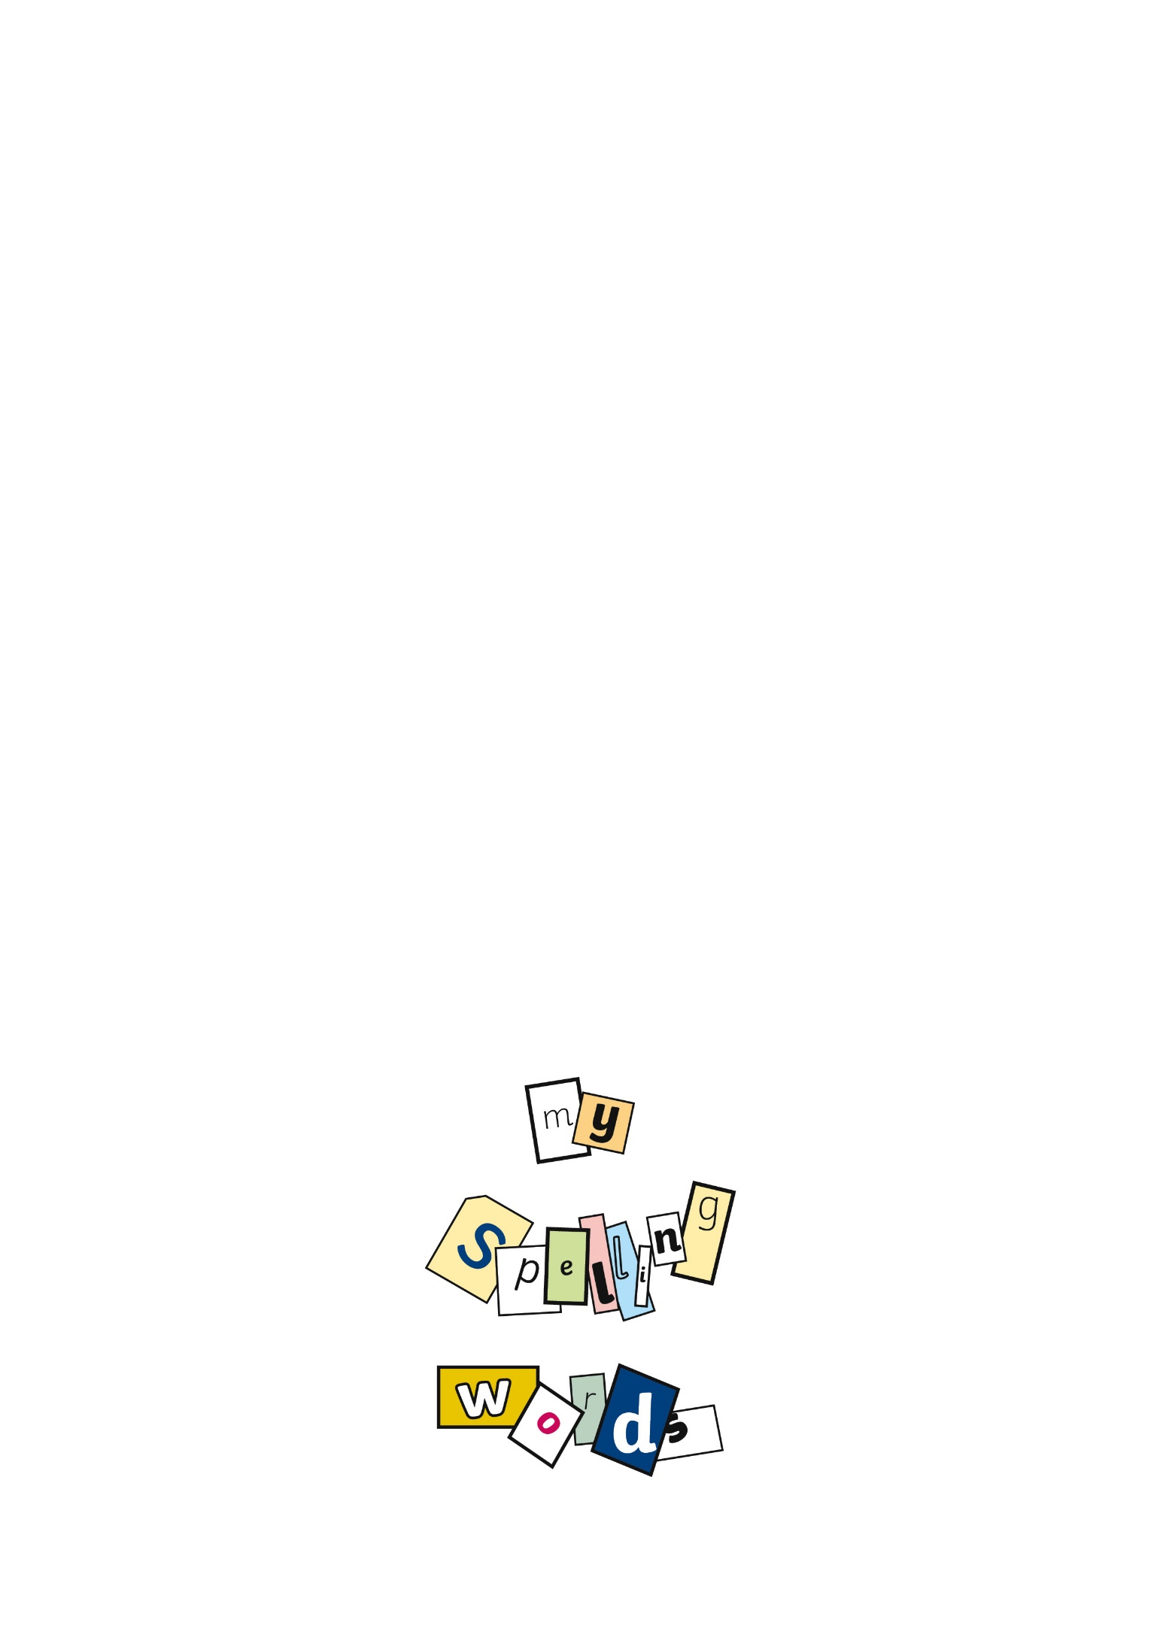 | Build a Pyramid
Write your words out three times each. Use different colours if you want to.  spelling  spelling spelling |  | Make a pyramid using the letters in your words.
w wo
wor
word words

Create with Colour  Write your words with each letter in a different colour, or write them with all the vowels in blue and all the consonants in red.  spelling  spelling | Capital Idea  Write your words three times, each in capital letters.  SPELLING  SPELLING  SPELLING | Learn Your ABC  Write your words in alphabetical order, then rewrite them in order of the second letter, third letter and so on.  my words spelling spelling words my
Take a Test  Ask someone at home to test you by reading each word as you write it down. To make it more of a challenge, set a time limit, for example 20 seconds per word.  - my  - spelling  - words | Picture This  Include each of your words in a funny picture that makes you think of the word.    words | Build a Sentence  Write each of your words in a sentence. See if you can build your sentences into a story.  One day a huge spelling monster came to my town and ate all the words!

