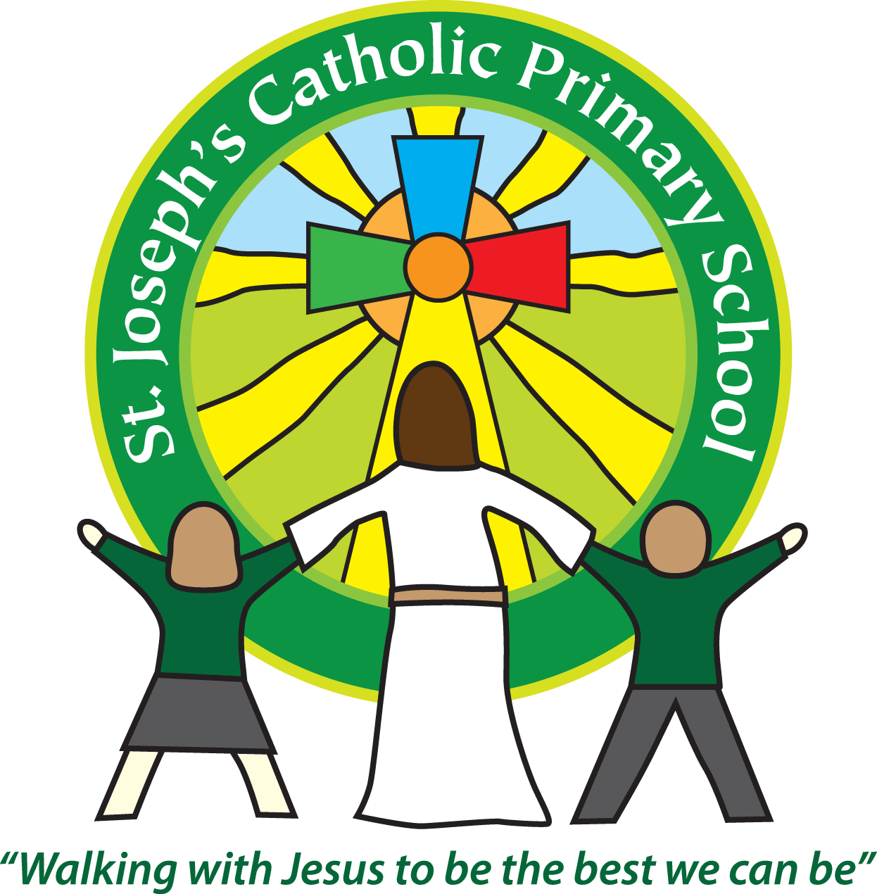

St Joseph’s Catholic

Primary School

Newsletter

June 17th 2016

**Dear all,**

It has been a varied week here at St Joseph’s. Fortunately most of the children seem to have recovered from the horrible sickness bug which has been going round, with only 1 child off today with it. We will continue with the deeper cleaning but please can I ask that if any child has a stomach upset that they stay off school for 48hrs from the last symptom. We have had children sent in after only 24hrs and by the time we see them at register to send them home again they have already mixed with lots of the children on the playground.

On a positive note we had Governor’s day yesterday where many of our governors spent the day in school, observing lessons and chatting with the children. The Governors thoroughly enjoyed the day and it was a good opportunity for them, staff and children to get together.

The Foundation Stage also had their first session with the new parents and children for next year. This was a great success and hopefully the children are excited about joining us in September and any worries or concerns have been erased.

Next week we have two more of our parent activity sessions. Please join us if you can:

**Year 3 parents - Monday 20th June - 2.15-3.15pm  
Year 4 parents - Tuesday 21st June - 2.15-3.15pm**

As St Joseph’s is part of the CAST academy we need to have all our accounts submitted before the end of the academic year. If you have any monies outstanding such as Nursery fees, breakfast club or dinner money, please can you bring them up to date as soon as possible.

We still have a vacancy for a cleaner in school. Please drop your CV into the Office if you are interested.

For any 5/6 pupils who enjoy Scootering:

‘Are you interested in representing East Devon area in Street Sports at The Devon Youth Games on Sunday 3rd  July. **Trials are being held at Ottery St Mary Skate Park on Friday 17th June – 6.30pm -8.30pm** for Scootering’ There is a poster by the main front door with more information.

**Best wishes & thank you for your continued support**

**Mrs Taylor-Bashford**



**Stars of week:**

Well done to: FSU - Penny Yr 1 - Alfie Yr 2 -Olivia Yr 3 - Oliver Yr 4 - Oliver

Yr 5 - Henry Yr 6 – Maisie

**Gospel Values Cup:** Well done to: St David’s team