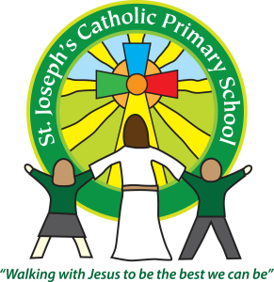
St Joseph’s News
Friday 13 November 2015
stjosephsprimaryschool.com

Stars of the Week  FS2 Alicia  Y1 Jack  Y2 Charlie  Y3 Darcie  Y4 Emily  Y5 Amelia  Y6 Jesbin | Head Teacher’s Awards  Congratulations to Oliver in Class 1 and Beau in Class 2 who received Head Teachers Awards this week. | Courtesy Cup  Well done to the YELLOW team, St David’s who are this week’s winners.
Attendance - for the week ending 6 November
Class FS2 | 96.3% | Joint 3rd
Class 1 | 95.8%
Class 2 | 99.1% | 1st
Class 3 | 94.9%
Class 4 | 96.3% | Joint 3rd
Class 5 | 96.1%
Class 6 | 98.3% | 2nd

Scholastic Book Fair
The Scholastic Book Fair will be take place in the hall after school on Thursday 19th, Friday 20th and Monday 23rd of November. There will be books and accessories for all ages available. A good opportunity to buy gifts (cash or cheque only please) for birthdays and Christmas or just to celebrate the joy of reading! It also helps school funds as a percentage of sales can be translated into books for the library or individual classes.
Important Information for all parents and carers
After the sad news recently of the deaths of two young children after choking on grapes we have been sent the following advice from our Early Years and Childcare adviser:
“Whole grapes are a major choking hazard and it is recommended that they are cut length ways for children under 5, .......... you may wish to consider extending this (advice) to all older children.

I have attached a link to a quick way to cut lots at once http://www.theyummylife.com/How_To_Cut_Cherry_Tomatoes”
For more advice on choking and general first aid advice please see:
The Child Accident Prevention Trust (CAPT) http://www.capt.org.uk/safety-advice/how-stop-your-child-choking
St John’s Ambulance http://www.sja.org.uk/sja/support-us/our-campaigns/baby-choking-the-chokeables.aspx
The Red Cross http://www.redcross.org.uk/What-we-do/First-aid/Baby-and-Child-First-Aid/Choking-child
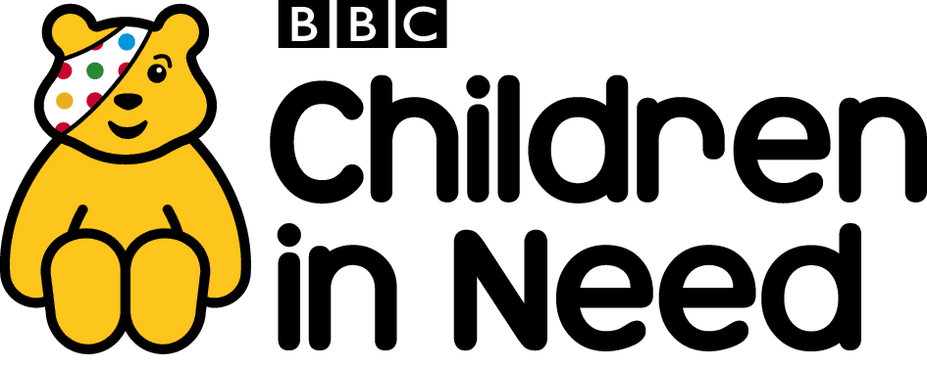
Don’t forget to support Pudsey today!

