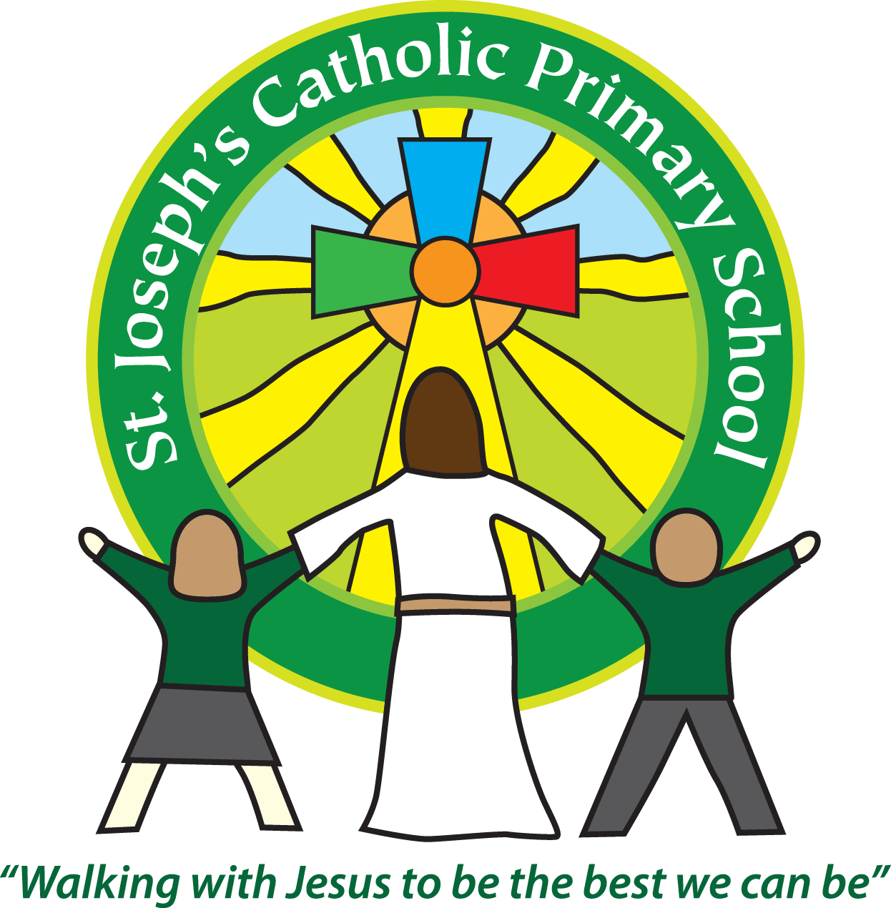 St Joseph’s Clubs Autumn 2018
**PLEASE READ THOROUGHLY**
The following clubs will run during the Spring Term. The times / dates will vary so please check the details for each individual club.
Booking
See the table below as booking varies depending on the club provider.
Payment
For fee paying clubs full payment must be made to the club provider (as listed on the club sheet) before the first session or the place will be allocated to another child.
Clothing
Please provide appropriate clothing for clubs, including warm clothing for outdoor activities. Please do not use school PE kit unless absolutely necessary as we need to ensure that this remains at school for use during the school day.
Medical issues
If your child suffers from any medical issues that the club leader needs to be aware of please provide written details.
Contact number for text messaging
Please ensure the number the office has for the first contact on your child’s record is up to date. This will be the number we use for the text messaging service.
If a club is unable to run we will contact you as soon as possible via the text messaging service.
Essential - Safeguarding
If your child cannot attend a session, please let us know by 12pm – at the latest on the day in question. This is to ensure we know for registration and to keep pupils safe.
Collection from clubs - We will only release your child to an adult we have listed for your child on our database. If you wish for your child to be collected by another adult (including other parents) please contact the school office to let us know.
Permission to walk home - It is expected that your child will be collected from the club unless written permission to walk is provided.
Day | Club | Dates running | Time | Classes | Cost | Contact details for booking
Monday | Spanish Club | Sept: 10th, 17th, 24th  Oct: 1st, 8th, 15th,  Half term  Oct: 29th  Nov: 5th, 12th, 19th, 26th  Dec: 3rd, 10th, 17th | 45 mins sessions.  Various times between 3.30-6pm | Yrs. 1-6 | £6 per session | Mrs Antonia Burrows  habloyhablo@gmail.com
 | Soccer Club | Sept: 10th, 17th, 24th  Oct: 1st, 8th, 15th,  Half term  Oct: 29th  Nov: 5th, 12th, 19th, 26th  Dec: 3rd, 10th, 17th | 3.30-4.30pm | Rec – yr 6 |  | https://www.saintssouthwest.co.uk/all-courses/afterschool-club/
 | St Joseph’s After School Club | Every day | 3.30-5.45pm (3.15pm for Nursery) | Nursery to Yr 6 (not 2yr olds) | Nursery:  £7 3.30-4.30pm  £10 - 3.30-5.45pm  Reception to Yr 6 - £6 3.30-4.30pm  £9 3.30-5.45pm | Please see the office or website for more information.  Please pay on Parent Pay
Tuesday | Science club | Sept: 11th, 18th, 25th  Oct: 2nd, 9th, 16th  Half term  Oct: 30th  Nov: 6th, 13th, 20th, 27th  Dec: 4th, 11th, 18th | 3.30-4.15pm | Yrs. 1-6 | £4.50 per session | Mrs Claire Williamson  yates.claire@btopenworld.com
 | St Joseph’s After School Club | Every day | 3.30-5.45pm (3.15pm for Nursery) | Nursery to Yr 6 (not 2yr olds) | Nursery:  £7 3.30-4.30pm  £10 - 3.30-5.45pm  Reception to Yr 6 - £6 3.30-4.30pm  £9 3.30-5.45pm | Please see the office or website for more information.  Please pay on Parent Pay
Wednesday | Guitar Club | Sept: 12th, 19th, 26th  Oct: 3rd, 10th, 17th  Half term  Oct: 31st  Nov: 7th, 14th, 21st, 28th  Dec: 5th, 12th | 12.30-1.00pm | Yrs. 1-6 | £6 per session | Mark Knightbass  markknightbass@gmail.com  07772905944
 | Girls football club | Sept: 12th, 19th, 26th  Oct: 3rd, 10th, 17th | 12.30-1.00pm | Yrs. 3- 6 | Free  Limited spaces | Mrs Turner  Email aturner@stjo.uk for more details and booking.
 | Running Club | Sept: 12th, 19th, 26th  Oct: 3rd, 10th, 17th  Half term  Oct: 31st  Nov: 7th, 14th, 21st, 28th  Dec: 5th, 12th | 3.30pm – 4.30 pm | Yrs. 3-6 | Free | Mrs Turner  Email aturner@stjo.uk for more details and booking.
 | St Joseph’s After School Club | Every day | 3.30-5.45pm (3.15pm for Nursery) | Nursery to Yr 6 (not 2yr olds) | Nursery:  £7 3.30-4.30pm  £10 - 3.30-5.45pm  Reception to Yr 6 - £6 3.30-4.30pm  £9 3.30-5.45pm | Please see the office or website for more information.  Please pay on Parent Pay
Thursday | St Joseph’s After School Club | Every day | 3.30-5.45pm (3.15pm for Nursery) | Nursery to Yr 6 (not 2yr olds) | Nursery:  £7 3.30-4.30pm  £10 - 3.30-5.45pm  Reception to Yr 6 - £6 3.30-4.30pm  £9 3.30-5.45pm | Please see the office or website for more information.  Please pay on Parent Pay
Friday  Please note Friday 9th November is a non-pupil day. | St Joseph’s After School Club | Every day | 3.30-5.45pm (3.15pm for Nursery) | Nursery to Yr 6 (not 2yr olds) | Nursery:  £7 3.30-4.30pm  £10 - 3.30-5.45pm  Reception to Yr 6 - £6 3.30-4.30pm  £9 3.30-5.45pm | Please see the office or website for more information.  Please pay on Parent Pay
Mrs Cowdrey and Mrs King run St Joseph’s Breakfast Club every morning from 7.45 – 8.55am. Please ask at the Office for more details
Music lessons can be arranged through Exmouth Community College and carried out here at St Joseph’s School by one of ECC’s specialist teachers. Please see our Office for more details or ring Paul Stock, Head of Music at ECC – 01395 255627

