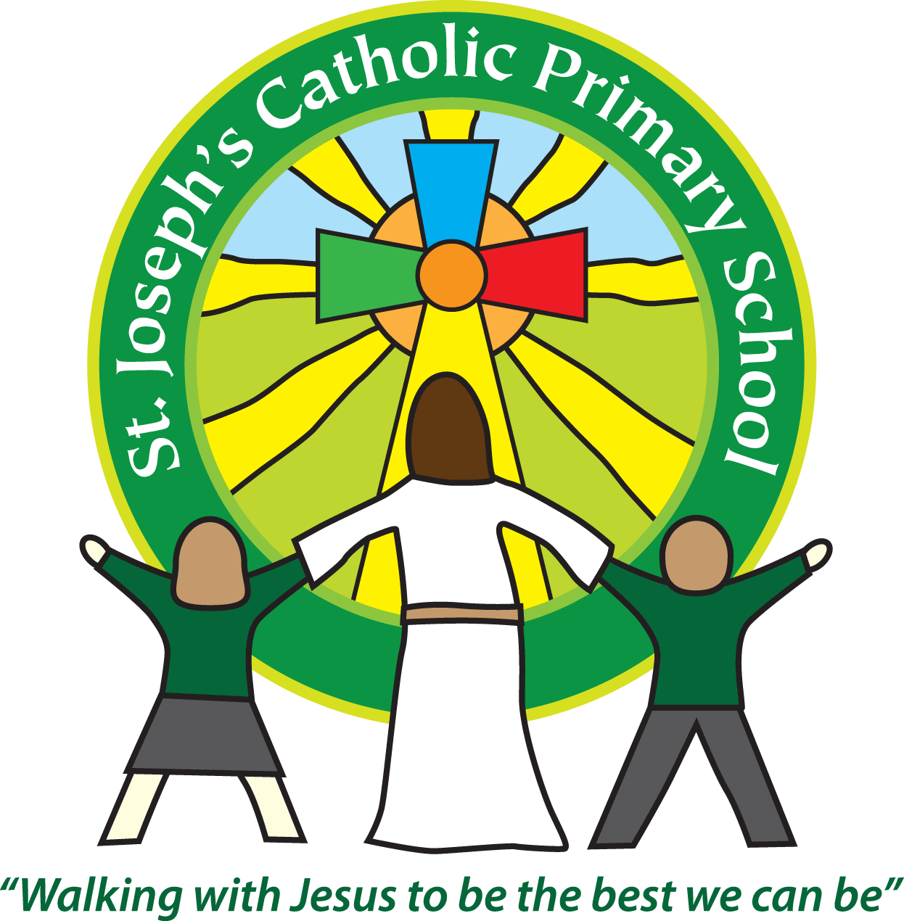

St Joseph’s Catholic Primary School

Newsletter

Friday 8th February 2019

**Headteacher’s awards:** Oak – Jake, Finley, Rowan – Lydia, Chloe, Harry, James, Sycamore – Adam, Dean, Esmee, Beech – Scarlett, Laura, Jeff

**Gold Awards:** Beech - Rafa

**Silver Awards:** Rowan – Ellis, Emma

**Bronze Awards:** Oak – Jake, Liam, Isla, Maple -Ralph

**Star of the Week Awards**: Oak - Liam, Rowan – Finlay, Sycamore - Dean, Cherry - Amber , Willow - Piran, Maple – Jasmyne, Beech – Hannah

**Breakfast club Award:** Sophie R

Dear all,

Cherry and Willow Class had a wonderful time at the Bournemouth Symphony Orchestra last Friday. The children really enjoyed listening to the music, with many having a go at conducting from their seats! Thank you to all the parent helpers who made the trip possible.

Unfortunately, the Fire engine was booked to come and see FSU but they were called away at the last minute. Hopefully, they will be able to reschedule. However, the police van did come and visit FSU. There was much excitement and joy when the siren was set off! The children had a great time looking around the van and asking the police officer’s questions.

All the classes took part in Safer Internet day and Mr Edmunds ran a Safer Internet assembly. The children learnt about cyber-bullying and keeping themselves safe online. Please talk to your child about what they did and the learning that took place.

This morning we have a group from KS1 taking part in an Aesthetics festival and then this afternoon a group from KS2 taking part in a dance festival. I’m sure they will have had a great time taking part and mixing with children from other schools. Many thanks to Mrs Turner who has a very busy day with both events on!

**New play equipment for lunch time**

The children have had a great week. We have purchased some new equipment for lunch times. So the children have been out playing with new balls, scarves, cars etc. It has been lovely to see them playing some of the games we played when we were younger like ‘Kings and Queens’ and ‘Piggy in the middle’.

**Parenting course**

Mrs Keeping has recently taken part in some extra training and is now qualified to run a Solihull Approach parenting group. We would like to offer a group of parents the opportunity to understand more about their children’s behaviour. We would explore issues such as tuning into your child, exploring feelings, parenting styles, sleep patterns and behavioural difficulties.

It is a 10 week course that gives parents the time and space to discuss and explore strategies for effective parenting. Please contact Mrs Keeping if you would like more information.

**Works in Regents Gate**

During half term South West Water are going to start works outside school. They are building a rain garden which will help to catch excess water and prevent it flowing into the town sewers. The works are likely to last 4 -5 weeks. They are going to try and keep disruption to a minimum but they are going to have to use 3 of the parking spaces outside and the pedestrian path next to the school will be closed so you will have to use the pavement opposite and then cross by the entrance. This means it will be more important than ever to park considerately, making sure that children can cross safely. Please be mindful that there is nothing that can be done about this work taking place and hopefully it will be finished quickly and be a lovely addition to the town when complete.

**Upcoming dates:**

Monday 11th February – Quiksticks hockey team from Maple and Beech

Tuesday 12th February – Maple Class assembly. 9.10am in the hall.

Friday 15th February - Hi-Five Netball at ECC - Team from Beech and Maple Class

Friday 15th February – Teacher from ECC coming in for Maths session with Beech Class

Friday 15th February – 3.30pm half term begins

Monday 25th February – 8.55am children back after half term

**Best wishes & many thanks for your continued support**

**Mrs Taylor-Bashford**