St Joseph’s Catholic Primary School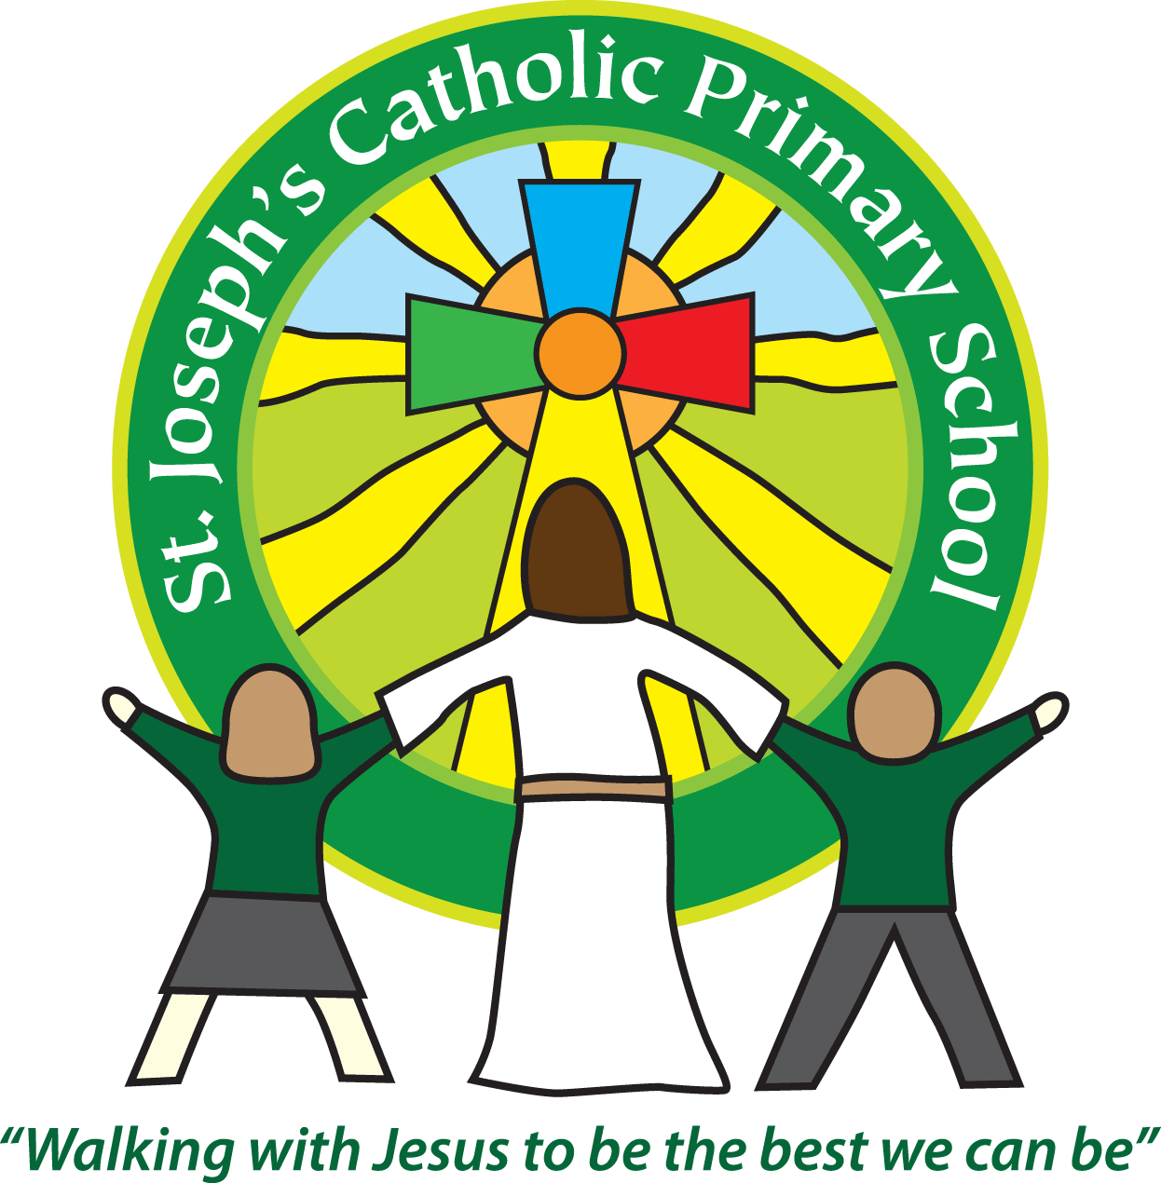
Year 1 – Autumn (2nd half)
Welcome back. We hope you had a wonderful half term break as a family.
Thank you to everyone for coming to Parents evening last term. It’s been wonderful to catch up. If you were unable to make your previous appointment, please get in touch about booking in to see us.
We post homework on Google Classroom every Friday as well as any other updates. It is vital that you check it each week.
We are really pleased with how the children are settling into Year 1. We are so proud of them all. They are enjoying their buddy time each week and the Year4’s have been great at helping them to find an adult or a friend at playtime. The MTA’s are also introducing a wider variety of activities for them at lunchtime, as the weather changes, to help support them further.
This half term our topic is Home Sweet Home
Please see attached our topic overview.
Year 1 home learning
Subject
Reading | Friday | We expect the children to read at home daily. Daily practice can really support your child’s progress, even if it is just for five minutes every day. Each week we will continue with the three reading practise sessions, they will then share this with you at home. They will also bring home a book to read for pleasure to share with you. Thank you for your support with this. As part of your reading routine, you can support your child by asking questions about the book. E.g How is Lucy feeling when …….? What do you think will happen next? Can you discuss your favourite words and phrases?
English/Maths/Topic/  Spelling | Friday | Every week we will post spellings, a Maths task and an English task linked to our learning in class that week. Homework will be posted every Friday on Google Classroom. Please share with us any home learning on Google Classroom.
Reminders
School lunch and snacks | Year 1 children are entitled to a free school lunch every day. Please see the school website for the menu and now order the meals on Parent Pay. You can send a packed lunch if you prefer.  We promote healthy eating at school and so lunch boxes should not contain more than one chocolate snack and one packet of crisps.  Children are welcome to bring fresh fruit or vegetables for a snack at break time.  We are a nut free school. We have children with potentially fatal nut allergies in school, therefore no food containing nuts may be sent into school.
Drinks | Your child must have a named water bottle in school every day. Please only send in water, no juice or fizzy is allowed.
Uniform | Please ensure all uniform is clearly named.  Grey trousers or shorts, grey skirt or pinafore dress, white or grey socks, grey tights, White polo shirt, Green logo school sweatshirt or cardigan. Warm weather option – green and white gingham dress (dress with shorts instead of skirt is acceptable)  Hair past shoulder length must be tied back – please use plain hairbands in green, black or white, not brightly coloured bows.  Nail varnish is not allowed. School shoes must be black and no heels, trainers or boots.
PE kit | Green t-shirt with school logo, black shorts, black or navy jogging bottoms and trainers. All kit must be named and in a named bag.  Ear rings must be removed or covered with tape for PE lessons.  Watches must be removed for PE.  PE kit must be worn to school on a Wednesday and Friday.
Bags | Reception, Yr 1 and 2 children must have a book bag in school. This is so books can easily be checked and letters put in. Children can have a bag or rucksack in school, but please avoid the large bulky ones as 30 rucksacks take up a lot of room in the class.
Mornings | School starts promptly at 8.55am.  Your child will be greeted at the patio gate by an adult. Please only pass on quick messages then, for a longer meeting please make an appointment.  Children and parents arriving after 9.00am will be asked to sign in at the office.
After school | School finishes at 3.30pm. If someone other than yourself is collecting your child please ensure the office has their details. We will not let them leave unless we are sure they are safe.
Contact details | Please ensure you contact details and those of other people who may collect your child are always kept up to date. Please see the office asap if you change your phone number or address.
Teaching assistants: The teaching assistants who will be working with your child this half term are Mrs Jones and Mrs Cowdrey.
Specialist teachers: Mrs Gates will continue to work with the children every Friday afternoon and alternate Monday afternoons.
Key dates for this half term
Tuesday 15th November – Animals South West Workshop
Wednesday 16th November – Bedtime Stories Reading Event after school 5-6pm
Tuesday 22nd November - Parent Activity Session on Science
Thursday 1st December – KS1 Nativity 2pm
Friday 2nd December – PTA Present Wrapping
Wednesday 7th December – Forest School (Come to school in clothes ready)
Friday 9th December – Christmas Jumper day in school
We recognise the importance of passing information between parents and school so we are available at the start and end of the day if you need to pass on any messages. However, if you would like a longer chat please make an appointment with us.
Yours sincerely, Mrs Robertson and Mrs O’Mahony.

