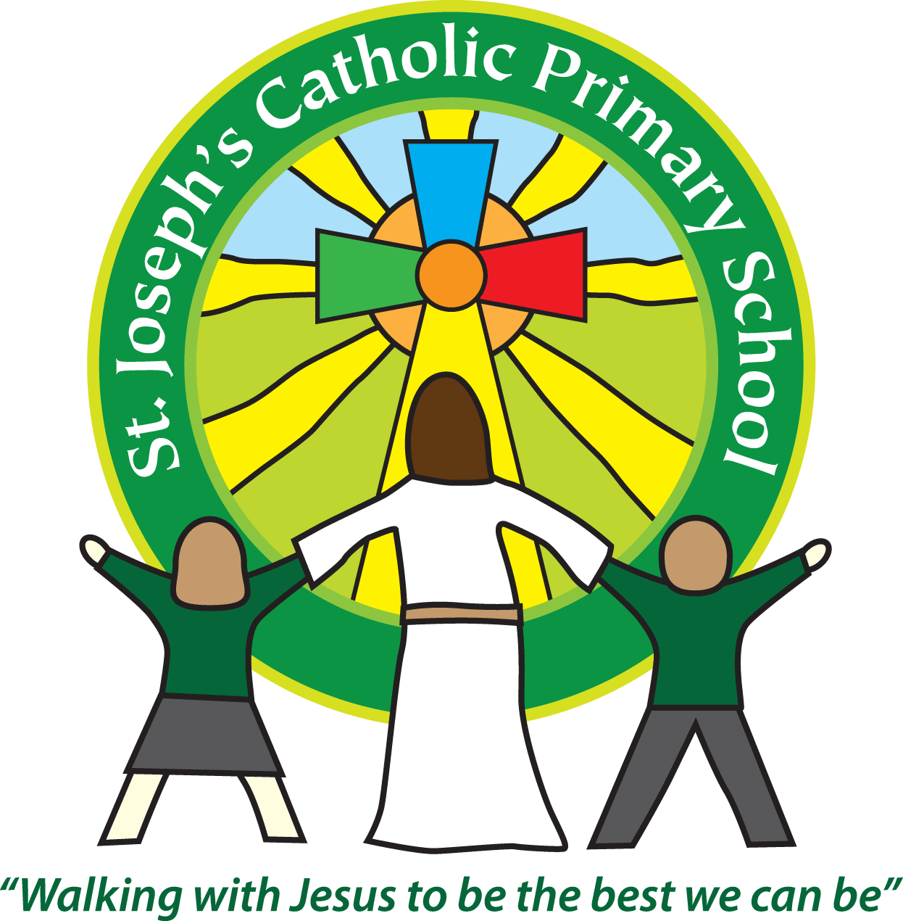
St Joseph’s Catholic Primary School Home Learning Pack – 15.06.2020-26.06.2020
Willow Class
The way we are doing home learning is changing a little. We will be sending tasks home every two weeks and reducing the number of tasks to 3 maths, 3 English and 3 topics per week (so you will receive 6 maths, 6 topic and 6 English every other Monday).
Just to be clear, we are not expecting everyone to do all of the activities and these are only suggestions. We understand that our circumstances are all very different at the moment and that lots of you will be trying to juggle ‘home school’ and your own work as well as caring for elderly neighbours and family. Please only do what you feel you can. We do not want to set anything that causes any worry so please do what you feel. There are some references to resources but they do not need to be printed and can be viewed online and the work can be completed or copied onto paper. Please contact us at admin@stjo.uk and in the subject name it… For (Your Child’s teachers name and Class) if you need any further support. For example; For Mrs Spinks, Willow Class. This will help us to ensure your request is dealt with quickly.
All of the resources for the home learning below can be found at: https://www.stjosephsprimaryschool.com/website/home_learning_04052020/477542 on the Coronavirus information page – Home learning and then select the date and appropriate class.
Maths | Activities | Resources
Times tables | Please continue to practise your times tables everyday this can be done on TTRS or offline through a variety of games and activities. Here are a few ideas to help you:  - Use playing cards – Choose 2 cards at a time and multiply the numbers together and then discuss corresponding division facts.  - Exercise while reciting your times table facts e.g. skipping  - Play times table ping pong – in partners take it in turns to ask each other questions  - Times table bingo – draw a 3x3 grid and choose numbers from the tables – bingo caller to ask multiplication and division question.  - Why not invent your own times table game to play?
Week 1  Activity 1 | Can I subtract 3-digit numbers?  - Read the learning reminders to refresh your understanding.  - Complete the practice questions  - If you are finding it tricky complete the ‘A bit stuck sheet’.  - Complete the questions to check your understanding. | PDF document ‘Maths activity 1’ on the website
Activity 2 | Can I subtract 3-digit numbers?  - Read the learning reminders to refresh your understanding.  - Complete the practice questions  - If you are finding it tricky complete the ‘A bit stuck sheet’  - Complete the questions to check your understanding. | PDF document ‘Maths activity 2’ on the website
Activity 3 | Can I find the area of a rectangle?  - Go through the power point or read the learning reminders to refresh your understanding.  - Complete the practice questions  - If you are finding it tricky complete the ‘A bit stuck sheet’.  - Have a go at the investigation to check understanding | PDF document ‘Maths activity 3’ on the website  PPT Activity 3.
Week 2  Activity 4 | Can I find the area of shapes ?  - Read the learning reminders to refresh your understanding.  - Complete the practice questions  - Complete the questions to check your understanding.  - If you are finding it tricky complete the ‘A bit stuck sheet’. | PDF document ‘Maths activity 4’ on the website
Activity 5 | Can I subtract 3-digit numbers?  - Go through the power point or read the learning reminders to refresh your understanding.  - Complete the practice questions  - If you are finding it tricky complete the ‘A bit stuck sheet’.  - Have a go at the investigation to check understanding. | PDF document ‘Maths activity 5’ on the website.  Activity 5 PPT
Activity 6 | Can I subtract 4-digit numbers?  - Read the learning reminders to refresh your understanding  - Complete the practice questions  - If you are finding it tricky complete the ‘A bit stuck sheet’.  - Complete the questions to check your understanding. | PDF document ‘Maths activity 6’ on the website.

Please continue to keep a written diary recording what you have done each day.
English | Activities | Resources
Week 1  Activity 1 | Can I punctuate direct speech with inverted commas?  - Look at the front cover of ‘Peter and the Wolf’ and predict what might happen in the story.  - Listen to the story being read https://www.youtube.com/watch?v=ickziSniXkI  - Use the PowerPoint about speech marks and reporting clauses or, if this is not possible, use the Revision Card to remind yourself.  - Complete Peter and the Wolf Sentences. You can use some of the Said Synonyms for your reporting clauses.  - Look closely at the Six Illustrations. What is happening in each? What has happened just before and what will happen just after?  - Write sentences on Story Summary about the illustrations. | PDF document ‘English activity 1’ on the website.
Activity 2 | Can I use direct speech in my writing?  - Look at the picture of Duck and Bird.  - Listen to the music that goes with this part of the story: https://www.youtube.com/watch?v=Vp2Y8ytYDns  - Imagine all the things that Duck and Bird might have said in their argument? What else might they have boasted about? How might they have insulted each other?  - Write your ideas on Duck and Bird Arguments.  - Write a paragraph that tells this part of the story.  - Include some direct speech in your writing. Use the Revision Card to remind you about how to do this. | PDF document ‘English activity 2’ on the website.
Activity 3 | Can I write the ending of a story?  - Look at the picture of the Procession. What is happening in the story in this picture? What has happened just before? What could happen next?  - Listen to the music that goes with this part of the story: https://www.youtube.com/watch?v=HM0lMX5BJAg  - Complete New Ending. Imagine what will happen when the procession arrives at the zoo.  - Write your new ending to the story. Include some direct speech. Use the Revision Card to remind you about using a new line for a new speaker. | PDF document ‘English activity 3’ on the website.
Week 2  Activity 4 | Can I read poetry and recognise different techniques used?  - Read the poem Revenge. Read it three times so you are really familiar with the words. Now cover up the words. Can you say the poem using just the pictures at the bottom? If you can’t, look at the words and try again.  - Read Poetry Vocabulary.  - Read Snow, Mrs Sprockett’s Strange Machine and The Moon.  - Choose your favourite of these three poems.  - Read Performance Questions. Think about your answers for your favourite poem and make notes about them. | PDF document ‘English activity 4’ on the website.
Activity 5 | Can I write a poem?  - Read Snow. What patterns can you spot in this poem?  - Fill in the boxes on the Memory Frame with quick pictures that will help you to remember each line of the poem.  - Read Summer Days. What do you like about the poem? Which is your favourite line?  - Fill in the Word Table to show the pattern of words used in Summer Days.  - Decide a title for your poem. It could be one of these, or you could choose your own idea: A day at the beach, Summer meadow or Seasons of the tree. | PDF document ‘English activity 5’ on the website.
Activity 6 | Can I use possessive apostrophes?  Follow the instructions on the BBC Bitesize website to revise and practise using possessive apostrophes.  https://www.bbc.co.uk/bitesize/articles/znyf382 | BBC Bitesize: https://www.bbc.co.uk/bitesize/articles/znyf382

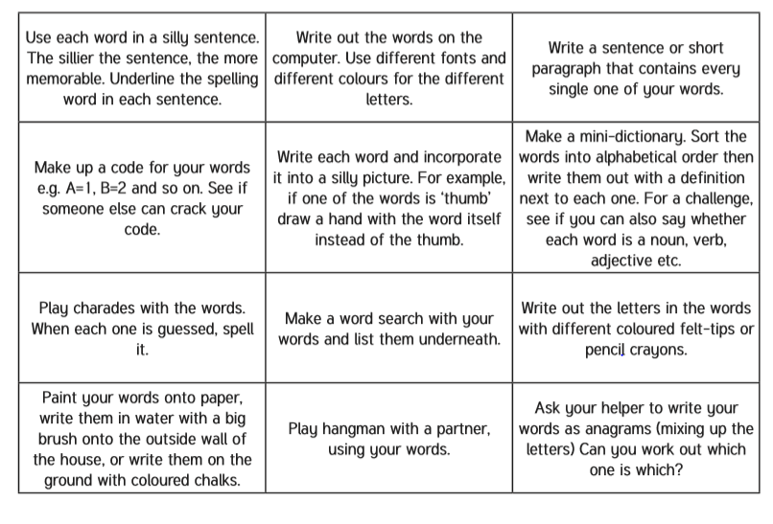
Spelling – Practise the year 4 spellings using a range of strategies. Below are some ideas that you can try.

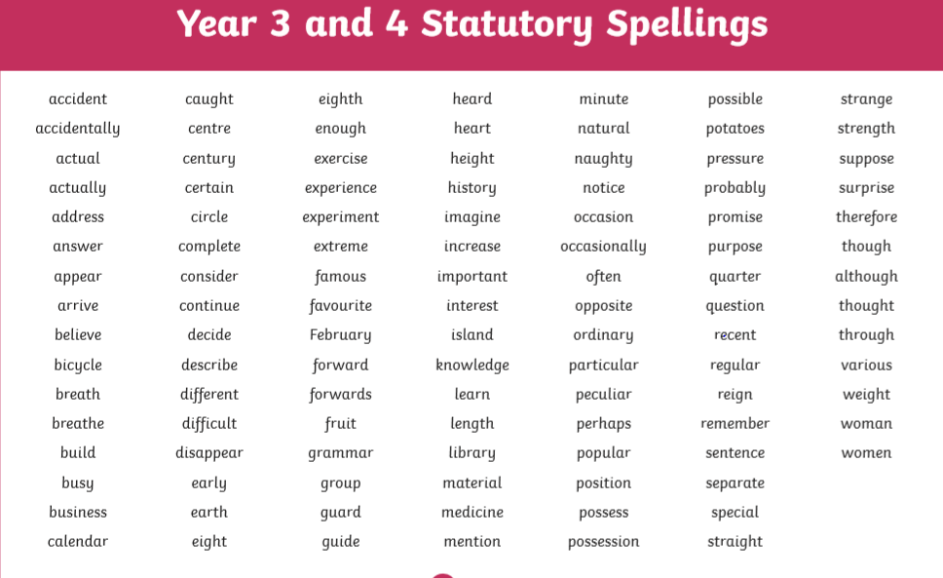
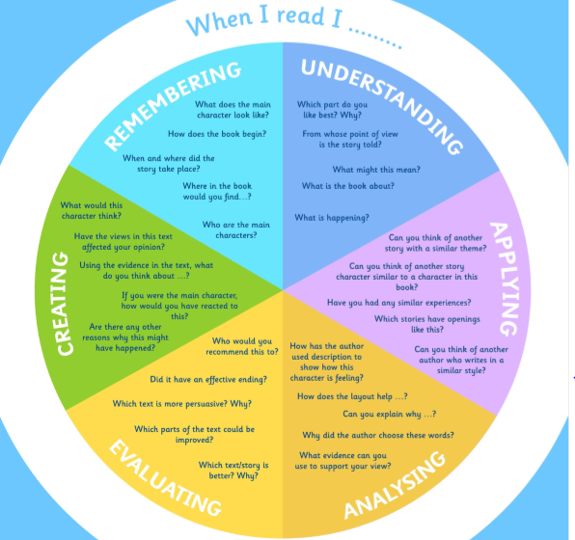
Suggested Reading Activities
This is an essential skill that the children need to continue to practise daily. It is recommended that the children read for at least 20 minutes each day. Continue to record all reading in the reading record books and remember to quiz on accelerated reader. You should have received an email with log in details. Please contact me if there is an issue with this. When listening to your chid read ask questions regularly to check and support understanding. Here is some example questions which would really support the children in their development.

Varied activities of Science, Music, Topic (History, Geography, Art) and R.E
 | Activities | Resources
Week 1  Activity 1 | This week we will reflect on the Feast of Corpus Christi, which celebrates Jesus’ great gift of his own Body and Blood. When we gather as a church or school family to receive the Body of Christ, we show that we are united as the Body of Christ. When we share with our neighbour, we become sisters and brothers in Jesus, and bring his life and love into the world. Just as one loaf of bread is made with many grains of wheat, so there are millions of people around the world, but we are all joined together as one family.  - Research bread around the world and design a poster or create a slideshow presentation to present your findings.
Activity 2 | Using your research from activity 1, design a bread recipe to make some bread for your family.  If you do not have any yeast, I have attached a recipe for a flat bread which you could try: https://www.jamieoliver.com/recipes/bread-recipes/easy-flatbreads/
Activity 3 | If we were in school this week, NSPCC would have been visiting us to lead a whole school assembly. As this is not able to happen, NSPCC have created an online assembly about speaking out and staying safe. Follow the link to watch the assembly: https://www.youtube.com/watch?v=qm0kccbZpYY&feature=youtu.be
Week 2  Activity 4 | As this is such an uncertain time at the moment, I am sure that we all have lots of worries that we are thinking about. It is important to share our worries with somebody. This week I would like you to create a worry monster.  - Design a worry monster  - Create your worry monster using any resources that you have at home.  - Here are some examples:  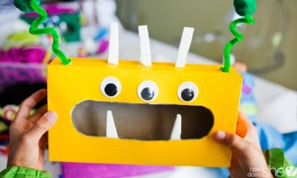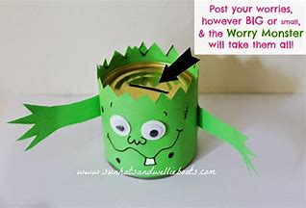 | Worry monster instructions on the website.
Activity 5 | This week we are celebrating other faiths. I would like you to research Sikhism and answer the five questions below.  - Who founded Sikhism?  - What do Sikhs believe?  - What are the 5 K’s?  - Do Sikhs have a holy book?  - Where do Sikhs worship?  This is a useful video:  https://www.bbc.co.uk/bitesize/topics/zsjpyrd/articles/zkjpkmn
Activity 6 | Launching Rockets  Resources:  - 1 straw  - Paper  - Sticky tape  Wrap paper tightly around a pencil, securing with tape, then make one end air-tight by folding over and taping down.  Remove the pencil and you will have a cylinder with one sealed end.  Push the straw into the paper cylinder (rocket)  The straw is your launcher  Take your rockets to an open space and blow down the straw to launch your rocket. Measure how far your rocket travels each time.  How can you make your rocket go further?  This could include:  - changing the paper rocket: size, shape, type of paper  - changing the straw launcher: length/diameter of straw, launch angle  - changing how hard you blow

