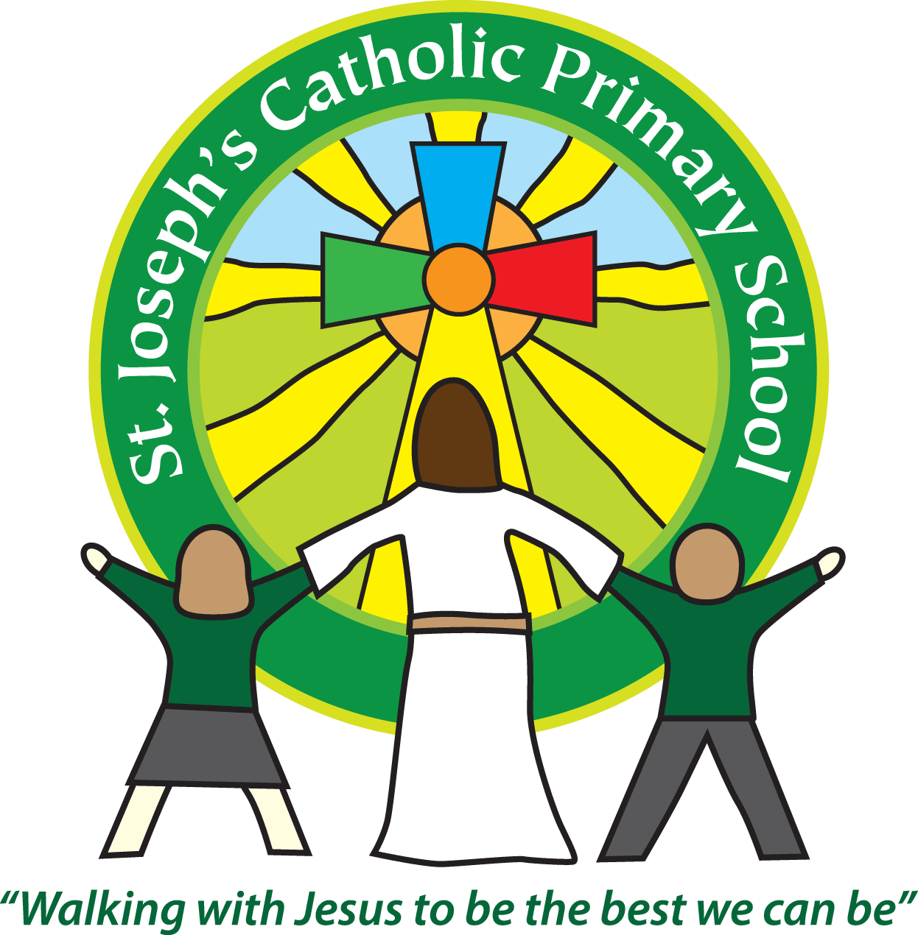Diary dates for parents/carers Autumn 2018

|  |  |  |
| --- | --- | --- |
| Date | Time | Event |
| September |  |  |
| Monday & Tuesday 3rd/4th Sept | All day | School closed for Non-Pupil days |
| Wednesday 5th September | 8.55am | Children return to school after summer holidays |
|  |  |  |
| Friday 8th September | 9.30am | Mass in School |
| Friday 21st September | 9.15am | Donkey Sanctuary Roadshow for FSU, Yr 1 and 2. |
| Tuesday 25th September | Morning | School photos |
| Wednesday 26th September | 2.15-3.15pm | Oak and Acorn parent activity session |
| Thursday 27th September | Evening | Exmouth Community College open evening |
| Friday 28th September | 3.30pm | Catch up photos for any children away on Tuesday or for children with siblings that are not in school. |
| October |  |  |
| Tuesday 2nd October | 9.10am-10.10am | Maple Class parent activity session |
| Tuesday 2nd October | 2.15-3.15pm | Rowan Class parent activity session |
| Wednesday 3rd October | 9.10am-10.10am | Sycamore Class parent activity session |
| Wednesday 3rd October | 2.15-3.15pm | Willow Class parent activity session |
| Thursday 4th October | 9.10am – 10.10am | Beech Class parent activity session |
| Thursday 4th October | 2.15-3.15pm | Cherry Class parent activity session |
| Friday 5th October | 11.00am | Harvest celebration in school – donations go to Exmouth Food larder |
| Friday 5th October | KS1 6-7 pm  KS2 7.15-8.15pm | School disco |
| Tuesday 9th October | 3.40 – 6pm | Parents evening, times to be issued |
| Wednesday 10th October | 3.40 – 6pm | Parents evening, times to be issued |
| Friday 12th October | 9am | Bags 2 School |
| Monday 15th – Friday 19th October | Residential | Beech Class PGL trip |
| Monday 15th October | 2.30pm | Maple Class Mass in school |
| Monday 22nd – Friday 26th October | All week | Half term |
| November |  |  |
| Thursday 1st November | All day | Dress up as a Saint Day |
| Thursday 1st November | 10am | Mass in Church |
| Monday 5th November | 2.30pm | Class 5 Mass in school |
| Friday 9th November | All day | Non-pupil day |
| Monday 12th November | All day | Anti-bullying week – workshops all day |
| Friday 16th November | All day | Children in Need day. Non-uniform day. Children to come in wearing spots for £1 donation. |
| Friday 23rd November | 6 – 7.30pm | Film night |
| Sunday 25th November | 11am | New school starters invited to Mass at Church |
| Friday 30th November | Morning | Flu vaccines - Reception children up to Class 5 |
| December |  |  |
| Tuesday 11th December | 2pm & 6pm | Class 1 and 2 Nativity play |
| Thursday 13th December | 6 – 7pm | Class 3 and 4 Christmas service in school |
| Friday 14th December | All day | Christmas jumper day £1 donation to Save the Children and PTA present wrapping |
| Tuesday 18th December | 6.30– 7.30pm | Class 5 & 6 Advent Service in Church |
| Wednesday 19th December | Afternoon | Carols around the Christmas tree |
| Thursday 20th December | 3.30pm | Children break-up for Christmas |
| January |  |  |
| Monday 7th January | All day | Non-Pupil day |
| Tuesday 8th January | 8.55am | Children return to school for Spring term |