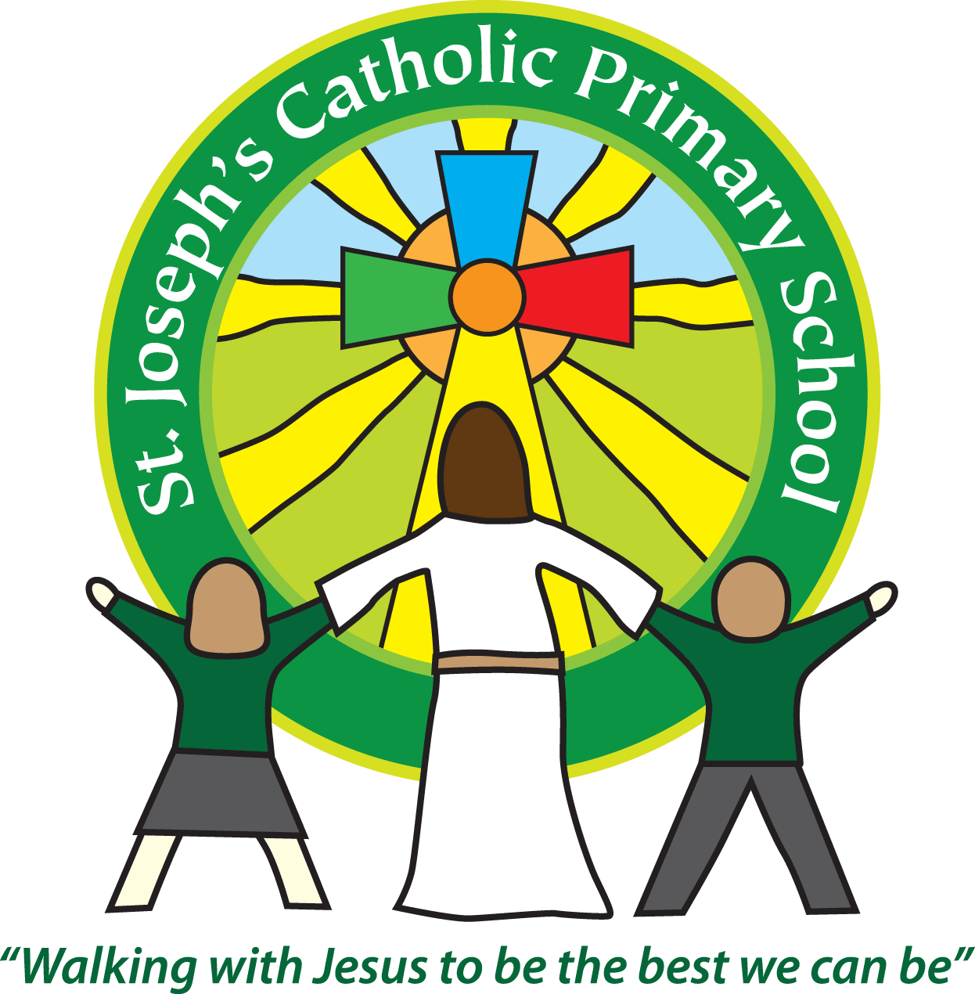
St Joseph’s Catholic Primary School Home Learning Pack
Class: Sycamore Year 2 – 04.05.2020
Please find the suggested timetable. This is just a suggestion and you need to find what works for you and your child as we understand that everyone learns differently. Just to be clear, we are not expecting everyone to do all of the activities and these are only suggestions. We understand that our circumstances are all very different at the moment and that lots of you will be trying to juggle ‘home school’ and your own work as well as caring for elderly neighbours and family. Please only do what you feel you can. We do not want to set anything that causes any worry so please do what you feel. There are some references to resources but they do not need to be printed and can be viewed online and the work can be completed or copied onto paper. Please contact us at admin@stjo.uk and in the subject name it… For (Your Child’s teachers name and Class) if you need any further support. For example; For Miss Rowe, Sycamore Class. This will help us to ensure your request is dealt with quickly.
Suggested Family Home Learning Timetable
This is a guide to help you establish a routine for your children – this is just a suggestion and you will need to adapt it to the needs of your family.
Time | Activity
Before 9.00 | Get up, washed, dressed, make beds and eat breakfast
9.00 – 9.30 | PE with Joe or family walk
9.30 – 9.45 | Drink and get ready for home learning
9.45 – 10.30 | English – writing, spelling or grammar activity from your home learning pack
10.30 – 11.00 | Break time - take a snack and drink outside if you can
11.00 – 11.45 | Maths – choose an activity from your home learning pack
11.45 – 12.30 | Creative time – draw, paint, sew, bake, do a job in the garden, stop-motion animation with lego / plasticine (the list is endless). Have a project that you can do a bit of everyday.
12.30 – 1.15 | Lunch – help to make it AND clear up behind it!
1.15 – 1.30 | Chores – do a job around the house e.g. put laundry away, tidy your room, vacuum or polish
1.30 – 2.00 | Quiet time – shared or independent reading
2.00 – 3.15 | Topic time – science / art / history / geography / music – choose a topic activity from the home learning pack
3.00 – 3.15 | Break time – take a snack and drink outside if you can
3.15 – 3.30 | Reading – enjoy a book together

All the PDF’s and resources will be on the school website under Coronavirus – Home Learning – Sycamore.
Maths |  | Activities | Resources
Day 1 | Can I practise my times tables? | This week, there is a TTRS Battle against Cherry Class so please have a go and see if you can contribute to our team score.  At the end of Year 2, the expectation is that children can recall their 2, 5 and 10 times tables and count in steps of three so you could start to learn this as the 3 x table.  To practise them you could…  - write your times tables out and see what patterns you notice  - chant them and make them into a song  - write them on flashcards, hide them and answer them | Resources as needed
Day 2 | Can I round numbers? | Recap multiples of 10.  Use the vocabulary the next 10, nearest 10, next multiple of 10.  Say a number such as 37. Which is the nearest multiple of 10?  Work through the learning reminders. There is a powerpoint if you have access to this. If not don’t worry, it is the same as what is on the Learning Reminders sheet.  Work through the activities. | Resource Day 2  PowerPoint Day 2
Day 3 | Can I round prices to the nearest 10? | Recap rounding from yesterday.  Work through the learning reminders.  Explain to the children how we use this Maths in an everyday context.  Complete activities. | Resource Day 3
Day 4 | Can I measure in cm? | Explain that a cm is a unit of measurement. Can you think of anymore? Show a ruler. Look at the measurements.  Work through the learning reminders and complete the activities. | Day 4 Resource (It says Day 5 as you open it up)  Ruler
Day 5 |  | BANK HOLIDAY

English |  | Activities | Resources
Day 1 | Can I create similes? | Read Whale Words together.  Remind of adjectives using the reminder sheets.  Introduce a simile. A simile compares something to something else.  Complete activities. | Resource Day 1  Whale Words Doc
Day 2 | Can I create similes? | Recap similes from yesterday.  Complete these similes.  ……………was as silent as a …………..  …………..was as tall as a…………….  ……………….was round like a ………………….  ……………..was a sweet as……………..  ………………was as strong as a …………….  ……………….was kind like ………………….  ………………was as cold as……………………  Challenge – Can you make up any of your own? | Paper and a pencil
Day 3 and 4 | Can I create my own book? | Read Whale Words again.  Choose a type of animal such as a big cats, birds, dogs etc.  Choose a few of them. For example – dogs  Golden Retriever, Labrador, Dachshund, Poodle  Draw a picture of each dog on a different page of your book. Take care over the pictures.  Label each page with the breed of dog. Remember to use a capital letter for its name. On each page also include an adjective or verb that tells us about the animal and then add a simile for each animal.  For example:  Golden Retriever  (Picture)  Obedient  As soft as a pillow.  You can do bubble writing if you like!  If you want to send your book into school you can send it by post or you could photograph it and send it to admin@stjo.uk.  I would love to see some!  I may create one of my own…. | Paper  Pencils and colouring pencils  Pictures of animal to support drawing  Whale Words Doc
Day 5 |  | BANK HOLIDAY

Suggested Reading Activities
Reading Daily
Please enjoy a bedtime story together each night. I have included some questions/ideas below that you could explore as part of your reading.
- Look for any words with apostrophes. Explain why these words have them.
- Choose a character to draw and label from your book. Write about their appearance and likes and dislikes.
- How do you feel whilst reading the book? Why?
- Make a mini-quiz about the book.

Spellings
Here are a list of this weekly spellings.
knot | know | knee | gnat | gnaw
knife | knit | kneecap | knobbly | gnome
knight | knew

You could quiz them each week, like we do in class if you would like to.

Varied activities of Science, Music, Topic (History, Geography, Art) and R.E
 |  | Activities | Resources
Day 1 | Can I carry out a fair test? | This week, we are setting another whole school Science Activity.  If you want to, you can send us a photo of you doing the investigation or of your poster to show us what you have found. | Task 2 Fair Test
Day 2 | Can I design a symbol of peace? | What does peace mean?  Can you think of any symbols of peace?  (dove, handshake, a poppy, an olive branch)  Design your own symbol of peace.  Write a sentence to explain why you have chosen the ideas you have for your design. | Paper  Colouring pencils
Day 3 | Can I find out about different flags? | On Friday this week, the nation will celebrate VE Day. This is the day the Second World War ended in Europe. The Second World War was between 1939 and 1945 so it was six years long. People’s lives changed massively because of this. They were not able to continue with their everyday lives as they were used to. Many people also lost their lives as a result of this war.  We have a special Bank holiday for celebrations to mark the end of this war but because of social isolation many of the events have had to be cancelled but it will still be remembered but in a different way.  This week, as a school we have planned some activities to help you learn a bit more about it.  When the war ended many people took to the streets waving flags. Many people also had street parties to celebrate the freedom.  Find the colours of the Union Jack and colour it in. Make your own flag as a reminder of this day.  Challenge – Can you research any other national flags? | Flag Template
Day 4 | Can I design a piece of bunting to celebrate VE Day? | As part of the VE Day celebrations, many people have had street parties over the years to celebrate the freedom after war.  Design your own piece of bunting. Try to include different pictures and patterns that represent the end of the Second World War, being together, hope, peace and symbols of our nation such as the flag that you might have made yesterday.  Captain Tom was a soldier in the Second World War and he has raised lots of money for the NHS to support our health service during Covid-19. You may want to make some references to him on your bunting too. | Bunting Template  You can find one on this link or you could make your own.  https://www.twinkl.co.uk/resource/t-t-7473-blank-bunting-template
Day 5 |  | Bank Holiday

