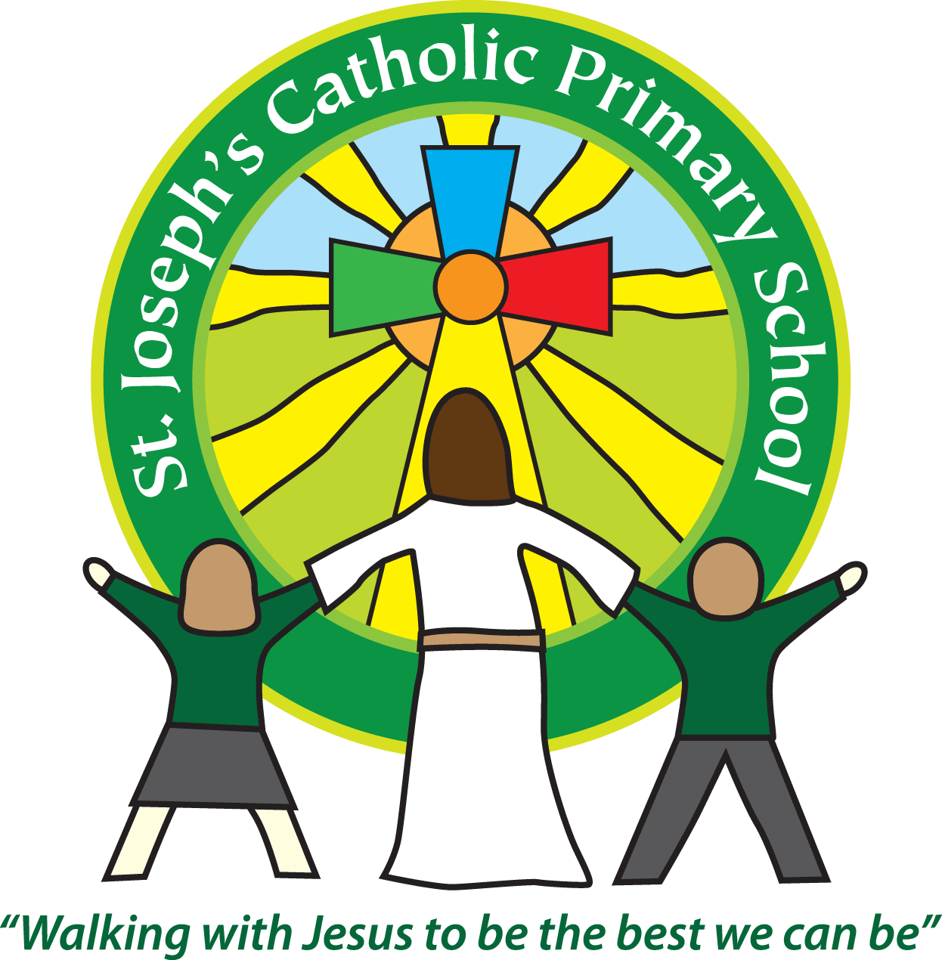St Joseph’s Catholic Primary School
Foundation Stage – Summer term

Welcome to the Summer Term of 2022!
Over the Easter holidays Miss Atkins became Mrs Parkes – Barton. We have shown the children pictures and videos of the wonderful special day so they understand the sacrament of a wedding and why her name has changed. She is known as Mrs P-B!
This half term is a relatively short half term where we will continue our topic ‘Ready, steady, change’
Our seeds have been busy growing and the children are enjoying watching them grow each day. We have some green strawberries already and the courgette plants are starting to take over! Thank you to all those who helped to provide us with compost, seeds and pots etc. We hope to get some produce before the end of term.
This week we have been reading and learning the story of Jack and the Beanstalk. This will continue for a couple of weeks where we will retell and write the story and even our own version of the story.
In Mathematics we will continue with our Power Maths where this term we focus on developing our counting skills and exploring the composition of numbers. The Oak children will be exploring counting on and backwards when adding and subtracting as well as numerical patterns with odd and even numbers, halving and sharing.
For Creative development, as well as the roleplay and imaginative play around our traditional story, we will also be looking at some pencil and painting skills.
The Summer term is usually when we can get out and about a bit more to explore our natural world and local / school environment. We have rearranged our trip to the church. This will now take place on Friday 6th May. If you can help support us on this visit please let me know.
We will also continue to be physically active with our outdoor play, using bikes and trikes, obstacle courses, P.E sessions as well as yoga, movement and music.
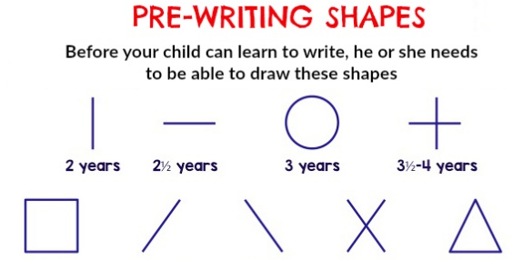
During Funky fingers sessions we will continue to practise fine motor activities from tweezers to pegs and threading beads/cheerio’s onto different strings. In Acorn class - our school starters, and those children that are ready, will look at forming the letters in their names and the pre-writing shapes that help us to form our letters.
The Oak children will continue to practise their letter formation for each letter family.

Oak Class -
Subject | Set on Tapestry | Due in | Frequency
Oak Class  home learning | Friday | Wednesday | Weekly
Reading | Your child will continue to receive their hot and cold reading books - Practise really does make perfect!  Please ensure you write in the yellow reading book to let me know how your child is getting on at home.  Get them writing! Encourage your child to write independently using their growing phonic skills. They could write shopping lists, cards, post-its, notes, messages, letters, little books and postcards – anything at all. It’s all great practise.
Reminders:
School lunch | Oak children are entitled to a free school lunch every day. Thank you for selecting your menu choices already.  For Acorn children a school lunch can be ordered at a cost of £2.35 School dinners must be ordered on Parent pay before 8am.  We promote healthy eating at school and so lunch boxes should not contain more than one chocolate snack and one packet of crisps.  Children are welcome to bring fresh fruit or vegetables for a snack at break time.  We are a nut free school. We have children with potentially fatal nut allergies in school, therefore no food containing nuts may be sent into school.
Drinks | Your child must have a named water bottle in school every day. Please only send in water, no juice or fizzy is allowed.
Uniform | Now that the uniform has been through the wash a few times please ensure labels are still securely attached or that the pen can still be read easily.  Grey trousers or shorts, grey skirt or pinafore dress, white or grey socks, grey tights, white polo shirt, green logo school sweatshirt or cardigan. Warm weather option – green and white gingham dress (dress with shorts instead of skirt is acceptable)  Hair past shoulder length must be tied back – please use plain hairbands in green, black or white, not brightly coloured bows.  Nail varnish is not allowed. School shoes must be black (no heels, trainers or boots.)
PE kit ( Oak class only) | Green t-shirt with school logo, black shorts, jogging bottoms and trainers. All kit must be named and in a named bag.  Ear rings must be removed or covered with tape for PE lessons.  Watches must be removed for PE.  PE kit should be worn to school on a Friday.
Wellies | Please ensure your child has a pair of clearly named wellie boots that can be kept in school this will enable the children to explore outside without getting their school shoes muddy!
Bags | Reception, Yr 1 and 2 children must have a book bag in school. This is so books can easily be checked and letters put in.  Acorn children should bring their book bags so they can exchange their books  Children can have a bag or rucksack in school but please avoid the large bulky ones as 30 rucksacks take up a lot of room in the class.
Mornings | Our Foundation Stage doors are open from 8:50am. Please pass on any quick messages then, for a longer meeting please make an appointment.  Children and parents arriving after 9am will be asked to sign in at the office.  We are very impressed with how independent the children have been this term with sorting their belongings. Thank you for your help with ensuring their snack and bottles are easily accessible and supporting them with putting on their own coats and shoes.
After school | All the children in Foundation finish at 3.15pm. If someone other than yourself is collecting your child please ensure the office has their details. We will not let them leave unless we are sure they are safe.
Contact details | Please ensure you contact details and those of other people who may collect your child are always kept up to date. Please see the office asap if you change your phone number or address.

We always encourage the children to feel proud when they can achieve things by themselves. This includes taking responsibility for their own possessions. We have established routines whereby children are able to ensure snack pots, water bottles and book bags find their place in the classroom and are taken home at the end of the day. Jumpers / cardigans are put safely on their pegs or in their tray. Please ensure jumper/ cardigans are clearly named in case of any going astray!
Grown-ups - you can help your child by encouraging them to put on their clothes, coats and shoes at home and by helping them to eat independently at meal times. Children should be encouraged to use a knife and fork at home.

As the weather is warming up the sun seems to be increasingly powerful. We have a great outdoor area and the children have access to it for many parts of the day. Please make sure you have applied sun cream to them before they come to school. You can buy high factors and long lasting creams that will give your child all day protection. A sun hat (clearly named) should also be worn.

A final message to keep an eye on Tapestry and the Foundation Class page on the school website which will show you how our topic develops and how busy we have been!
http://www.stjosephsprimaryschool.com/website/foundation

We recognise the importance of passing information between parents and school so please remember our door is always open and you can come and talk to us if you have any questions and concerns.

Yours sincerely,
The Foundation Stage Team.

