School Council Newsletter
Issue 2 - Summer 2019

Class 6  Last term’s theme was ‘In the Footprints of the Tiger…’  We entered the BBC 500 words competition and successfully completed the SATS! Everyone worked really hard and our teachers were also super pleased with us. We are all going crazy for ‘Times Table Rock Stars’. Mr Lucas visited us and gave us a taster maths lesson to give us an experience of what other lessons might be like from the Community College. We are enjoying our new RE topic on Pentecost and hope you will all come to see our work display on 19th June. | Class 6 news (2)  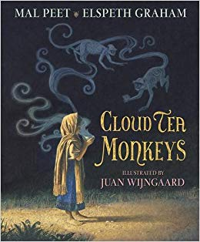  We have learnt about India (like class 5) and we have focused on a story called Cloud Tea Monkeys. This book is about a young girl called Tashi who has befriended some Grey Langur monkeys. We wrote a diary account or narrative on what has been the story happening. Some of us have been doing it from a different point of view like monkeys.  In maths, we have been learning about fractions, decimals and percentages We have also been looking at converting imperial and metric units.

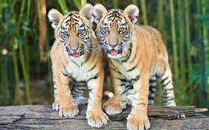 | Class 5 news  Our topic in class 5 was The Footprints of the Tiger. Tiger numbers climbed down since 1970 (20th century). Tigers can grow up to 95 cm. Different species of tiger are adapted to their environment. Also, we were drawing pictures of various animals (turtle shells, tiger fur, margays and other animals). Learning about India linked really well about our RE topic of Hinduism which we found fascinating. In English we have been writing mythical stories and focusing on the Indian gods it has been very fun learning this term.  We have also had an amazing time at Magdalen Farm residential and are enjoying our new topic ‘Food for Thought’.

Class 3 and 4 news  Learning  Last term, class 3 and 4 started our topic on Ancient Egypt. We learnt all about Howard  P.T.O.  Carter, burials and mummification through our  English work on information texts. We also learnt about The River Nile and the geographical features of Egypt. Class 3 and 4 looked at the tombs of great Pharaohs, which we have carried on into the second half of the term. In Science we have learnt about sound waves and how sound travels to the brain, as well as conducting fair experiments. Class 3 and 4 also have great awareness of e-safety after our work in class.  Years 3 and 4 went on a trip to The Bournemouth Symphony Orchestra where we heard classical music and participated by learning body percussions. On red nose day, we did a dance-a-thon where everybody danced to raise money for comic relief.  We learnt all about the resurrection in RE, even though we were familiar with the story we learnt even more this time!  Now we are learning about Parklife. We had a great trip to the Estuary and have been doing lots of learning outdoors. | Class 3 and 4 news (2)  We have learnt to build suspense in our story writing by using ‘The Old Mill’ by Pie Corbett. In maths, we are converting units of time as well as  P.T.O.  completing work on fractions, decimals, multiplication and division. We loved our forest school sessions last term and made bug hotels, dens, bird feeders and have searched for treasures. We also did a brilliant performance on Little Red Riding Hood!  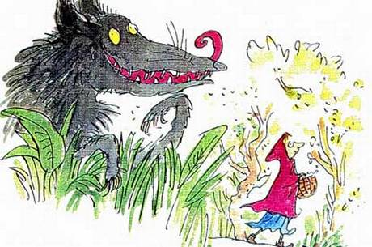  We have also been working on our singing.

In Year 1 and 2, we learnt about the Great Fire Of London. We painted some great pictures of the fire and cut out some black paper in the shape of important and famous London buildings, glued them onto the fire background we made before and stuck our masterpieces on the wall so everyone could see our work.
We found out that a baker on Pudding Lane called Thomas Farynor started the fire. We also wrote this fascinating story as well to go with our interesting topic.
We also made an Easter Garden in RE which one of our Governors opened!
In maths, Class 1 have been learning our number bonds to twenty and taking away numbers from twenty.
We had a wonderful trip to The Tiverton museum and are looking forward to our trip to the estuary.

We look forward to seeing you all soon at some of our great events like Public Speaking and Sports Day!

