Year One
Week ending 6.3.20 . . . What could you do?
English
This week we have been writing facts about fossils. You could . . .
Write some facts about an animal of your choice. Remember your full stops and capital letters.
Practise reading and spelling these words with the ‘ee’ phoneme.
been, beach, happy, money, field, she, these, people
Phonics
The week we have been revisiting the different spellings for the phoneme ‘ee’
(ee, ea, e-e, e, y, ey, ie). Play Phonics Frog practising reading real and nonsense words using our Phase 5 diagraphs. https://www.phonicsbloom.com/uk/game/phonics-frog?phase=5
Maths
This week we have been introduced to multiplication. You could…

Find arrays around your house! (Eg: an egg box)
Draw an array to match these number sentences (2x3 =, 5 x4 =, 10 x2 =)
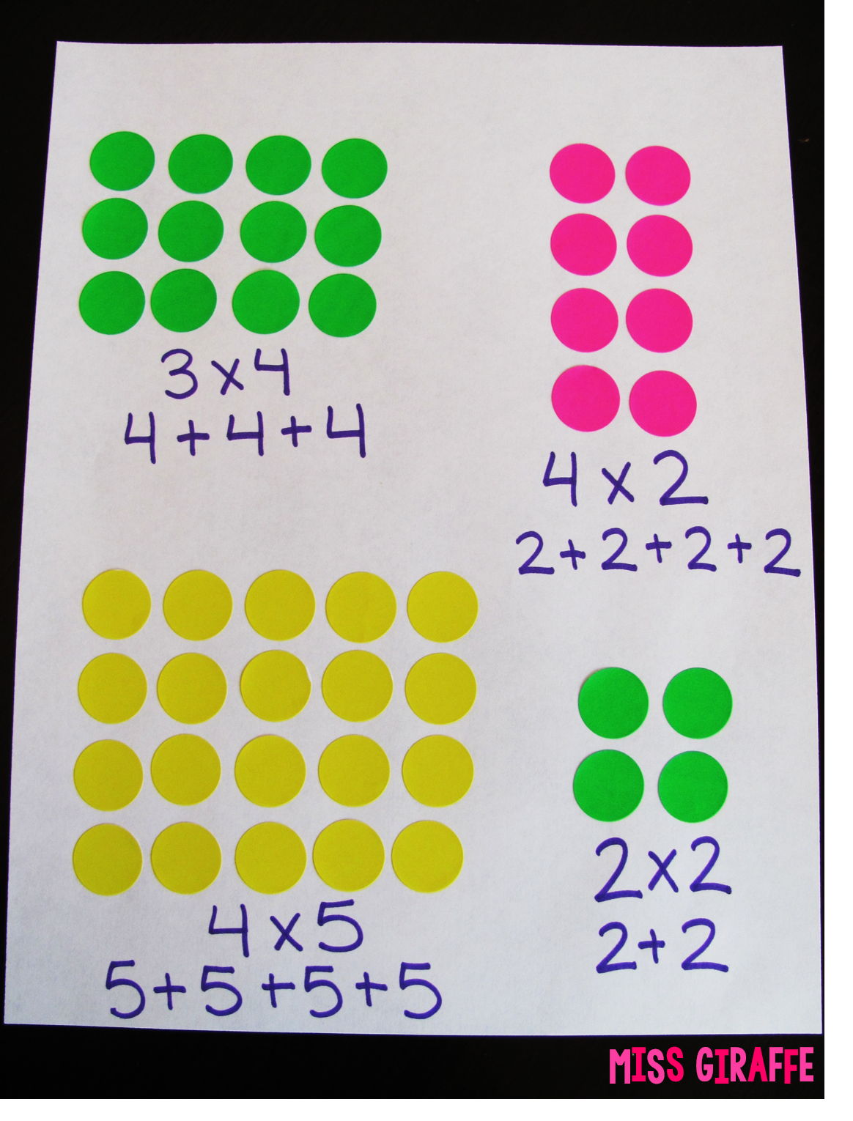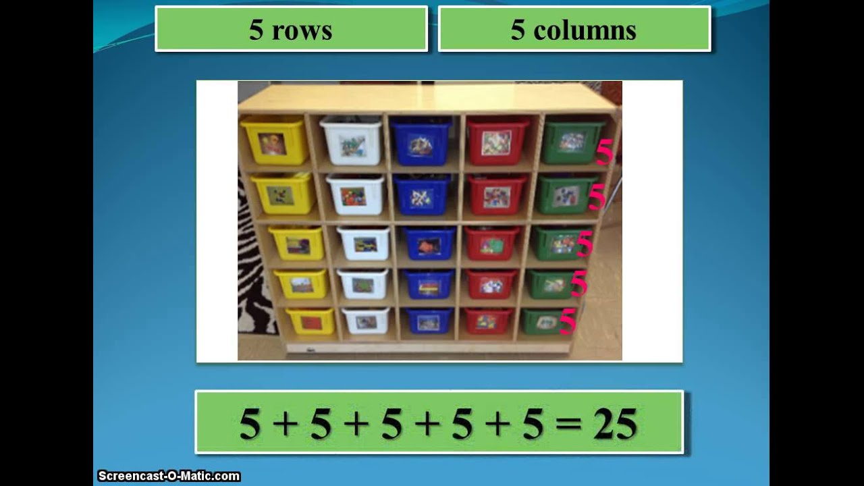

Topic
This week we have begun learning about Mary Anning. Can you find out why she is famous?

