28.4.2020

Can I find factors and common factors?

**Step 1**

A factor is a number that divides exactly into another number. We find them in factor pairs.

For example, the factors of 12:

**Step 2**

Then list your factors in ascending order, ignoring any duplicates.

Factors of 12: 1, 2, 3, 4, 6, 12

**Step 3**

To find the common factors of two (or more) numbers, list the factor pairs of both numbers.

**Step 4**

Circle the number that appear in both lists. These are the common factors.

Common factors of 8 and 12: 1, 2, 4

The highest common factor (HCF) of 8 and 12 is 4.

Magnificent

|  |  |
| --- | --- |
| Find the Highest Common Factor (HCF) of: | Answer: |
| 12 and 18 |  |
| 30 and 48 |  |
| 36 and 45 |  |
| 18 and 21 |  |
| 9 and 20 |  |
| 28, 56 and 70 |  |

Marvellous

|  |  |
| --- | --- |
| Find the factors of: | Answers: |
| 8 |  |
| 35 |  |
| 16 |  |
| 40 |  |
| 24 |  |
| 64 |  |

4

3

6

2

x

x

12=

x

1

12=

2

4

x

8

1

x

=

8

x

4

3

6

x

2

12

x

1

Answers

Fluent in Five: 1) 54.7 2) 238 3) 14 4) 61 r5 or 61.71 5) 14.11

Marvellous

|  |  |
| --- | --- |
| Find the factors of: | Answers: |
| 8 | 1, 2, 4, 8 |
| 35 | 1, 5, 7, 35 |
| 16 | 1, 2, 4, 8, 16 |
| 40 | 1, 2, 4, 5, 8, 10 20, 40 |
| 24 | 1, 2, 3, 4, 6, 8, 12, 24 |
| 64 | 1, 2, 4, 8, 16, 32, 64 |

Magnificent

|  |  |
| --- | --- |
| Find the Highest Common Factor (HCF) of: | Answer: |
| 12 and 18 | 6 |
| 30 and 48 | 6 |
| 36 and 45 | 9 |
| 18 and 21 | 3 |
| 9 and 20 | 1 |
| 28, 56 and 70 | 14 |

Mind-blowing

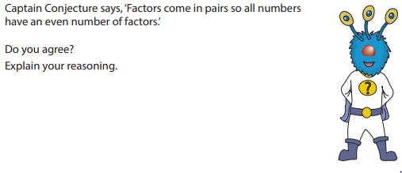

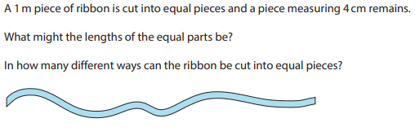

If you are feeling confident with multiples and factors, have a go at this game:

<https://nrich.maths.org/factorsandmultiples>