St Joseph’s Catholic Primary School Home Learning Pack – 27.04.2020
Willow Class

Please find the suggested timetable. This is just a suggestion and you need to find what works for you and your child as we understand that everyone learns differently. Just to be clear, we are not expecting everyone to do all of the activities and these are only suggestions. We understand that our circumstances are all very different at the moment and that lots of you will be trying to juggle ‘home school’ and your own work as well as caring for elderly neighbours and family. Please only do what you feel you can. We do not want to set anything that causes any worry so please do what you feel. There are some references to resources but they do not need to be printed and can be viewed online and the work can be completed or copied onto paper. Please contact us at admin@stjo.uk and in the subject name it… For (Your Child’s teachers name and Class) if you need any further support. For example; For Mrs Spinks, Willow Class. This will help us to ensure your request is dealt with quickly.
Suggested Family Home Learning Timetable
This is a guide to help you establish a routine for your children – this is just a suggestion and you will need to adapt it to the needs of your family.
Time | Activity
Before 9.00 | Get up, washed, dressed, make beds and eat breakfast
9.00 – 9.30 | PE with Joe or family walk
9.30 – 9.45 | Drink and get ready for home learning
9.45 – 10.30 | English – writing, spelling or grammar activity from your home learning pack
10.30 – 11.00 | Break time - take a snack and drink outside if you can
11.00 – 11.45 | Maths – choose an activity from your home learning pack
11.45 – 12.30 | Creative time – draw, paint, sew, bake, do a job in the garden, stop-motion animation with lego / plasticine (the list is endless). Have a project that you can do a bit of everyday.
12.30 – 1.15 | Lunch – help to make it AND clear up after it!
1.15 – 1.30 | Chores – do a job around the house e.g. put laundry away, tidy your room, vacuum or polish
1.30 – 2.00 | Quiet time – shared or independent reading
2.00 – 3.00 | Topic time – science / art / history / geography / music – choose a topic activity from the home learning pack

Maths | Activities | Resources
Times tables | Please continue to practise your times tables everyday this can be done on TTRS or offline through a variety of games and activities. Here are a few ideas to help you:  - Use playing cards – Choose 2 cards at a time and multiply the numbers together and then discuss corresponding division facts.  - Exercise while reciting your times table facts e.g. skipping  - Play times table ping pong – in partners take it in turns to ask each other questions  - Times table bingo – draw a 3x3 grid and choose numbers from the tables – bingo caller to ask multiplication and division question.  - Why not invent your own times table game to play?
Day 1 | Can I match fractions and decimals?  - Read the learning reminders to refresh your understanding of fractions and decimals.  - Complete the practice questions  - If you are finding it tricky complete the ‘A bit stuck sheet’.  - Complete the questions to check your understanding | PDF document ‘Maths day 1’ on the website.
Day 2 | Can I compare and order decimals?  - Go through the power point or read the learning reminders to refresh your understanding.  - Complete the practice questions  - If you are finding it tricky complete the ‘A bit stuck sheet’  - Have a go at the investigation to check understanding | PDF document ‘Maths day 2’ on the website.  Power point day 2.
Day 3 | Can I add and subtract decimals?  - Go through the power point or read the learning reminders to refresh your understanding of adding and subtracting decimals.  - Complete the practice questions  - If you are finding it tricky complete the ‘A bit stuck sheet’.  - Complete the questions to check your understanding | PDF document ‘Maths day 3’ on the website.  Power point day 3.
Day 4 | Can I describe a 3D shape?  - Read the learning reminders to refresh understanding of 3D shapes and their properties.  - Complete the practice questions  - If you are finding it tricky complete the ‘A bit stuck sheet’.  - Have a go at completing the investigation to check understanding | PDF document ‘Maths day 4’ on the website.
Day 5 | Can I compare 3D shapes?  - Go through the power point or read the learning reminders to refresh understanding.  - Complete the practice questions  - If you are finding it tricky complete the ‘A bit stuck sheet’.  - Complete the questions to check your understanding | PDF document ‘Maths day 5’ on the website.  Power point day 5.

Please continue to keep a written diary recording what you have done each day.
English | Activities | Resources
Day 1 | Can I use the text to answer questions?  - Look at the Front Cover of Mufaro’s Beautiful Daughters.  - Predict what you think might happen in the story.  - Read Mufaro Beginning and answer the questions.  - Write notes to explain what you know and think about Mufaro, Manyara and Nyasha. | PDF document ‘English day 1’ on the website.
Day 2 | Can I reflect on the characters reactions?  - Read Messenger’s Proclamation and imagine how the characters might react.  - Read Manyara’s Journey to find out what happened to her after she had heard the proclamation.  - Write down what you would have done, with each of the people that she met.  - Listen to the story and answer the questions. | Power point on the website.  PDF document ‘English day 2’ on the website.
Day 3 | Can I plan and write a letter?  - Use words and pictures to summarise the story.  - Read Manyara’s Letter  - Plan a letter from a future you to you now  - Write your letter | PDF document ‘English day 3’ on the website.
Day 4 | Can I write sentences using fronted adverbials?  - Read the poem Summer and Winter  - Answer some of the poetry questions  - Look at the power point refresh your understanding of adverbials  - Complete the adverbial sheet | PDF document ‘English day 4’ on the website.  Adverbial power point on the school website.
Day 5 | Can I use adverbials to make my sentences interesting?  - Read the poem Winter – what do you like about the poem? Do you notice any patterns?  - Look at the revision cards to revise adverbials  - Practise using adverbials by writing sentences with a fronted adverbial that could go with the months of the year. | PDF document ‘English day 5’ on the website.

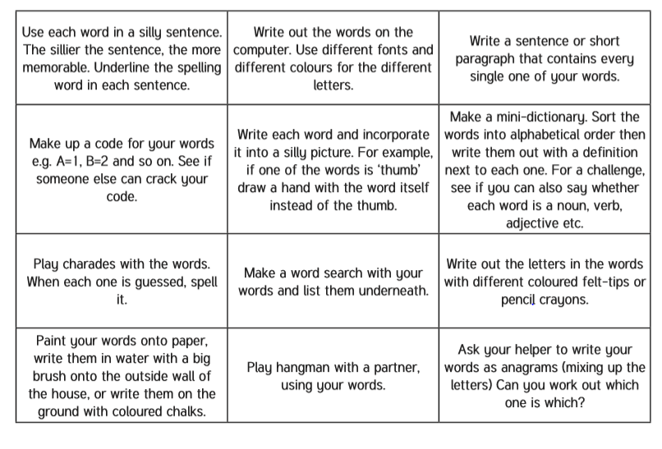
Spelling – Practise the year 4 spellings using a range of strategies. Below are some ideas that you can try.

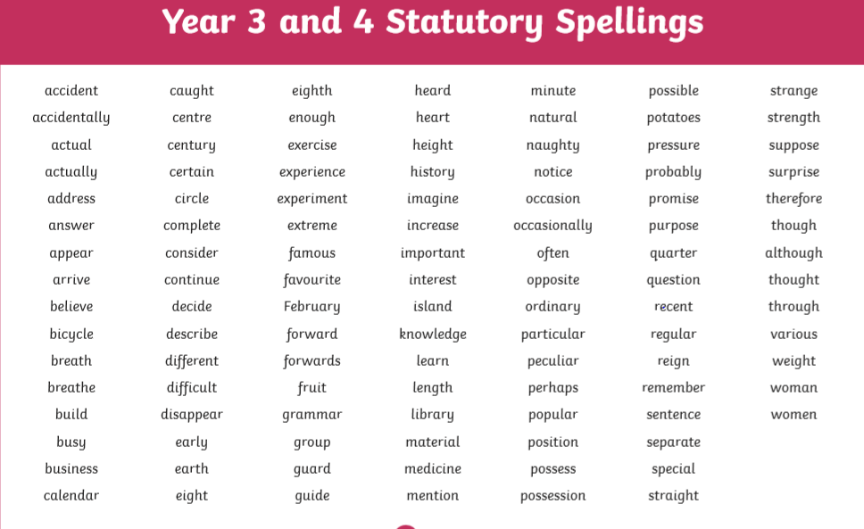
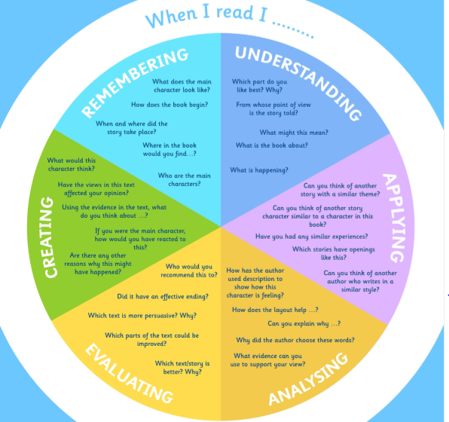
Suggested Reading Activities
This is an essential skill that the children need to continue to practise daily. It is recommended that the children read for at least 20 minutes each day. Continue to record all reading in the reading record books and remember to quiz on accelerated reader. You should have received an email with log in details. Please contact me if there is an issue with this. When listening to your chid read ask questions regularly to check and support understanding. Here is some example questions which would really support the children in their development.

Varied activities of Science, Music, Topic (History, Geography, Art) and R.E
 | Activities | Resources
Activity 1 | As we are currently living in a changing world we thought that it would be good to document this piece of history. This week I would like you to have a go at completing a time capsule. | Time capsule document on the website.
Activity 2

Activity 3

Activity 4 | An important part of working scientifically is being able to identify patterns in life. Scientists are currently using pattern seeking techniques in order to work out the best way to fight the Coronavirus. We are going to use patterns to help us answer this question: Is there a link between the length of your outstretched arms and your height? If your brother or sister have this task you can share the data – ask lots of members of your family to help to get as much information as you can.  All the instructions are on the attached sheet. | Science ‘pattern seeking’ document on the website.
Activity 5 | The Amazon rainforest is an amazing ecosystem. There are many different plants and animals that have their habitat there. What plants and animals can you find in your garden or safe space? How are they the same or different from the Amazon?  - Look up the different types of plants and animals that you may find in the Amazon rainforest.  - If you have a garden, go outside and see what animals and plants you can find. Compare them to the plants and animals that you may find in the Amazon rainforest.  - Make a poster showing the similarities and differences. | Internet or books to research.

