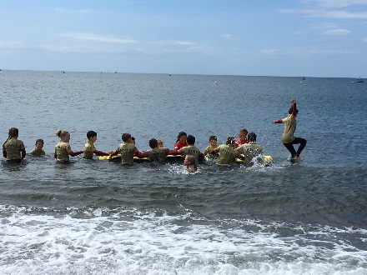
PE @ St Joseph’s

Sports Report 2017 -18
Our aim at St Josephs is to have every child developing a love of PE and sport. We want them to grow up to be active, healthy and to have felt like they have tried lots of different activities during their time with us. This year more children have participated in clubs and represented the school than ever before! This has been achieved with the help of our incredible staff, who have embraced opportunities to develop their knowledge and understanding of PE.
Dartmoor School Sports Partnership (DSSP) have facilitated a variety of sports festivals and competitions. As a school we attended with sometimes 2 teams to all the events our own school calendar enabled us to.
This year we have attended:
Indoor Athletics
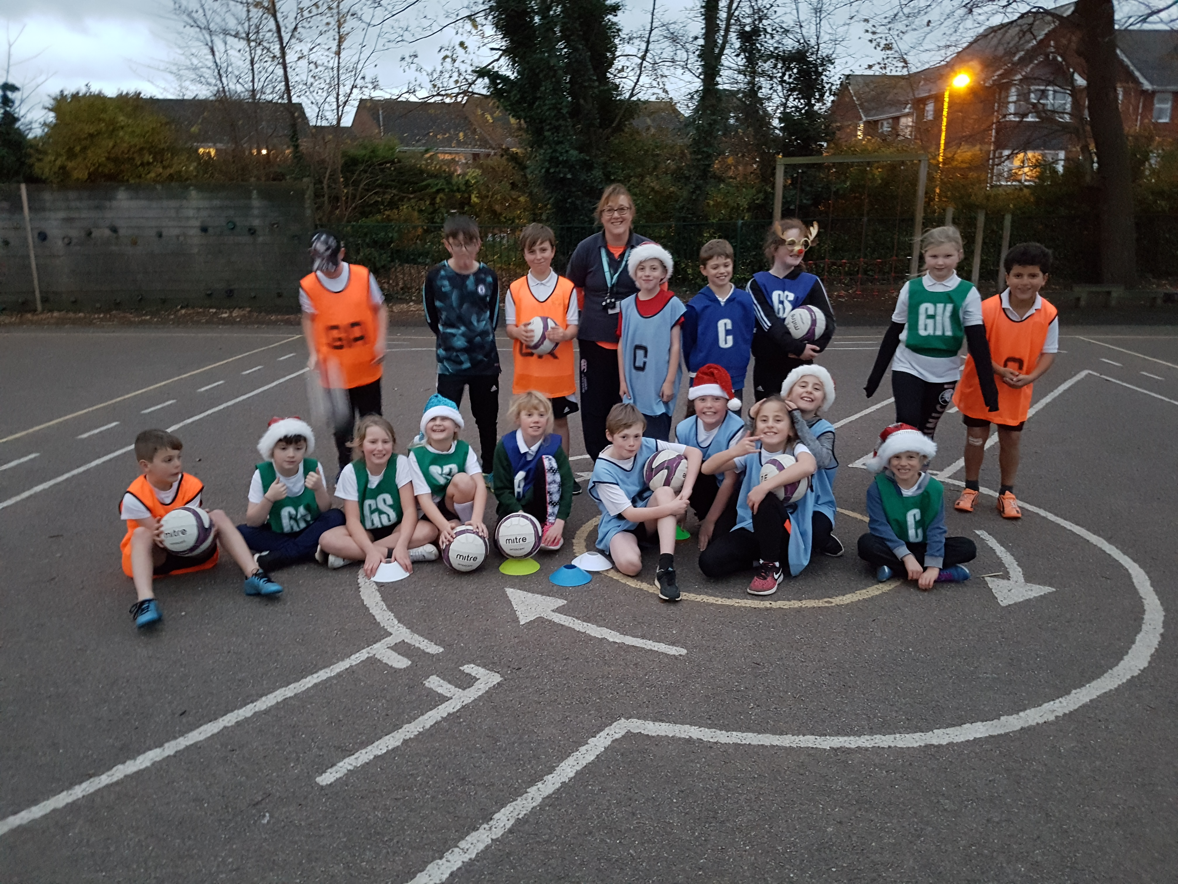
High 5 Netball Year 5&6 Festival
High 5 Netball Year 5&6 Competition
Quick Sticks Hockey Year 3 &4 Festival
Quick Sticks Hockey Year 5&6 Festival
Quick Sticks Hockey Year 5&6 Competition
Aesthetics Festival Years 1 &2
Dance Festival Years 3-6
Gymnastic Competition Years 5&6
Autumn Cross Country Race Years 3 – 6
Spring Cross Country Race Years 3 – 6
SEND Festivals in the Autumn, Spring and Summer Terms

At all these DSPP events our teams showed great sportsmanship and worked together to achieve.

An invitation from one of the schools in the Exmouth Learning Community (ELC), The Beacon School, challenged us in the summer term to a Duathlon, which one of our year 6 boys won.

We also took 2 teams when invited by another ELC school, Otterton, to their summer Football Tournament. Our year 3&4 boys’ team lost in the final

We also attended a new event this year hosted by Exeter Football Community Project, using our local magnificent beach at low tide to play a Beach Football Tournament. We took 2 teams to this event and one team were medal winners.

Years 3 and 4 celebrated the National Swim day in style this year with a swim session in a recently refurbished pool at the local Cranford Club.

We ran a variety of Sports after school clubs in the autumn and spring term. These included: Running Club, High 5 Netball Club, Cricket Club and Yoga Club. Running club continued to run in the summer term but the opening of our own child care After School Club has meant that we have needed to limit the sports clubs. However we plan next year to run some of these in the lunch times so that children get to experience different sports in school, building on their experiences in PE lessons.

Probably one of our greatest successes in sport this year is the popularity and consistent attendance at the Running Club. We have over 50 children on the register for the club and most weeks over 40 enjoy running focused activities. The Club had a trip to the Exeter Athletics Arena where they ran on a real running track, jumped real hurdles and tried out a real long jump track and pit.
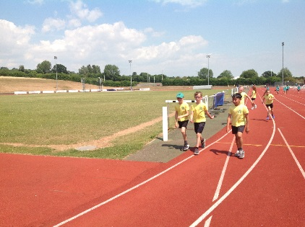
We introduced a new sport this term, Quick Sticks Hockey. It was fantastic
to see 2 girls who had not played competitively for their school, compete at the
DSPP Quick Sticks Year 5&6 Competition.
The hockey was also successful with the year 3 &4 children. The wearing of a
protective gum shield was embraced well. In fact several girls, as they smiled at
me on the High 5 Netball court, revealed gum shields! We discussed that they
were not necessary in netball!
We were able to sign post children to Exe Hockey Club who have hockey training in Exmouth on Monday nights at the local Community College.

The DSPP have also supported us in the development of our gymnastic teaching. We have had an expert coach working with both teachers and their classes in year 3 & 4. The whole school staff have had an inset session with another booked to reinvigorate our teaching of gymnastics in the spring. New gymnastic equipment should support this development.
Fitter Future has been running in the school for the last year, a computer based daily fitness platform. We have had lots of success with it but hope to encourage even more use in the next academic year.

Trying new sports!
