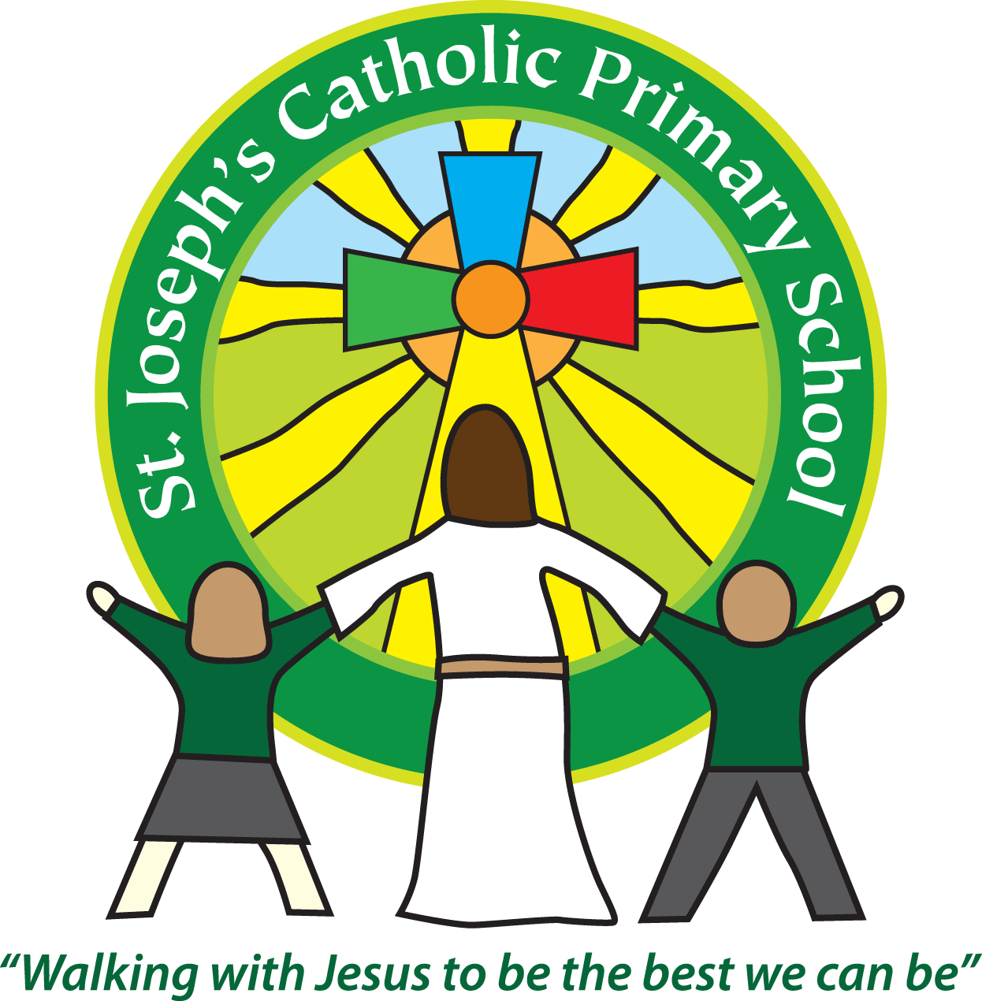St Joseph’s Catholic Primary School
Year 5/6 Autumn 1st half
Welcome back!
Please see our curriculum topic web attached.
Year 5/6 home learning
Subject | Sent home | Due in | Frequency
Spellings | Thursday | Tuesday | Weekly
Times Tables up to 12 x 12 and related division facts | On going | Tested half termly | These are best learned and retained with daily practice.
Maths | Thursday | Tuesday | As required
History / Geography / Science | Thursday | Tuesday | As required
Reading | We expect the children to read at home daily.  Please make sure that you regularly read with your child and discuss the books that they are reading. Please note: it is important to question your child about what they have read. eg. How do you think Tess felt when she left the house? Why? These open questions require children to use evidence from the text to support their judgements. It would also be useful if you could ask your child to collect new/unknown words from their book, find their meaning and share them with the class. I will add question stems to Google classroom – these are the ones we will be using in class and so the children will become familiar with them.

Reminders
School lunch and snacks | For yr 3-6 school lunch can be ordered daily at a cost of £2.34. Please pay on ParentPay.  We promote healthy eating at school and so lunch boxes should not contain more than one chocolate snack and one packet of crisps.  Children are welcome to bring fresh fruit or vegetables for a snack at break time.  We are a nut free school. We have children with potentially fatal nut allergies in school, therefore no food containing nuts may be sent into school.
Drinks | Your child must have a named water bottle in school every day. Please only send in water, no juice or fizzy is allowed.
Uniform | Please ensure all uniform is clearly named.  Grey trousers or shorts, Grey skirt or pinafore dress, Black, white or grey socks, Black or grey tights, White polo shirt, Green logo school sweatshirt or cardigan. Warm weather option – green and white gingham dress (dress with shorts instead of skirt is acceptable)  Hair past shoulder length must be tied back – please use plain hairbands in green, black or white, not brightly coloured bows.  Nail varnish is not allowed. School shoes must be black and no heels, trainers or boots.
PE kit | Green t-shirt with school logo, black shorts, jogging bottoms and trainers. All kit must be named and in a named bag.  Ear rings must be removed or covered with tape for PE lessons.  Watches must be removed for PE.  PE kit must be in school every day.
Bags | Reception, yr 1 and 2 children must have a book bag in school. This is so books can easily be checked and letters put in.  Children can have a bag or rucksack in school but please avoid the large bulky ones as 30 rucksacks take up a lot of room in the class.
Mornings | School starts promptly at 8.55am.  Your child will be greeted at the class door by an adult at 8.50am. Please only pass on quick messages then, for a longer meeting please make an appointment.  Children and parents arriving after 9.00am will be asked to sign in at the office.
After school | School finishes at 3.30pm. If someone other than yourself is collecting your child, please ensure the office has their details. We will not let them leave unless we are sure they are safe.  Yrs 5 and 6 - if your child sometimes walks home alone or with friends please ensure the teacher or office knows that you have given permission for this.
Contact details | Please ensure you contact details and those of other people who may collect your child are always kept up to date. Please see the office asap if you change your phone number or address.

Teaching assistants
The teaching assistants who may be working with your child this half term are Mrs Gates and Mrs Waite.
Forest School
Year 5/6 will visit the forest school area for a session with a specialist teacher on the 21st September and the 9th November this term. Please make sure that on those days, your child brings a bag with old clothes and a pair of wellies to change into for forest school. They will also need a warm coat.
For your diary:
We have booked a residential trip to Magdalene farm for year 5/6 on the 19th – 21st June 2023. A letter with further details will follow.

From now on to cut down on paper usage we will only email these class letters out. Please ensure the office has your current email address and let me know if you require a paper copy.
We recognise the importance of passing information between parents and school so I am available at the start and end of the day if you need to pass on any messages. However, if you would like a longer chat please make an appointment with me.
If you are able to support our learning with resources or would like to help in class, please let a member of staff know. We value your involvement in your child’s education.

Yours sincerely,
Mrs Jukes and Mrs Taylor-Bashford

