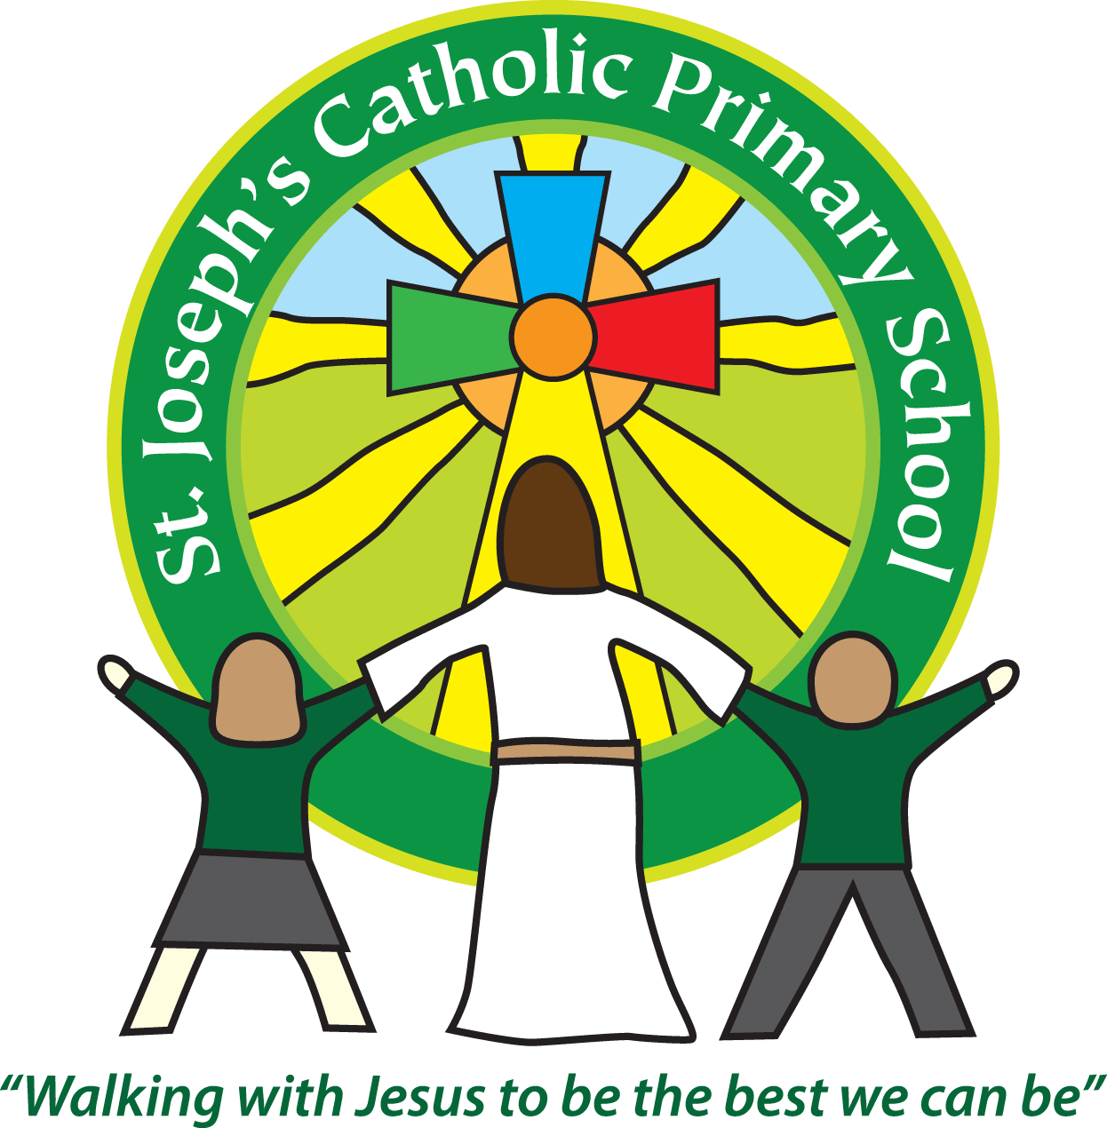

St Joseph’s Catholic

Primary School

Newsletter

May 20th 2016

**Dear all,**

This week the PTA voted in a new Chair – Sarah Stroud, Vice Chair – Vicky Southwell and Treasurer – Karen Garraway. Many thanks for putting yourselves forward, we are very grateful! I would also like to say a massive thank-you to Adele Fulner, who has now finished as Chair of the PTA. You have done a wonderful job and there are lots of things in school now that we have you to thank for.

Many thanks to the PTA for organising an excellent sponsored bounce this week. The children (and staff!) had a lovely time bouncing! Thank you also to those of you who have already returned your sponsorship forms.

The new PTA have already been busy and have organised for a meeting at Sarah’s house on May 25th at 9am and then at 730pm. They have also already arranged a date for the Summer Fair which will be on **Wednesday 13th July** at 3.30pm. If you would like to attend one of the meetings or can help at the Summer Fair please email Sarah at: [stjoesptachairman@gmail.com](mailto:stjoesptachairman@gmail.com)

To keep you updated, the interviews for the new Head teacher next week, have had to be postponed as unfortunately one of the candidates had to cancel, so they will take place after half term.

To celebrate the Queen’s 90th birthday we will be having a royal dress up day on **Friday 10th June**. For a voluntary donation of £1 the children can come in dressed as royalty or in red, white and blue. We will have various activities and a Queen’s tea party so please send your child in with a small selection of cakes/snacks on the day. We will have a royal parade in the playground at 3pm which parents are welcome to join us for.

**A few reminders:**

* We have children in school with severe nut allergies – please do not send your child to school with nuts as snacks or as part of their lunch.
* Children are not allowed on the school premises before 8.30am.
* No dogs are allowed on the school grounds, with the exception of guide dogs.
* When parking outside school to drop off or collect your children please park considerately. It is not only for other parents and residents but mainly to ensure the safety of our children.
* Please return your forms for Move with me to the office by next Wednesday 25th.

**Goodbye**

Next week we say good-bye to Mrs Lambert. She has worked tirelessly at school, particularly with our SEN children and she will be greatly missed. We wish her every luck and happiness with her new baby.

**Best wishes & thank you for your continued support**

**Mrs Taylor-Bashford**

**Headteacher’s Awards:** Well done to: Reception - Holly, Bella E, Mischa, Lewis, Niamh, Theo, Mylo, Ellie, Bella C, Azi, Phoebe, Annie, Year 3 - Darcie

**Stars of week:** Well done to

FS2 – Niamh, Yr 1 – Nicola, Yr 2 – Nathan, Yr 3 - Madison, Yr 4 – Oliver, Yr 5 – Hailin, Yr 6 - Saskia

**Gospel Values Awards: Bronze certificates:** Well done to: Grace – Yr 4, Connor – Yr 4, Ellie – Yr 4, Tom – Yr 4, Sophia – Yr 4, Poppy – Yr 4, Jack – Yr 4





