School Council News!
Autumn term 2018
This is the School council newsletter, a newsletter written for you by the school councillors. This is the first issue. We hope to keep you informed of some of the events that happen in school. Each class has written a little bit about what they have been doing this term. We hope you enjoy it!

A GIANT SPOTTED AT SCHOOL!
In the playground a giant's footprint was spotted in the playground near the bushes. As well as a footprint, many other things were seen around in the classroom; in Year 5 a handprint, Year 6, a beanstalk. Whatever next?

This term at school ….

Class 4 news (1)
Kents Cavern
Class 4 and 3 went to Kents Cavern. We went on a cave trip, woodland trail and dig for gems. It was a fantastic day!
Learning
Last half term, Class 4 learnt about electricity and Sir Walter Raleigh the explorer. In english we learnt about poems and in maths we learnt about multiplication and we have learnt our 9, 6 and 7 times tables. We are very proud of ourselves!
We also went to the community college to listen to them play music in a concert.

Year 4 news (2)
Water features
Last year the classes all had a go at designing a water feature for outside their classrooms.
In half term South West Water and watershed made some of our designs.
Year 1 and 2 have a water cloud. Year 3 and 4 have a plant pot and a dinosaur. Year 5 and 6 have a power box. With all the rain we have been able to see them working. We are very proud that we are one of the only schools that recycles our water and uses rain water to flush the toilets. We are stopping the water flooding into the town.

Class 6 news(1)
PGL
One week before half term, we went to PGL. PGL (Peter Gordon Lawrence) is a place in Torrington where schools can visit and be involved in lots of exciting activities. Some of these include: High ropes, trapeze, zip wire, quad-biking and many more! Some activities were slightly scary but it was really nice to see people helping each other out. As well as the fun activities, we also had really nice meals ( yum, yum)!

Class 3 news (1)
Walking with giants
In class 3 we learnt about fossils and volcanoes. We had fossils in class and then this linked to our learning at Kents Cavern. It was lots of fun.

Class 5 news (2)
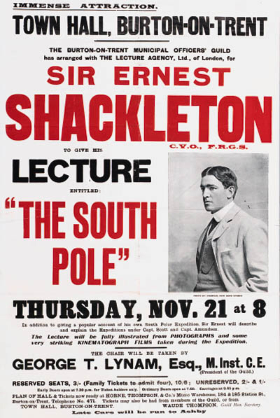
We have learnt about Shackleton.
Shackleton put up a variety of posters saying men wanted. The men did not know what the job was but they had
to bring toasty clothing to wear! They
took part in a dangerous but daring expedition.

Class 2 news (1)
Amazing animals
Before half term, Crealy brought in animals to show Class 2, for our topic ‘Amazing Animals’. We also had donkeys in from the donkey sanctuary. We really enjoyed this. The best bit was stroking the donkeys and meeting the snakes. Mrs Taylor-Bashford was a bit nervous about having snakes in the same day as Ofsted!

Class 2 News (2)
Nativity
We have started learning our lines and the songs for our nativity. We are a bit nervous about being on the stage in front of everybody but we are also excited about it.
In maths, we have been learning about shapes. In English we have been learning about The Papaya that spoke! It is great fun!

Class 6 News (2)
Class 6 wrote their own version of Jack and the Beanstalk (very exciting)! We looked at how we could make it sound really exciting and add lots of description. We have been enjoying Forest School, this week we are making decorations out of natural materials to hang on the St Joseph Christmas tree in town.
In Maths, we looked at Place Value and how it worked. We had to read lots of big
numbers and explore numbers below zero (like decimals).

Class 3 news
Incredible journeys
Our latest topic is called incredible journeys. We have been recounting journeys we have done and learning about others. We have been writing stories about journeys which include a problem and resolution. We are loving learning how to play the steel drums - we think we are very good!

Class 1 news
We looked at the story of Jack and the Beanstalk in English and we found it all really fun!
In maths, we did some mental maths like adding and subtracting by using number bonds to 10 and 20. We have done some phonics and are learning split diagrams. We had animals in from Crealy which we could hold and stroke.

Class 5 news (1)
Go Ape!
Year 5 had a incredible life changing time up above the clouds. Some people had a few wobbles but got back up and that made everybody work as a team. There was a big zipline, everybody was scared!

Whole school
Mrs Taylor-Bashford gave us all class advent calendars with chocolate in! She also gave us all a St Joseph’s Spread the Happiness calendar. We are all going to try and spread the happiness to everyone!
We all dressed up for Children in Need. This was lots of fun and raised money for children who really need it.
We are taking part in the Exmouth Christmas fair on 8th Dec. As school council members we are meeting Mrs Taylor-Bashford in town on the morning and helping to decorate the school tree. Lots of children are also taking part in the lantern parade in the evening. We hope to see you there.

Chief editors:
Cameron and Laura

We hope you have enjoyed reading our first school council newsletter.
We wish you a very Merry Christmas and a Happy New Year.

From:

