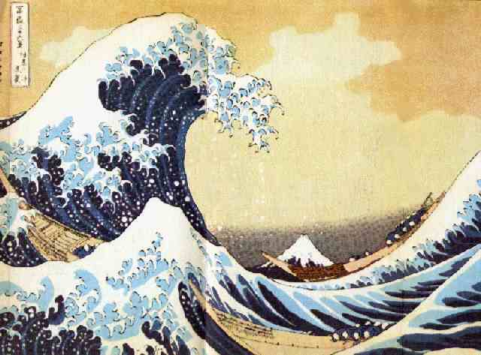
Can I make a Hokusai landscape collage?

Success Criteria
- I can sketch the outline in pencil
- I can build up the image with paper (coloured, magazine pages, newspaper etc)
- I can use different tones of the same colour

CHALLENGE: pick a more complex composition, use smaller pieces, use newspaper and magazines, show a greater range of tone, add extra detail

