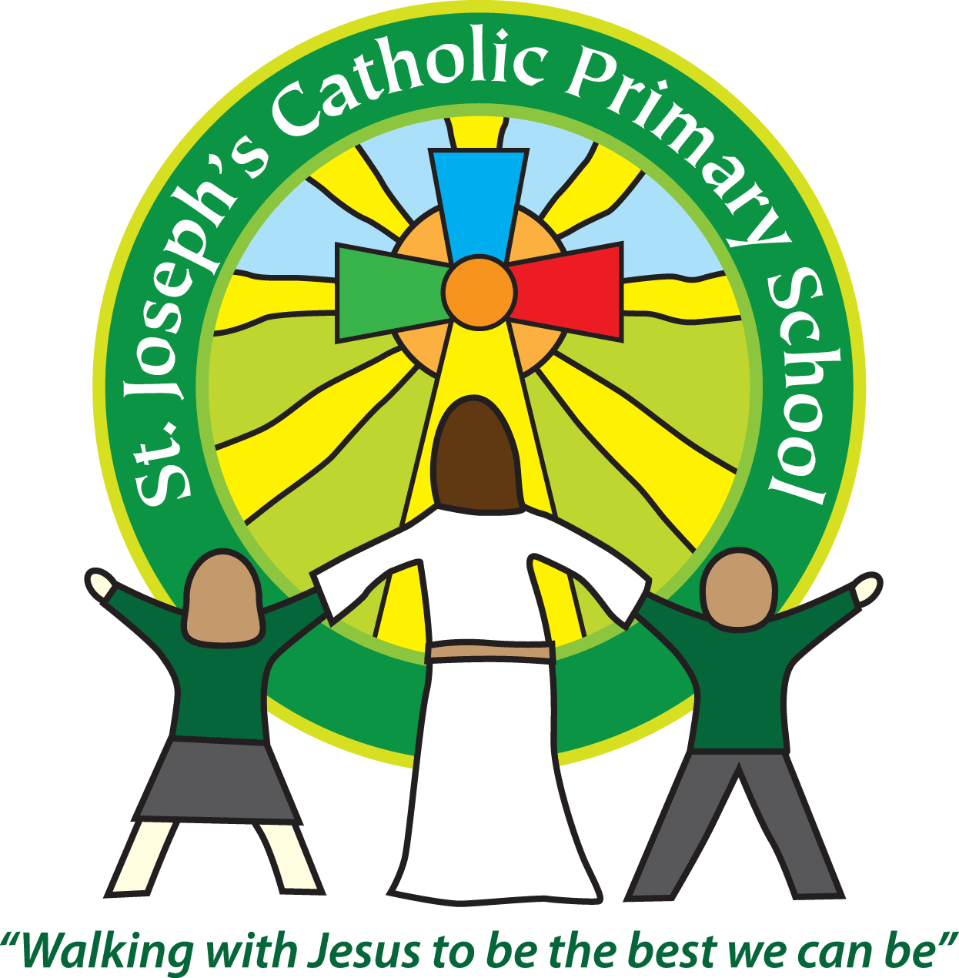
St Joseph’s Catholic Primary School
Regents Gate
Long Causeway
Exmouth
Devon
EX8 1TA

Executive Headteacher: Mrs R Pattison
Acting Head: Mrs N Taylor-Bashford

Tel: 01395 264875

Data for Year 1 children phonics test 2015-2016

In Year 1 children are required to undertake a national phonics test comprising of a series of words they are asked to read phonetically.

Children are considered to have passed the phonics test if they score 32 out of 40.
The results for the % of children who passed the phonics test are shown below.

 | 2016 | Comparison
St Joseph’s | 83% | + 2%
National | 81%

