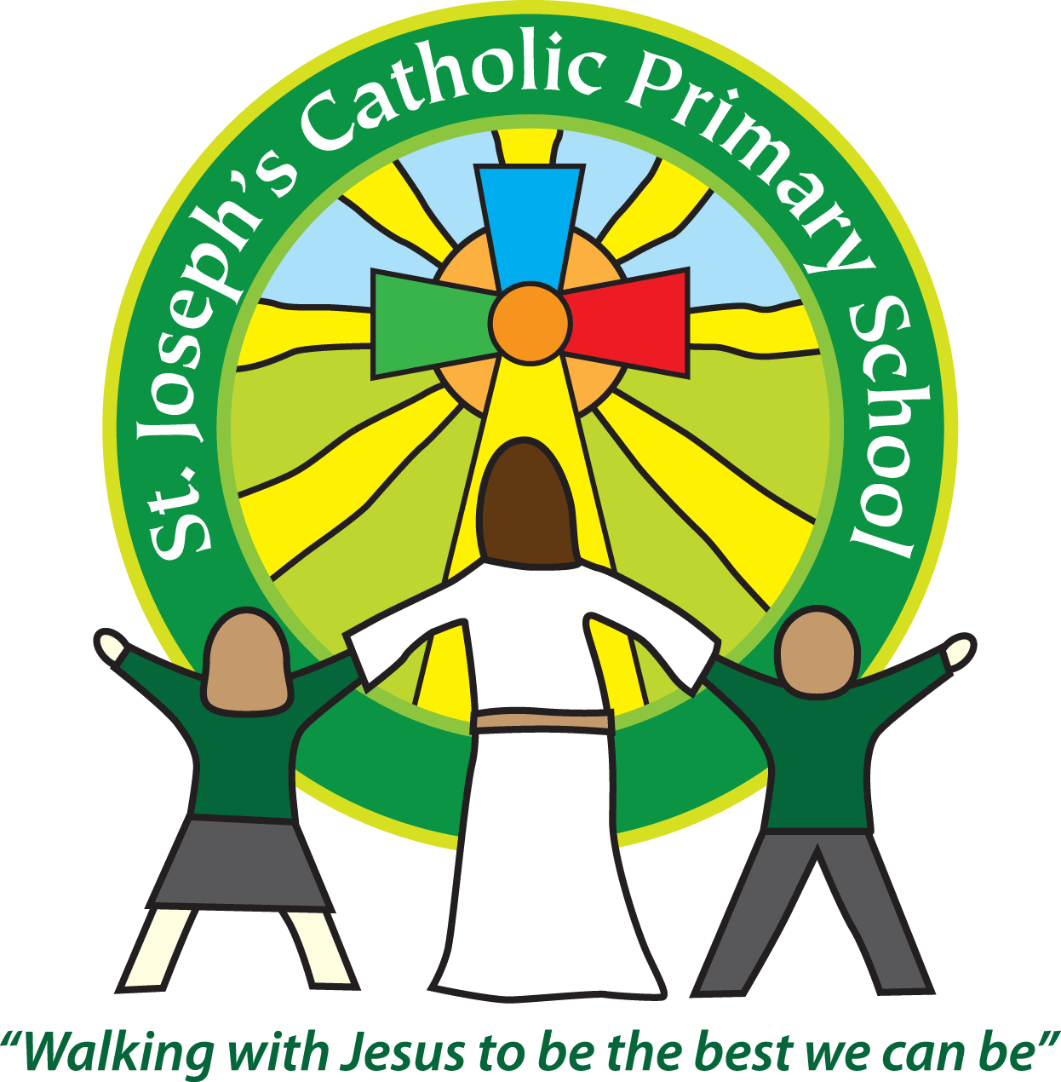
St Joseph’s Catholic Primary School
Regents Gate
Long Causeway
Exmouth
Devon
EX8 1TA

Executive Headteacher: Mrs R Pattison
Acting Head: Mrs N Taylor-Bashford

Tel: 01395 264875

Data for Foundation Stage children 2015-2016

- Children are assessed against the Foundation Stage Profile in all curriculum areas
- A GLD (Good Level of Development) is awarded when a child is considered to have achieved (reached the required level) for the Early Learning Goal in the prime areas of Personal Social and Emotional Development, Communication and Language Physical development & reading , writing and number.

The % of Foundation Stage children achieving a Good Level of Development is shown below:

 | % of children achieving Good Level of Development | Comparison
St Joseph’s | 73.3% | + 4%
National | 69.3%

