St Joseph’s Catholic Primary School
Exmouth

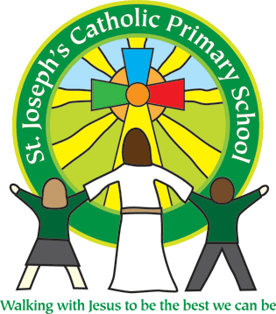

Year 3

Parent Curriculum Information Booklet

Welcome to Year 3

Welcome to year 3 . During this year at school, your children will be continuing to develop independence in their learning. We aim to encourage them to have a love of learning for life.

Lower Key stage 2 is an action packed time, with many opportunities for the children to immerse themselves in learning, whilst building upon those essential skills developed in previous years. We believe that by the end of their time at St Joseph’s your child will have much to celebrate and reflect on, not just academically but personally too.

In this booklet, we aim to outline some of the core skills your child will be taught. We have included objectives that they are expected to meet and examples so you can support them.

We also hope you will join us in the events and parents sessions that are offered throughout the year and feel free to make an appointment with your child’s class teacher if you have any questions or concerns about your child’s progress.

Reading

Key Skills

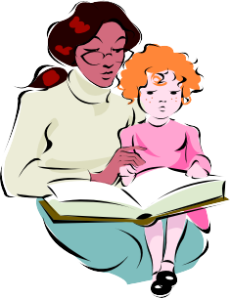
The National Curriculum sets out key skills that children should learn throughout Year 3 . We teach key reading skills at school through shared reading in English, guided reading sessions and independent reading. The main key skills for children to develop can be found in this booklet and on the school’s website where the national curriculum expectations for year groups are available. If you have any questions about this, please come and see your child’s class teacher.
In order to develop their key reading skills, please encourage your child to read every night and at least one book a week. They must record their reading in their reading record book. To achieve this, children are expected to read for at least 20 minutes a night. It is the aim for a child to read approximately 40 books in an academic year. They should read with an adult at least once a week at home and this should be recorded in their reading record.
If a child is on book bands White or below, then they should read with an adult every night. If children are on book bands, they should be reading one book a day. Some will need to read their book twice.

The main key skills for children in Year 3:

Children should be able to:
- Read with good expression and fluency and show an understanding of what they have read.
- At this stage teaching comprehension takes precedence over teaching basic decoding of reading. (However if your child is still reading at Book Bands they will receive further intervention.)
- Use their knowledge of root words, prefixes and suffixes to read and understand unfamiliar words.
- Read a range of common exception words which cannot be sounded out
- Use a dictionary to find the meanings of unfamiliar words
- Read and discuss a wide range of texts including fiction, non-fiction, plays and poetry.
- Identify the themes and conventions in different books
Reading Stages

Book Band | Year Group
Lilac  Wordless Pictures Books | Age 4-5  Foundation
Pink (1) | Age 4-5  Foundation
Red (2) | Age 4-5  Foundation
Yellow (3) | Age 5-6  Foundation/Year 1
Blue (4) | Age 5-6  Year 1
Green (5) | Age 5-6  Year 1
Orange (6) | Age 5-7  Year 1
Turquoise (7) | Age 6-7  Year 1
Purple (8) | Age 6-7  Year 2
Gold (9) | Age 6-7  Year 2
White (10) | Age 6-7  Year 2
At this point the children will begin the AR system | Age 6-8  Year 2/3

This chart can only give a rough idea of the right level for your child. There will be a wide range of reading abilities in any school year.
As a rough guide, children should be able to read at least 90% of the words on the page without any problem. They should also demonstrate good understanding of the text they read through comprehension questions. If the book is too easy, they can become bored. If it’s too difficult, they can become frustrated, and may have to concentrate so hard on reading the words that they lose the enjoyment of understanding the story.
How you can help your child to develop key reading skills.

To enable your child to progress with their reading they need to read to an adult every day. Please note this within their reading record book.
  - Most important of all; make reading with you as enjoyable as possible.
  - Remember you are a reading role model so let your child see you enjoying reading and remember to still relish opportunities to read to your child.
  - Simple unknown words can be sounded out.
  - Look at the first and last letters/sounds of unknown words and make a sensible guess – does it make sense?
  - Miss out the unknown word, read on then go back and work out the missing word. Read the whole sentence again to check it makes sense.
  - Look for 2 letters which make one sound e.g. sh /ch /th.
  - Look out for words they already know in longer words.
  - Remind children to think about how speech might be said to encourage them to read with expression.
  - When reading a new book, talk about the front and back cover. Ask questions such as; who is the author and what clues does the title and picture give you about the book?
  - Encourage your child to read a variety of different types of book; storybooks, information books, magazines and newspapers.

To help develop your child’s reading you might want to consider some of the following questions.

- Can they read with expression?
- Can they sound out unknown words?
- Are they able to explain the story so far?
- Can they recall the important parts of the piece they have just read?
- Can they summarise the key events of the story?
- Are they able to predict what will happen next?
- Can they discuss the characters involved in the story?
- Can they say whether they like the story or not and give clear reasons?
- When reading non-fiction can they use an index or contents to locate information?
- When reading non-fiction can they say how the text is organised?
- Are they using inference to work out character and action
Writing

Reading and writing skills are taught through sequences of English lessons. Each English Teaching Sequence begins with reading a text and completing activities to ensure children have a secure understanding of the text and can talk about its features. The children will complete some spoken language and drama activities about the text before they gather ideas to plan and write a new text. They will also experience modelled writing.
What do children need to achieve at Year 3? Vocabulary, Grammar and Punctuation:
The children will explore words used in the texts they read in literacy and be expected to use similar words in their writing. Grammar and punctuation will be taught within the literacy lesson. The children will need to:
  - Revise work from the previous year
  - Use possessive apostrophes for plurals (The foxes’ tails swung- More than 1 fox)
  - Use conjunctions, adverbs and prepositions to express time in their writing.
  - Know whether to use a or an depending on what the next word begins with. E.g.
There was a large man/ There was an enormous elephant.
  - Use inverted commas to indicate direct speech, for example: The conductor shouted, “Sit down!”
  - Use apostrophes to mark singular and regular plural possession for example, the girl’s name, the girls’ names.
  - Understand how to use the different verb forms.
  - Group ideas into paragraphs
Children need to think carefully about the words they use in their writing. They should try to use precise and exciting words to make their writing interesting. During Year 3 children will:
  - Revise vocabulary and grammar skills taught in previous years
  - Use an increasing number of homophones
  - Add prefixes(dis, mis, in, re, inter, sub, super, auto, anti) and suffixes
(tion/cian/sion/ssion, ly/ally, ous) to change the meaning of root words
Year 3 and 4 spelling words
These are the spellings which the children will be given for home learning and will be tested on in class.
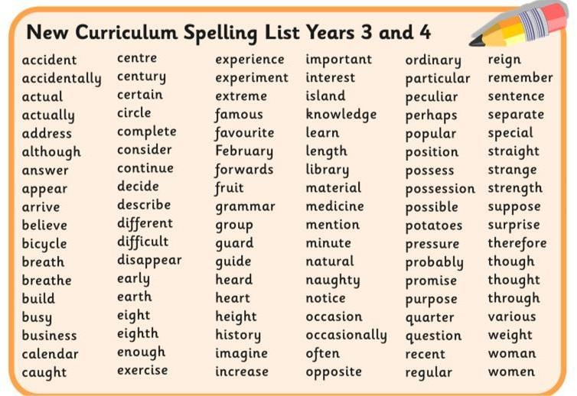
Ways of helping your child with spelling.
Segment a word | Learn a word in parts like con/den/sa/tion
Look, say, cover, write, check | Look: first look at the whole word carefully and if there is one part of the word that is difficult, look at that part in more detail.  Say: say the word as you look at it, using different ways of pronouncing it if that will make it more memorable.  Cover: cover the word.  Write: write the word from memory, saying the word as you do so.  Check: Have you got it right? If yes, try writing it again and again! If not, start again – look, say,  cover, write, check.
Trace, copy and replicate  (and then check) | This is a similar learning process to ‘look, say, cover, write, check’ but is about developing automaticity and muscle memory.  Write the word out on a sheet of paper ensuring that it is spelt correctly and it is large enough to trace over. Trace over the word and say it at the same time. Move next to the word you have just written and write it out as you say it. Turn the page over and write the word as you say it, and then check that you have spelt it correctly.  If this is easy, do the same process for two different words at the same time. Once you have written all your words this way and feel confident, miss out the tracing and copying or the tracing alone and  just write the words.
Quickwrite | Writing the words linked to the teaching focus with speed and fluency. The aim is to write as many words as possible within a time constraint.  Pupils can write words provided by the teacher or generate their own examples. For example, in two minutes write as many words as possible with the /iː/ phoneme.  This can be turned into a variety of competitive games including working in teams and developing  relay race approaches.
Pyramid words | This method of learning words forces you to think of each letter separately.  You can then reverse the process so that you end up with a diamond.
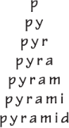
Encourage your child to have a go at spelling words they are unsure of. This will give them the opportunity to try out spelling strategies and to find those that they find useful. You can help them to use the strategies outlined above and praise their efforts.
Handwriting

All children will be taught joined cursive handwriting. The style we teach is shown below.
All children from Year 2 upwards are expected to start to become fluent in this style.
All children in Year 3 upwards will be using joined handwriting throughout their writing and will be using a blue handwriting pen, provided by the school.

A B C D E F G H I J K L M N O P Q R S T U V W X Y Z
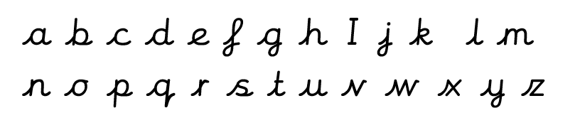

Mathematics

At St Joseph’s School, we are dedicated to promoting enthusiasm and enjoyment of mathematics through the provision of a range of experiences which enable all children to achieve and which develop, maintain and stimulate their curiosity and interest. We place great emphasis on encouraging children to talk about their ideas in mathematics and to reason, using a wide range of mathematical vocabulary. Developing the children’s confidence and accuracy with their understanding and recall of mathematical facts and knowledge and the application of these skills and concepts to real-life problem. Solving contexts is also at the heart of our teaching and learning.

How can you help your child’s maths learning?

One of the most valuable things you can do is talk to your child about their maths learning. Ask them what they have been learning and encourage them to explain. We all use maths in our everyday lives which means that are plenty of opportunities to help your child with their learning in mathematics by involving them in everyday activities:
- Count in jumps of the same size such as 2, 3, 5, 10, 4, 8, 25, 50, 100 and so on. Children should count backwards as well as forwards. Physical activities such as skipping and playing catch can be incorporated to encourage motivation.
- Help them to understand time, read both digital and analogue clocks. Involve them in dates and diaries, knowing the calendar months, days in a year, family celebrations and appointments.
- Collect items such as football cards, buttons, straws, milk bottle tops and group them into ones, tens and hundreds.
- Look for numbers in digits and words in books, on posters, in comics, on buses, cars and road signs and prices and ask children to read them. Children could also photograph them.
- Talk about the shape of 2D and 3D objects. Try and identify shapes in the world around us.
- Ask your child to help when you are doing things with money such as paying for items in shops. How much will these items cost? How much change will you receive?
- Ask them to help when you are measuring items such as weighing ingredients or measuring the length or height of an object. Use metric units of measure.
- Use a magazine or the internet to find out about when a TV programme or film is on and how long it will last.
- Read bus and train time tables and calendars.
TIMES TABLES
By the end of year 4, all children should know their multiplication facts and related division facts up to 12 x 12 and be able to demonstrate quick recall of these facts.
Children who are secure with their quick recall of times tables facts make faster progress, as they are able to apply this knowledge to all areas of maths, including mental calculations and problem solving in real-life contexts.
Children should therefore be practicing their tables regularly - 5 minutes a day is much more beneficial than 30 minutes once a week. Each week, your child will be tested on their knowledge of the table they are working on. Cards will be sent home to support this but online games are great too!

Years 1 to 4

In order to best support the children to learn their times tables, and to become secure with their quick recall and application of times tables facts, each term your child will focus on a particular times table. They will be taught strategies for learning these times tables in school and practise every day in class. For Home Learning, the children will also focus on the specific times tables that they are working on.

At the beginning of each new academic year, the children will revise the times tables learnt during the previous year, before then moving onto a new times table.
The chart below shows the focus areas for each term for each year group:

Year Group | Autumn Term |  | Spring Term |  | Summer Term
Year 1 | Number Bonds to 10 |  | Number Bonds to 20 |  | Counting in 2, 10 and 5
Year 2 | 2 |  | 10 | 5 | Mixed 2, 5, 10 | 3
Year 3 | 2, 5, 10 and 3 word problems |  | 4 | 8 | 0 and 1 and11 | 9
Year 4 | Recap  2, 3, 4, 5, 8, 9, 10, 11 | 6 | 7 | 12 | Mixed tables from 2-12

Websites for maths activities:

https://www.bbc.co.uk/bitesize/subjects/zjxhfg8
https://www.bbc.co.uk/bitesize/subjects/z826n39
https://ttrockstars.com/login (your child will have their own login)
www.IXL.com/signin/plymouthcast (your child will have their own login)

Science in Lower Key Stage 2

Science enables children to discover the world around them. It stimulates curiosity and leads to the development of investigative, analytical and practical scientific skills so they can discover how the world around them works. It also enables children to make meaningful links to both the natural and man-made environment they live in.
Science is essentially a practical subject and the children are given opportunities for careful observation and investigation. Children participate in a wide variety of problem solving activities. They are encouraged to devise their own experiments and communicate their findings in a variety of ways.

Forest School
Through careful, joint planning, Mrs Turner, our Forest School teacher, will supplement the science curriculum allowing children to engage with the natural environment. They will get a chance to explore science within the environmental area and pond habitat. Please ensure your child comes to school equipped with old clothes and wellies for these sessions. You will be advised of the dates in class letters.

At home
Children are naturally inquisitive and interested in the world that surrounds them. Whenever you are together, they are trying to make sense of things that they encounter and develop their understanding.
You could:
- Encourage them to ask questions such as ‘How?’ ‘Why?’ and ‘What will happen if…?’ and decide how they might find answers to them. Talk is really important – don’t undervalue your answers to the value of “Why?” You could use non-fiction books you might have at home, visit the library or use the Internet to help them discover ways of finding the answers they seek.
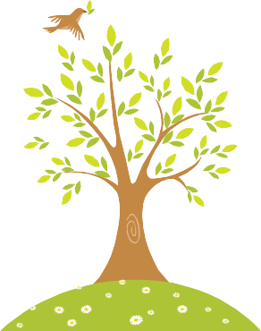
- Encourage them to predict what might happen.
- Help them to recognise when a test or comparison is unfair.
- Provide opportunities for them to explore, using the senses of sight, hearing, smell, touch and taste as appropriate.
- Encourage them to communicate what happened through speech, writing, drawing, or ICT.
- Help them to make simple comparisons e.g. hand spans or shoe sizes in your family and identify simple patterns.
- Compare what happened with what they expected and try to explain it, drawing on their knowledge and understanding.

Useful websites:

http://www.bbc.co.uk/bitesize/ks2/science/ http://www.woodlands-junior.kent.sch.uk/revision/Science/ http://www.primaryscience.ie/activities_science_home.php
http://primaryhomeworkhelp.co.uk/

Non Core subjects

Throughout their time in Year Three, the children will complete History, Geography, Art /Design and Technology, Music, PSHE, PE and Languages lessons through the topic lessons to ensure links.

R.E
As we are a Catholic School, we are required to teach a certain amount of Religious Education as it is one of our core subjects.
The 'God Matters' curriculum is split up into ten themes which are revisited and developed each year to support the faith development of the children. In each unit, related aspects of different world faiths are also taught.
Each topic is revisited each year building on the children’s knowledge. Therefore, although the unit titles remain the same, pupils’ experiences, knowledge and learning all progress.
UNIT | DATE | TEACHING TIME
AUTUMN TERM 2020
Creation | Start of Term | 4 weeks
Prayers Feasts and Saints | 07.10.20 | 2 Weeks
Half term
Islam | 29.10.20 | 1 Week
Sacraments | 04.11.20 | 4 Weeks
Advent | 02.12.20 | 2 weeks
Christmas | 16.12.20 | 1 week
SPRING TERM
Feasts of Christmas - Epiphany | Start of Term | 2 weeks
Revelation | 20.01.21 | 4 Weeks
Half Term
Judaism | 25.02.21 | 1 week
Lent | 02.03.21 | 3 weeks
Holy Week | 23.03.21 | 1 week
SUMMER TERM
Easter | 14.04.21 | 4 weeks
Pentecost and Mission | 11.05.21 | 2 weeks
Half Term
Pentecost and Mission | 02.06.21 | 2 weeks
Sikhism | 15.06.21 | 1 week
Hinduism | 22.06.21 | 1 week
Big Questions of Faith  Project RE | 29.06.21 | Until End of Term

RSHE lower Key Stage 2 (Relationships, Sex and Health Education):

As of September 2020, all school are required to teach RSHE (Relationships, Sex and Health Education). At St Joseph’s, we will be using a curriculum designed by Ten:Ten (a Catholic Education organisation). This allows us to teach this curriculum in the context of our school values.
See the programme below. If you have any questions or concerns please see your class teacher.
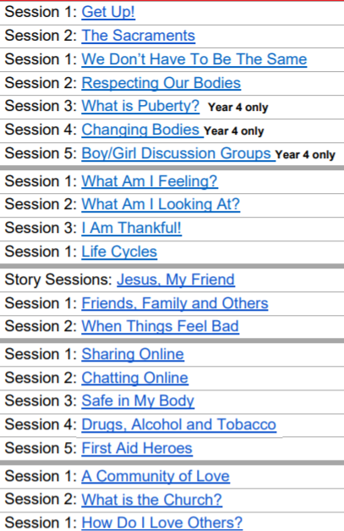
Computing
Computing prepares children to participate in a rapidly changing technological world. Children use computing tools to find, explore, analyse, exchange and present information.
They are taught Internet safety.

At school
Children explore IT and learn to use it confidently and with purpose to achieve specific outcomes. They start to use IT to develop their ideas and record their creative work. They become familiar with hardware and software.

Children are taught to:
- understand that computer programs execute by following precise instructions
- create and debug simple programs
- use logical reasoning to predict the behaviour of simple programs
- use technology to create, organise, store, manipulate and retrieve digital content
- recognise common uses of information technology beyond school
- use technology safely and respectfully, keeping personal information private; identify where to go for help and support when they have concerns about content or contact on the internet or other online technologies.

At home
If you do have a computer at home you could:
- Gather information from the Internet to support a topic being studied at school, or something that interests your child. We recommend that any use of the internet is supervised by an adult. You are obviously aware of the potential dangers and inappropriate material you would not want your child to access.
- When gathering information, please be selective and read the information found with your child. Printing off reams of paper from a website aimed at adults may not make a lot of sense to your child.
- Encourage your child to save and load work, print a finished piece and shut down the computer safely.
- Write letters, party invitations etc. and include clip art pictures.
- Use a paint package to create a masterpiece, experimenting with the use of colour and tools.
- Play an adventure game together to try things out and explore what happens in real and imaginary situations.
- Use websites / apps to support learning such as: https://ttrockstars.com/login (your child has their login). www.letters-and-sounds.com
www.phonicsplay.co.uk www.ictgames.com
http://www.topmarks.co.uk/maths-games/7-11-years/times-tables
www.bbc.co.uk/schools/bitesizeprimary
http://primaryhomeworkhelp.co.uk/
www.IXL.com/signin/plymouthcast

Home Learning in Year 3

At St Joseph’s School, we recognise the part that Home learning plays in the education of a child. Learning at home helps to develop good learning attitudes within children as well as helping to build a bridge between school, children and parents. Research shows that home learning can have a positive impact upon learning when used in a focused way:
- Children become enthused when faced with investigative, open ended and practical home activities.
- Parents are able to support where the school clearly links the home learning with school learning.
- Children can rehearse essential skills.
- Children can develop good learning behaviours.
- Homework will be placed in homework books and can be found on Cedar drive in Google classroom when they are signed into their email.
Reading at Home:
- If your child is on Book Band, then they should be reading every day with an adult or older sibling.
- Children should be reading every day. Please make a note of their reading in their reading record books, throughout the year, including during the holidays.
- Class teachers will keep track of how often children are changing their books on the Accelerated reader system

English Home Learning:
Children in Year 3 children may be asked to complete different types of English at different times.
Reading - Their personal books and comprehension pieces.
Talking - This will involve an activity, which requires the children to talk to you about a specific area e.g. what creatures they find on the beach. This talk is used to support their writing in class and allow them to develop knowledge and language. Recording notes or plans is optional.
Writing -This will be a written task and will vary in length and time given depending on the task.
Spelling and grammar – consolidating the learning that has already been completed in class.
They may be asked to complete an IXL grammar activity.

Spelling Home Learning:
As part of their spelling learning, the children will be set individual words from their Year 3/4 spelling list, which they will be tested on weekly in class.

Maths Home Learning:
Maths home Learning will be set in a variety of formats to support your child with their maths at home. Number bonds/times tables tests will take place every week. The children are expected to practice their set table during the week and there is a sheet to be dated and signed by a parent/carer.
Please complete TTRS activities regularly and IXL maths activities.

We encourage you to support your child with their Home Learning and if there are any concerns or queries over it, then please feel free to contact a member of staff. All learning will have due dates specified on them.

Keeping Children Safe

Children walking home from school
Children from foundation upwards should be collected by an adult from the class door. If another adult is collecting your child, please let the class teacher know – even if you have arranged for another parent to collect.
Children in year 3 and 4 will not be allowed to walk home on their own unless you have written us a short note / letter.
Children in year 5/6 frequently walk home on their own, please do let the class teacher know of your wishes.

Internet Safety
Within school we have strict filters on our computers that help block inappropriate sites for the children. The children are frequently reminded of Internet Safety Rules.

We urge parents to keep a close eye on the internet usage that children access at home.
Children will not use Social Media sites in school, as primary school children are too young to be accessing them.

Information for Parents can be found:
CEOP: www.ceop.gov.uk
Think U Know: www.thinkuknow.co.uk
Childnet: www.childnet-int.org

Our website offers more information or links.

Pastoral Support
Many of our teaching assistants are trained to offer pastoral interventions. They will support individuals and small groups when the need arises.

Safeguarding:
Our Senior Designated Person is Mrs N Taylor-Bashford
Our Deputy Designated Person is Mrs S Keeping
If you have any concerns about the welfare of any of the children within the school, please do speak with us.

When concerns are raised or noticed, we have to make sure that any information is recorded. Parents will be contacted to discuss any concerns as soon as possible. On a few occasions, where there may be serious concerns, the information has to be shared with our partners in the Police, Social Services and in Health first.

Let your child’s class teacher know if something has happened that means your child is upset or unhappy; or if there is something you feel we ought to know. This will enable us to support your child.

If you suspect ANY child is being neglected, abused or facing harm, let the school know or alternatively you may contact the MASH team on 0345 155 1071

