St Joseph’s Catholic Primary School Home Learning Pack – 29.06.2020 and 06.06.2020
Willow Class
The way we are doing home learning is changing a little. We will be sending tasks home every two weeks and reducing the number of tasks to 3 maths, 3 English and 3 topics per week (so you will receive 6 maths, 6 topic and 6 English every other Monday).
Just to be clear, we are not expecting everyone to do all of the activities and these are only suggestions. We understand that our circumstances are all very different at the moment and that lots of you will be trying to juggle ‘home school’ and your own work as well as caring for elderly neighbours and family. Please only do what you feel you can. We do not want to set anything that causes any worry so please do what you feel. There are some references to resources but they do not need to be printed and can be viewed online and the work can be completed or copied onto paper. Please contact us at admin@stjo.uk and in the subject name it… For (Your Child’s teachers name and Class) if you need any further support. For example; For Mrs Spinks, Willow Class. This will help us to ensure your request is dealt with quickly.
All of the resources for the home learning below can be found at: https://www.stjosephsprimaryschool.com/website/home_learning_04052020/477542 on the Coronavirus information page – Home learning and then select the date and appropriate class.
Maths | Activities | Resources
Times tables | Please continue to practise your times tables everyday this can be done on TTRS or offline through a variety of games and activities. Here are a few ideas to help you:  - Use playing cards – Choose 2 cards at a time and multiply the numbers together and then discuss corresponding division facts.  - Exercise while reciting your times table facts e.g. skipping  - Play times table ping pong – in partners take it in turns to ask each other questions  - Times table bingo – draw a 3x3 grid and choose numbers from the tables – bingo caller to ask multiplication and division question.  - Why not invent your own times table game to play?
Week 1  Activity 1 | Can I divide multiples of 10?  - Go through the power point or read the learning reminders to refresh your understanding.  - Complete the practice questions  - If you are finding it tricky complete the ‘A bit stuck sheet’.  - Have a go at the investigation to check understanding. | PDF document ‘Maths activity 1’ on the website  PPT Activity 1.
Activity 2 | Can I convert centimetres to metres?  - Read the learning reminders to refresh your understanding.  - Complete the practice questions  - If you are finding it tricky complete the ‘A bit stuck sheet’  - Have a go at the investigation to check understanding. | PDF document ‘Maths activity 2’ on the website
Activity 3 | Can I find all of the combinations?  - Go through the power point or read the learning reminders to refresh your understanding.  - Complete the practice questions  - If you are finding it tricky complete the ‘A bit stuck sheet’.  - Complete the questions to check your understanding. | PDF document ‘Maths activity 3’ on the website
Week 2  Activity 4 | Can I convert grams to kilograms?  - Read the learning reminders to refresh your understanding.  - Complete the practice questions  - Complete the questions to check your understanding.  - If you are finding it tricky complete the ‘A bit stuck sheet’.  - Have a go at the investigation to check understanding. | PDF document ‘Maths activity 4’ on the website
Activity 5 | Can I order weights?  - Read the learning reminders to refresh your understanding  - Complete the practice questions  - If you are finding it tricky complete the ‘A bit stuck sheet’.  - Complete the questions to check your understanding. | PDF document ‘Maths activity 5’ on the website.
Activity 6 | Can I tell the time to minute intervals?  - Look at the time PowerPoint on the website to revise telling the time.  - There is a clock template on the website if you would like to make a clock to help you to practice.  - Have a go at the telling the time worksheet – there are three different levels of challenge (3 stars is the most challenging). | Clock template on the website.  Telling the time worksheets on the website – choose which level will challenge you!  Time PowerPoint on the website.

Please continue to keep a written diary recording what you have done each day.
English | Activities | Resources
Week 1  Activity 1 | Can I write multi-clause sentences?  See the attached sheet and complete the activities. | PDF document ‘English activity 1’ on the website.
Activity 2 | Can I use prepositions?  See the attached sheet and complete the activities. | PDF document ‘English activity 2’ on the website.
Activity 3 | Can I use conjunctions and prepositions in my writing?  See the attached sheet and complete the activities. | PDF document ‘English activity 3’ on the website.
Week 2  Activity 4 | Can I investigate vocabulary?  See the attached sheet and complete the activities. | PDF document ‘English activity 4’ on the website.
Activity 5 | Can I use paragraphs accurately?  Complete activities 2 and 3 on the Bitesize website:  https://www.bbc.co.uk/bitesize/articles/zv4j7nb | https://www.bbc.co.uk/bitesize/articles/zv4j7nb
Activity 6 | Can I correctly use the suffixes -er, -ing, -est, -ed and –y?  Watch the video on the Bitesize website and then complete the activities:  https://www.bbc.co.uk/bitesize/articles/zvqn2v4 | https://www.bbc.co.uk/bitesize/articles/zvqn2v4

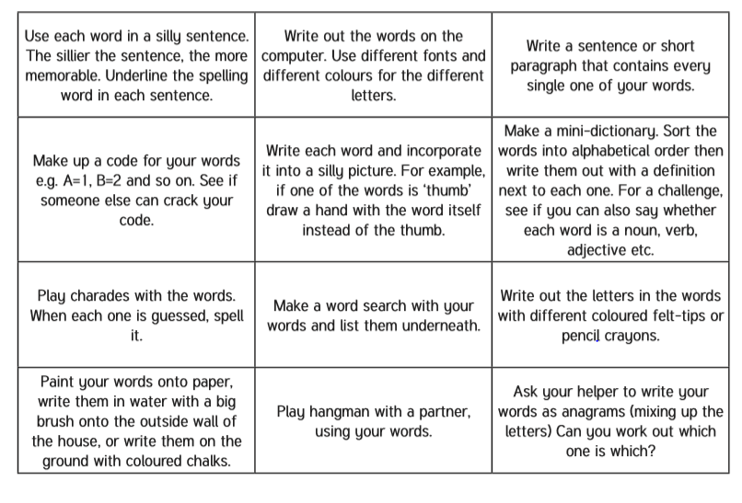
Spelling – Practise the year 4 spellings using a range of strategies. Below are some ideas that you can try.

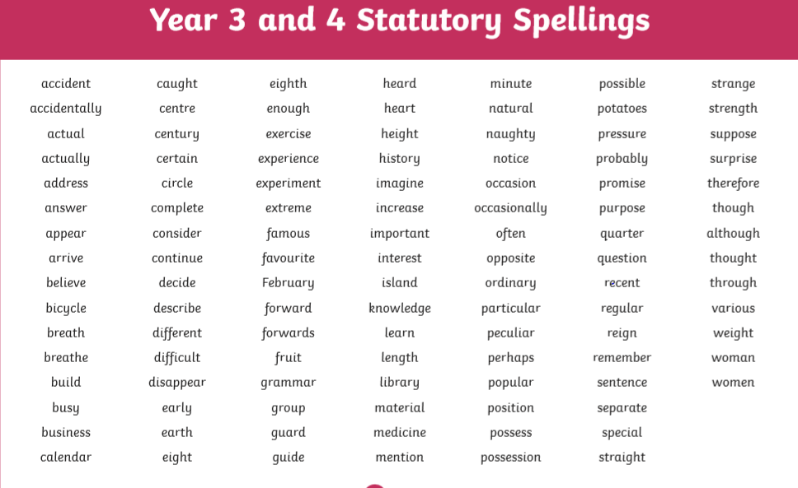
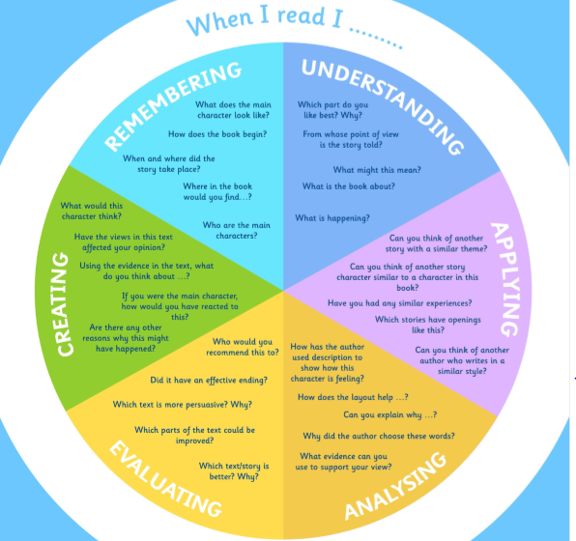
Suggested Reading Activities
This is an essential skill that the children need to continue to practise daily. It is recommended that the children read for at least 20 minutes each day. Continue to record all reading in the reading record books and remember to quiz on accelerated reader. You should have received an email with log in details. Please contact me if there is an issue with this. When listening to your chid read ask questions regularly to check and support understanding. Here is some example questions which would really support the children in their development.

Varied activities of Science, Music, Topic (History, Geography, Art) and R.E
 | Activities | Resources
Week 1  Activity 1 | The Jar of Hope: This week, think about the things that make you hopeful in these hard times. Find an empty jar and decorate it as your Jar of Hope. Write down the things that you are missing doing at the moment and put them in the jar. This way, once the current crisis passes, you can look in your Jar of Hope and celebrate and appreciate being able to do things again.  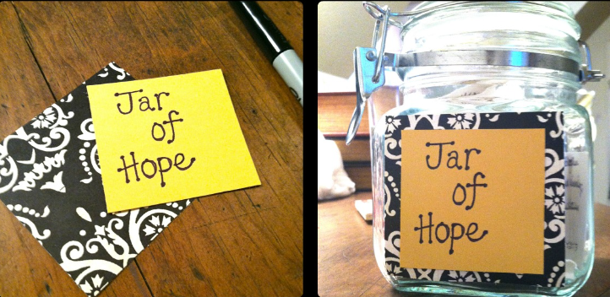 | Jar or container  Paper  Pens/pencils
Activity 2 | Create a piece of Op-art: Op-art is short for optical illusion art. An optical illusion uses colour, light and patterns to create images that mislead our brains. There are lots of popular examples and some which really blow your mind! Have a look at this website for some examples: https://www.optics4kids.org/illusions  This is a famous example, do you see a young lady or an old lady?  You are going to create your own piece of op-art using lines and colours. See the sheet attached for all the instructions. There are two ideas to choose from – but have fun and explore the world of op-art! | Op-art sheet on the website.
Activity 3 | Can I make a sock mascot?  Over the next few weeks, the children at St Joseph’s will have the opportunity to compete in a sock Olympics! To support you in your events you will need a mascot. You will need a pair of socks – one sock for your mascot and one sock to compete in the event.  I would like you to design and make a sock mascot. If you would like to share a photo of your mascot I would really love to see them! See bellow some examples for inspiration:  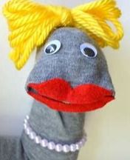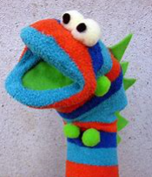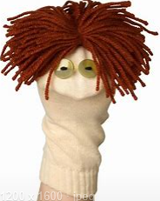 | A pair of socks – 1 sock for the mascot and 1 sock to compete in the sock Olympics.
Week 2  Activity 4 | Can I create an algorithm for somebody to follow?  This week you are going to become a dance teacher by creating an algorithm for your family to follow. First of all you need to think of your best dance moves! Your dance moves could be very simple (e.g. jump, spin, wave arms), or more complex (e.g. floss, dab). You need to have a card with a picture to represent each dance move. Then you need to create an algorithm of dance moves for a family member to follow. An algorithm is a precise sequence of instructions, or set of rules, for performing a task. Why not share this with a family member or friend via an online video chat (always get permission from a grown up first!) | Dance move instructions on the website.  Dance move cards – you do not have to print these, you could draw your own.
Activity 5 | Can I investigate how sound travels through different materials?  Watch the videos on sound:  https://www.bbc.co.uk/bitesize/articles/zb4jcmn  Have a go at the spoon swing experiment and record your findings.  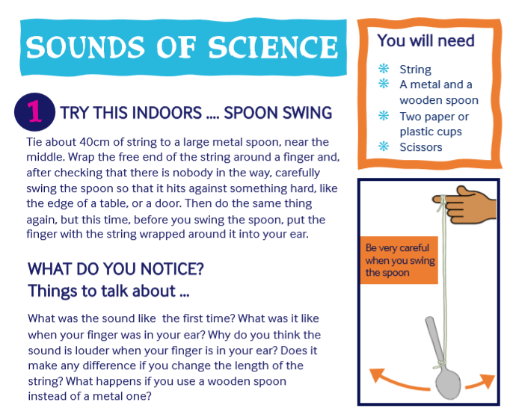  There are some other activities on the attachment which you could complete if you would like to. | Science sound activities on the website.
Activity 6 | Watch both of the videos about weather and climate: https://www.bbc.co.uk/bitesize/articles/zbwckmn  Research weather and climate around the world and complete the worksheet.  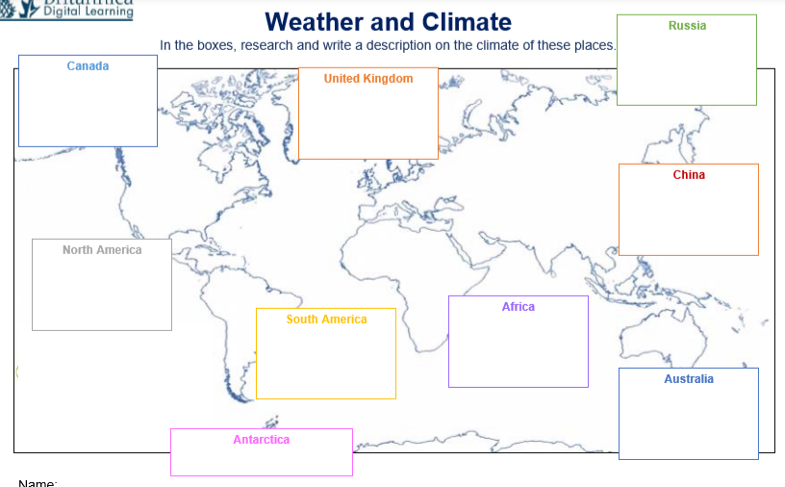 | Climate sheet on the website. (You do not have to print this you could write your findings on to paper)

