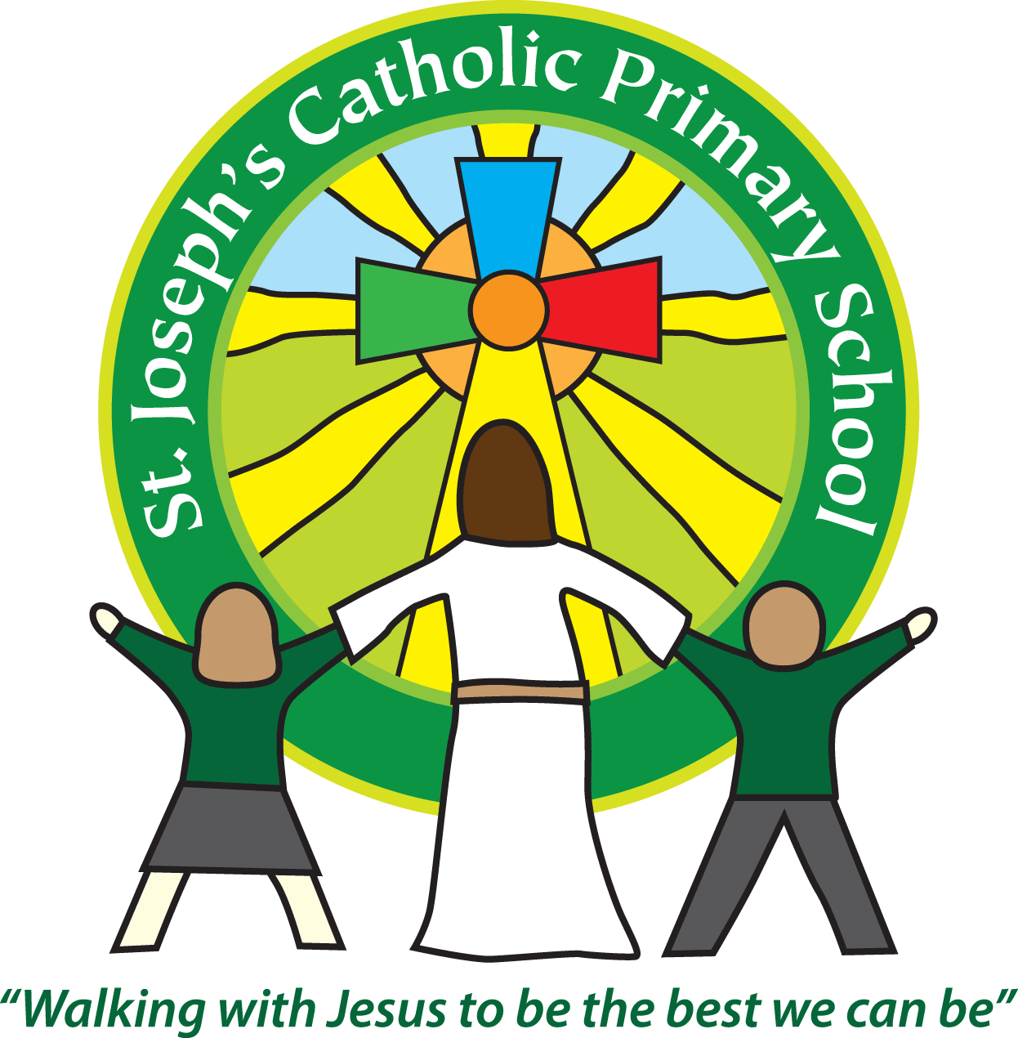

St Joseph’s Catholic

Primary School

Newsletter

June 30th 2016

**Dear all,**

Firstly, I would like to thank the four parents and Governor, who turned up for the ‘How to keep your child safe online’ talk by Cosmic IT. It gave lots of invaluable information about the risks young children face online and how we can help keep them safe. There were many tips given and information about risks that were not previously known. Plus we all got free pens!

Our Year 6s have gone off today for a morning of life skills with the Beacon School at the Donkey Sanctuary. They will be learning about keeping themselves safe e.g. fire safety, health, water safety, working with the police etc. I think they should have a great and useful morning out.

Our Year 5s have gone to a music festival at Buckfast today, which sounds like it should be lots of fun and is a chance to meet up with the children from other CAST schools.

What with the year 6 sleepover tomorrow night it’s a busy week!

**New class day**

On Monday our Year 6s are having their transition day at the Community College. It was originally Tuesday but due to the NUT strike affecting the college it has been changed to Monday. This means we will have our new class swap day on Monday as well. Your child should have come home today with a sheet with pictures of their new teacher(s) and teaching assistants who will at times be supporting in their class. On Monday morning the children need to go to their current class teacher for registration and then they will swap classes after that.

**Diary dates:**

Next Wed 6th July at 3.30pm the school is open for parents to meet their child’s teacher for next year. Each teacher will be giving a talk in class about the expectations for the year ahead: **Yr 1/2 talk 3.40pm, Yr 3/4 talk 4.10pm, Yr 5/6 talk 4.40pm.**

Thursday 7th July is the Year 3/4 sleepover at school.

On Wednesday 13th July at 9.15am our Foundation children will be having a special celebration assembly in the hall – everyone is welcome.

**Change in menu 21.7.16:**

On Thursday 21st July instead of the school dinner being roast it will be chicken nuggets or vegetarian nuggets and chips with Flapjack for pudding.

**Earrings in PE:**

Please can you ensure if your child has their ears pierced that they are only wearing studs in school. We recommend that the children do not wear earrings on the days they have PE due to Health and Safety. If they are doing a contact sport they will be asked to tape over their earrings or remove them. Many thanks for your cooperation with this.

Fingers crossed the weather is good for Sports Day tomorrow. KS2 start at 10am on the field, then everyone is welcome to have a picnic lunch on the field with their children. The Foundation Stage and KS1 Sports will start at 1.15pm on the field. I hope to see lots of you there.

**Best wishes & thank you for your continued support**

**Mrs Taylor-Bashford**

**Headteacher’s Awards:** Well done to: Ella FS1, Dean FS1, Alfie FS1, Annie FS1, Rose FS1, Jaydon FS2, Freddie FS2, Ben FS2, Lewis FS2, Ben Yr1, Laura Yr3, Charlotte Yr 3 and Rafa Yr 3.

