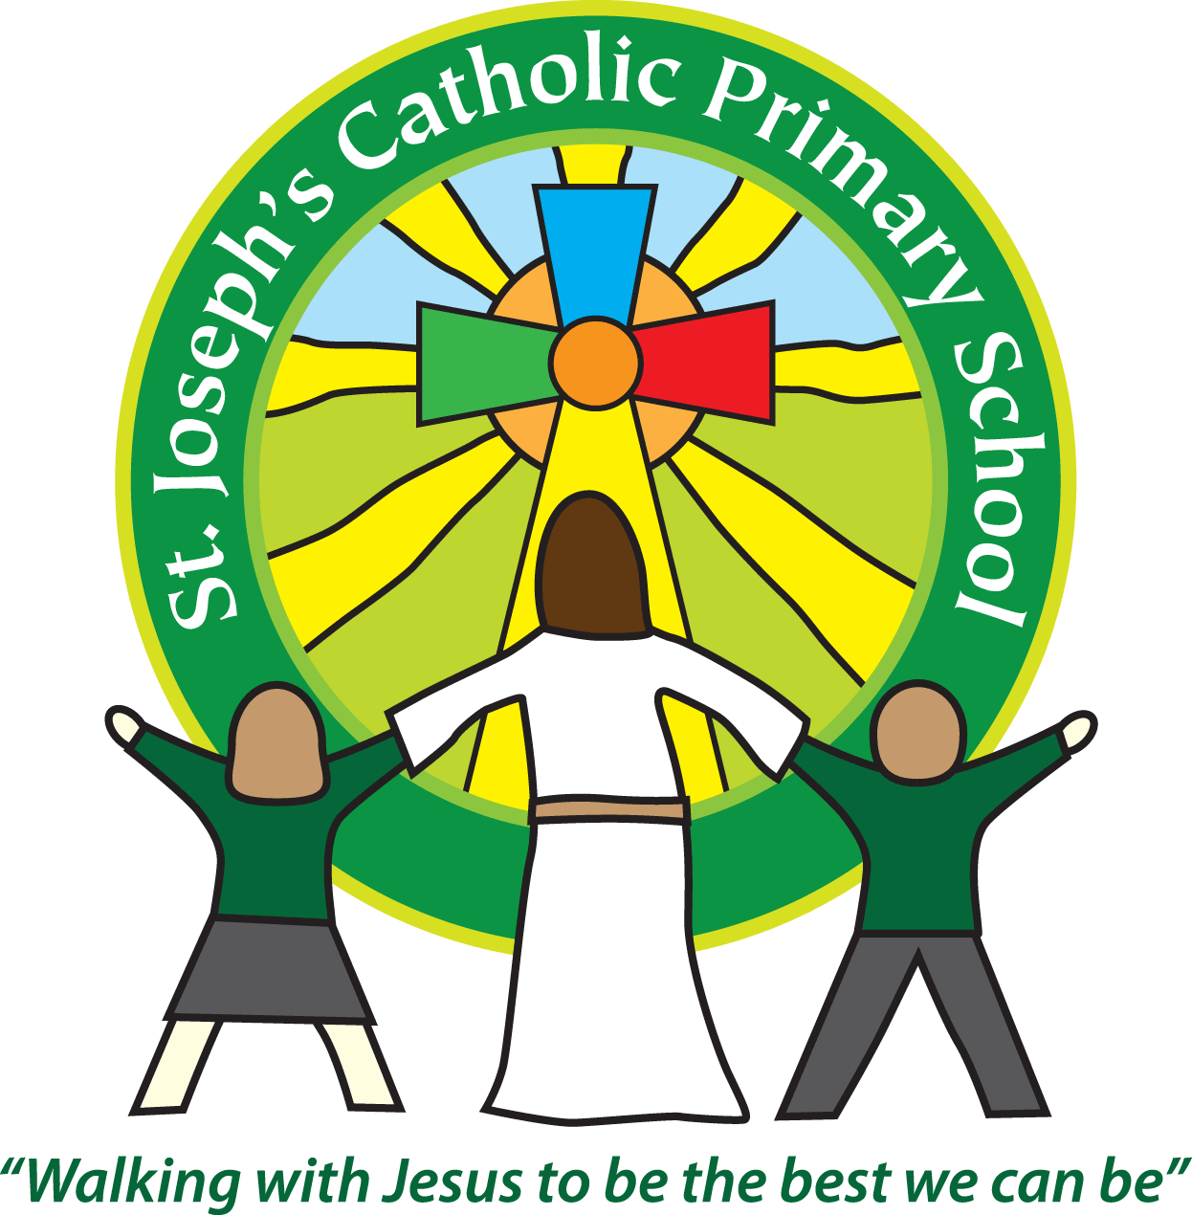 St Joseph’s Clubs Autumn 2019
**PLEASE READ THOROUGHLY**
The following clubs will run during the Spring Term. The times / dates will vary so please check the details for each individual club.
Booking
See the table below as booking varies depending on the club provider.
Payment
For fee paying clubs full payment must be made to the club provider (as listed on the club sheet) before the first session or the place will be allocated to another child.
Clothing
Please provide appropriate clothing for clubs, including warm clothing for outdoor activities. Please do not use school PE kit unless absolutely necessary as we need to ensure that this remains at school for use during the school day.
Medical issues
If your child suffers from any medical issues that the club leader needs to be aware of please provide written details.
Contact number for text messaging
Please ensure the number the office has for the first contact on your child’s record is up to date. This will be the number we use for the text messaging service.
If a club is unable to run we will contact you as soon as possible via the text messaging service.
Essential - Safeguarding
If your child cannot attend a session, please let us know by 12nonn – at the latest on the day in question. This is to ensure we know for registration and to keep pupils safe.
Collection from clubs - We will only release your child to an adult we have listed for your child on our database. If you wish for your child to be collected by another adult (including other parents) please contact the school office to let us know.
Permission to walk home - It is expected that your child will be collected from the club unless written permission to walk is provided.
Day | Club | Dates running | Time | Classes | Cost | Contact details for booking
Monday | Spanish Club | Sept: 9th, 16th, 23rd, 30th  Oct: 7th, 14th,  Half term  Nov: 4th, 11th, 18th, 25th  Dec: 2nd, 9th, 16th | 45 mins sessions.  Various times between 3.30-6pm | Yrs. 1-6 | Contact Mrs Burrows for payment information | Mrs Antonia Burrows  habloyhablo@gmail.com
 | Soccer Club | Sept: 16th, 23rd, 30th  Oct: 7th, 14th,  Half term  Nov: 4th, 11th, 18th, 25th  Dec: 2nd, 9th, 16th | 3.30-4.30pm | Rec – yr 6 | £54 per term | Premier Education at  https://family.premier-education.com/courses
Wednesday | Running Club | Sept: 11th, 18th, 25th  Oct: 2nd, 9th, 16th  Half term  Oct: 30th  Nov: 6th, 13th, 20th, 27th | 3.30pm – 4.30 pm | Yrs. 1-6 | £7 per half-term | Mrs Turner  Letters have been sent out to book a place.  Payable on ParentPay before the start of the first session.
Thursday | Science Club | Sept 12th, 19th, 26th  Oct: 3rd, 10th , 17th  Half term  Oct: 31st  Nov: 7th, 14th, 21st, 28th  Dec: 6th, 13th | 3.30-5.45pm (3.15pm for Nursery) | Nursery to Yr 6 (not 2yr olds) | Contact Mrs Williamson for payment information | Contact Mrs Williamson at: yates.claire@btopenworld.com for more information.
Mrs Cowdrey and Mrs King run St Joseph’s Breakfast Club every morning from 7.45 – 8.55am. Please ask at the Office for more details or to book.
Mrs Rush, Miss White and Mrs Kidd run After School Club every day from 3.30pm (3.15pm for nursery) – 5.45pm (4.30pm on a Friday). Please ask at the office for more information or to book.
Music lessons can be arranged through Exmouth Community College and carried out here at St Joseph’s School by one of ECC’s specialist teachers. Please see our Office for more details or ring Paul Stock, Head of Music at ECC – 01395 255627
We are hoping to have a self-defence club running on a Tuesday, we will send out details when it is confirmed and we have more information.

