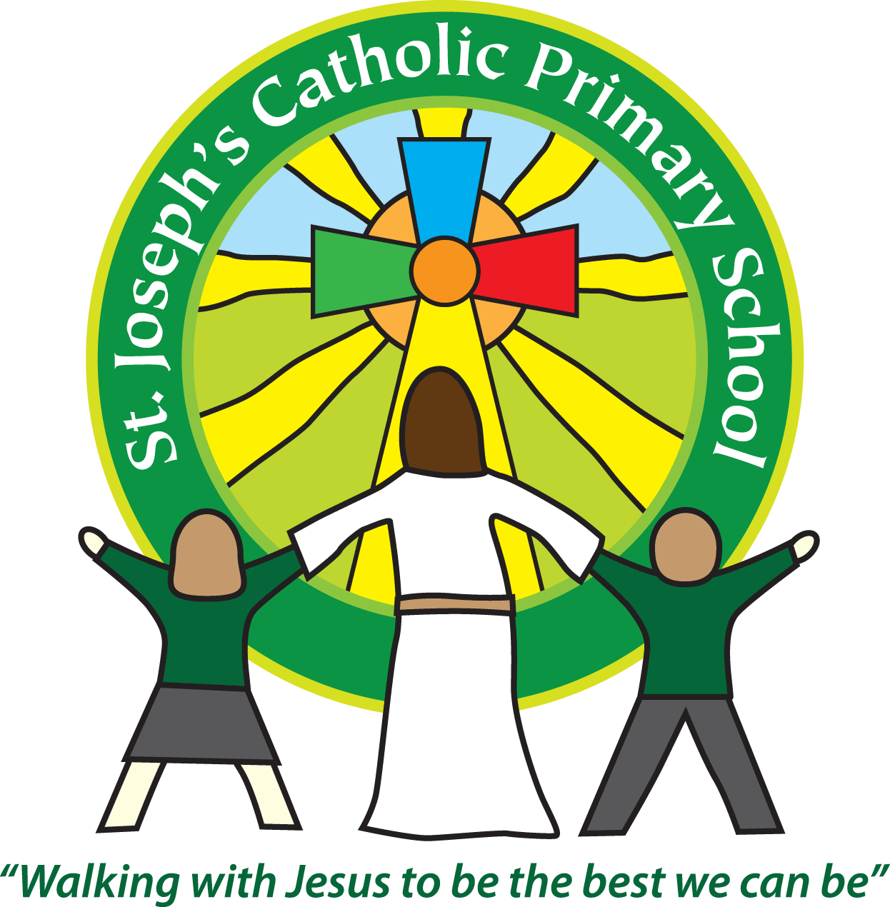

St Joseph’s Catholic Primary School

Newsletter

Friday 3rd May 2019

**Headteacher’s Awards:** Cherry - Jaydon

**Platinum:** Rowan - Ellis

**Silver Awards:** FSU – Jack S, Willow – Nell, Maple – Chloe, Lily

**Bronze Awards:** Willow - Jasmine

**Star of the Week Awards**: Oak – Quinn, Rowan – Fraser, Sycamore – Lucy, Cherry – Mason, Willow – Jessi, Maple – Lily , Beech – Oliver

**Breakfast club Award:** Rowan - Emma

Dear all,

This week we watched Cherry Class’ assembly. They taught us all about bees and shared all the learning they had been doing in class. They also performed some songs, poems and a rap! They are going to be growing bee friendly plants this term and making a bug hotel so it all sounds very exciting. Well done Cherry Class!

Cherry and Willow Class also had a tennis workshop on Monday. They really enjoyed the session and the coach commented on their excellent behaviour and team work.

Beech Class had an extremely interesting start to the week. Mrs Williamson came in and performed a Heart dissection for the class, also including looking at the lungs and diaphragm. The children were fascinated and it was also a really important lesson in ethics, about how the organs had been bought from an ethically responsible company and how animals must be treated respectfully at all times, even after death. Many thanks to Mrs Williamson for performing the dissection for us.

Today a group from Cherry and Willow Class have been to an athletics event at ECC. I’m sure they will have had a lovely time, practising their skills and mixing with children from other schools.

This afternoon the children have an assembly delivered by the RNLI about water safety. I believe learning about water safety and learning to swim is a life skill all children should have, particularly as we live right next to the beach. That is why as a school, instead of just delivering the statutory swimming lessons in Yr 3, we also deliver the catch up sessions as well as the life-saving course for every child when they reach Yr 5. We hope, combined with swimming outside of school, this gives them the first best chance of leaving school as able and confident swimmers, with a good understanding of water safety.

**Parent questionnaire.**

We have sent out a paper copy of a parent questionnaire today. It is to assess how parents feel about our school as a Catholic community. Your opinion is very important to us and we would be very grateful if you could complete this questionnaire and return it to the school office by Friday 10th May.

**E-Safety magazine**

The latest edition of DITTO e-safety magazine is on our website now, under the Parent section and then e-safety. This month’s edition includes information on distorted selfies, safe selfies, privacy app and age identification.

**Upcoming dates:**

Monday 6th May – Bank holiday

Thursday 9th May – Sycamore Class assembly 9.10am

Friday 10th May – Group from Beech and Maple Class to Rounders event at ECC

Monday 13th – Wednesday 15th May – Maple Class, Magdalen residential

Monday 13th – Thursday 16th May – Beech Class SATs tests

Friday 17th May – Cherry and Willow Class trip to the estuary

**Best wishes & many thanks for your continued support**

**Mrs Taylor-Bashford**