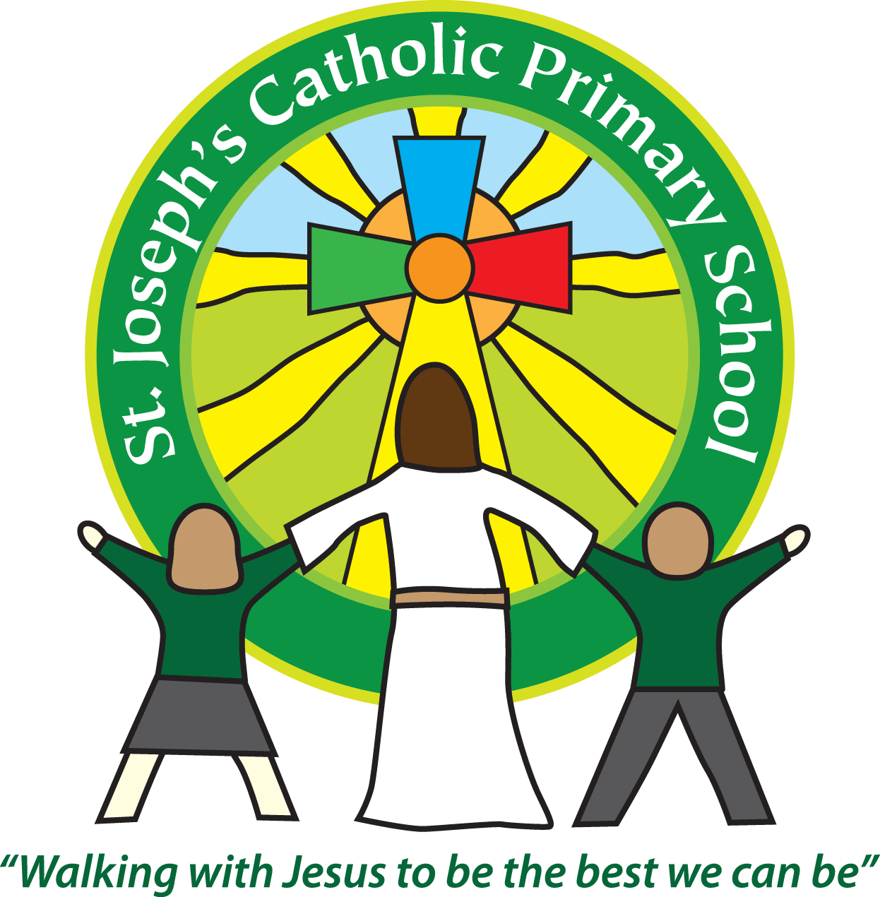

St Joseph’s Catholic

Primary School

Newsletter

May 13th 2016

**Dear all,**

The Yr 6 SATs are over and we are really proud of the children. They have worked incredibly hard, stayed positive and been very supportive of each other. Breakfast club with them every day has been lovely, although I never cease to be amazed by how many croissants they can eat - They have gone through 210 croissants and Pain au Chocolate, as well as cereal, toast and fruit!

The Year 5 have been really enthusiastic about Pompeii and Mr Edmunds reports they are showing a real ‘hunger for learning’. Well done Year 5! Yr 4 and 1 have been having fun with Grammar and punctuation - ask the Yr 1s about their Full stop tool! Yr 3s have been doing Science experiments with ramps and then writing them up using causal conjunctions and Yr 2 had a letter from the Man in the Moon! Whilst FSU have new explorer back packs to support and develop their writing.

We have had reports that some of the children have been accessing and uploading photos at home onto Instagram. On the school website I have uploaded Instagram’s guide for parents. While it clearly states there is a minimum age of 13 years, we are also aware that many children are using their parent’s accounts to put on pictures of themselves and friends. Whilst many of this pictures are very sweet, no pictures of children should be placed on there without parental consent, this includes whole class school photos and photos of children with the uniform/school logo on. Many thanks for your support with this.

Whilst children are taught about online safety throughout their time at school, I have booked for KS2 to have an talk delivered by ICT specialists on 9th June.

I have also booked a session for parents about ‘How to keep your child safe online’ at 6pm on Wednesday 29th June. It would be great to see as many people there as possible.

After half term we are pleased to say Amanda Turner, one of our excellent teachers, is running four sessions of ‘Move with Me’ on a Monday. Please see overleaf for details. And there are leaflets in reception.

Next week there is the PTA, EGM to vote in the new chair on Monday at 9am in the hall. On Wednesday there are class photos for all year groups and on Thursday is the sponsored bounce.

**Best wishes & thank you for your continued support**

**Mrs Taylor-Bashford**



Our local Church, the Holy Ghost has a vacancy for a part-time cleaner, minimum living wage applies. Please call into the Church or email: holyghost1@btconnect.com for details.

**Headteacher’s Awards:** Well done to: Sophia - Yr 1, Max - Yr1, Freddy - Yr 3, Darcie - Yr 3, Jessica - Yr 6 **Stars of week:**

Well done to: FSU - Annie Yr 1 - Piran Yr 2 - Ralph Yr 3 - Hannah Yr 4 - Tabitha Yr 5 - William Yr 6 – All pupils because of their SATs!

**Gospel Values Cup:** Well done to: St David’s team