Devon School Nursing Service Update_ March 2020
Find us online at: https://www.devon.gov.uk/educationandfamilies/health
We hope you and your families are remaining well (physically and mentally) at what is a uniquely difficult and stressful time for us all.
If you have any questions in relation to Coronavirus please refer to the NHS guidance at: https://www.nhs.uk/conditions/coronavirus-covid-19/
Please remember to wash your hands for the recommended 20 seconds and follow social distancing guidance. Advise on hand washing can be found at: https://www.nhs.uk/live-well/healthy-body/best-way-to-wash-your-hands/

Please also remember your 10 a day for mental health and health wellbeing - Talk about your feelings; Do something
you enjoy and are good at; Keep yourself hydrated; Eat well; Keep active in mind and body; Take a break; Stay connected to those you care about; Ask for help; Be proud of your very being; and Actively care for others

Centralised contact points for Public Health Nursing Services (PHN hubs)
We have 4 PHN hubs to improve access and responsiveness. All calls, referrals and correspondence are directed to the hubs where business support are co-located with duty clinicians.
Southern Hub: 0333 234 1901 Lescaze Offices, Shinners Bridge, Dartington, TQ9 6JE rde-tr.southernphnhub@nhs.net
Exeter Hub: 0333 234 1902 Frankyln House, Franklyn Drive, Exeter, EX2 9HS rde-tr.exeterphnhub@nhs.net
Eastern Hub: 0333 2341903 Jerrard Wing, Honiton Hospital, Marlpits Lane, Honiton, EX14 2DD rde-tr.easternphnhub@nhs.net
Northern Hub: 03332 341904 Taw View, Civic Centre, North Walk, Barnstaple rde-tr.northernphnhub@nhs.net
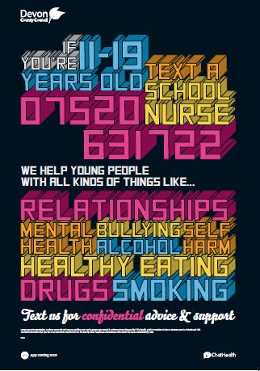

SINGLE POINT OF ACCESS (SPA)
ACCESS TO SPECIALIST SERVICES IN DEVON

https://childrenandfamilyhealthdevon.nhs.uk/
Tel: 0330 024 5321
Email: TSDFT.DevonSPA@nhs.net

This includes services such as: Learning Disability Team, Speech and Language Therapy, Child and Adolescent Mental Health Service (CAMHS), Occupational Therapy, Community Children’s Nursing Service, Autism Spectrum Assessment Service, Specialist Children’s Assessment Centres, Specialist School Nurses, Children in Care Service, Palliative Care Service, and Devon’s Family Information Service for Children with Additional Needs.
You can self refer and information to support this is available online or by speaking to one of the team.

Please only use Chat Health for health queries. Any appointment queries should be via PHN hub (phone or email). Please ensure you provide your contact details and full name and date of birth of child/young person in all calls and emails.

