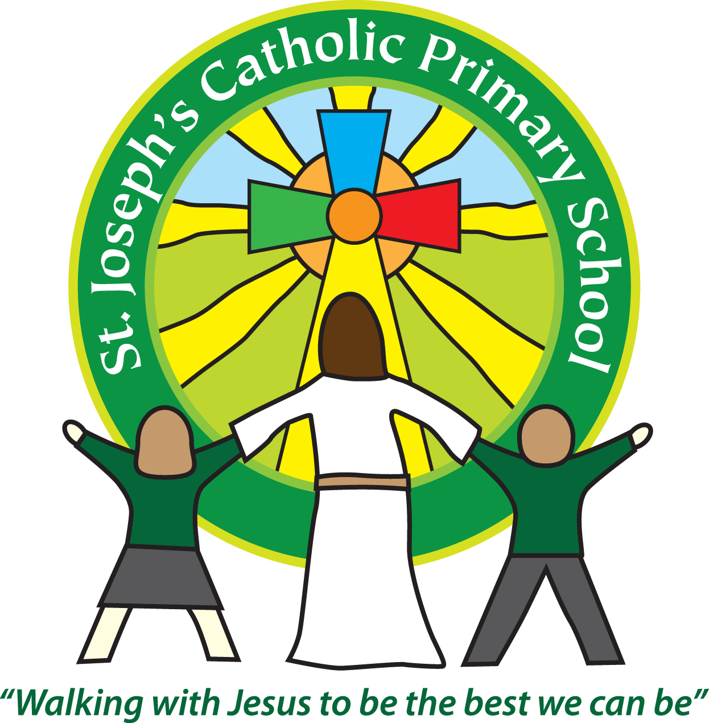

St Joseph’s Catholic Primary School

Newsletter

March 17th 2017

**Dear all,**

The Year 1 children had a fantastic visit to Powderham Castle this week. They looked super dressed up in their costumes and came back buzzing about all the activities they had taken part in.

**Mother’s Day messages**

The children wanted to send some special messages to the people they love. Please look out for some lovely messages from our children in the Journal on 23rd March.

**Hugo Swire**

As some of you will have seen there was a picture in the paper of me handing over the signed petition from parents to Hugo Swire about funding. I was disappointed that the news report incorrectly gave the impression that schools get a bigger lump sum as that is inaccurate. I have written in to request a correction. I have received a letter from Hugo Swire saying what a lovely time he had at St Joseph’s and how he will continue to put the case for more funding forward in Parliament. I have also been on the Radio to raise awareness of the funding crisis.

**Red Nose Day**

Next Friday 24th March is Red Nose Day. The School Council have decided what the school will do for Red Nose Day - so the children can come to school wearing red for a donation to Comic Relief (Except Class 4 who are on a trip and need to wear school uniform). There will be a cake sale after school so any donations of cakes in the morning would be gratefully received. There will be a ‘Guess the teacher’ competition, with baby photos of the teachers for children to guess – 20p to enter. All money raised goes to Comic Relief.

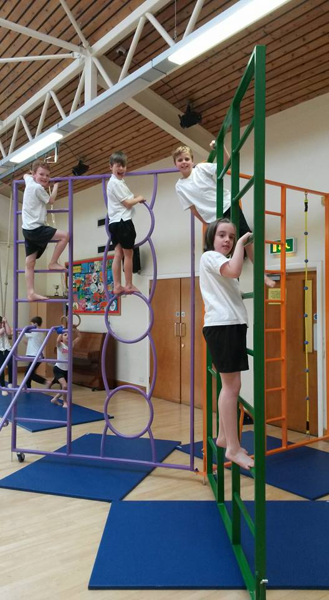 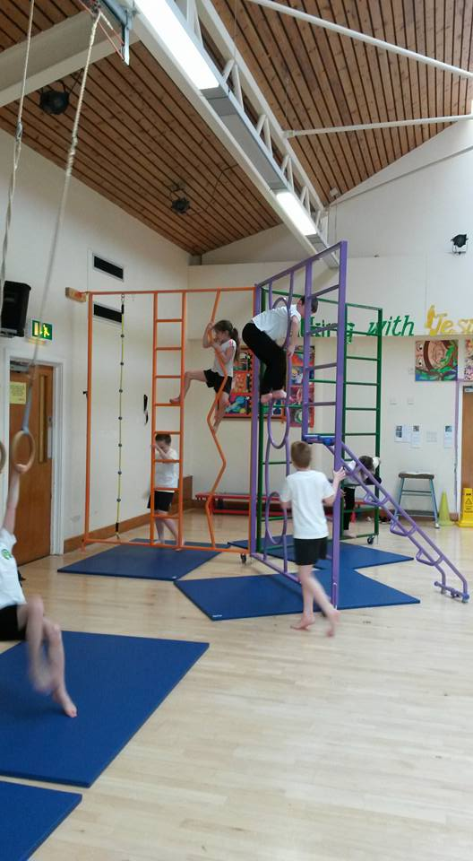 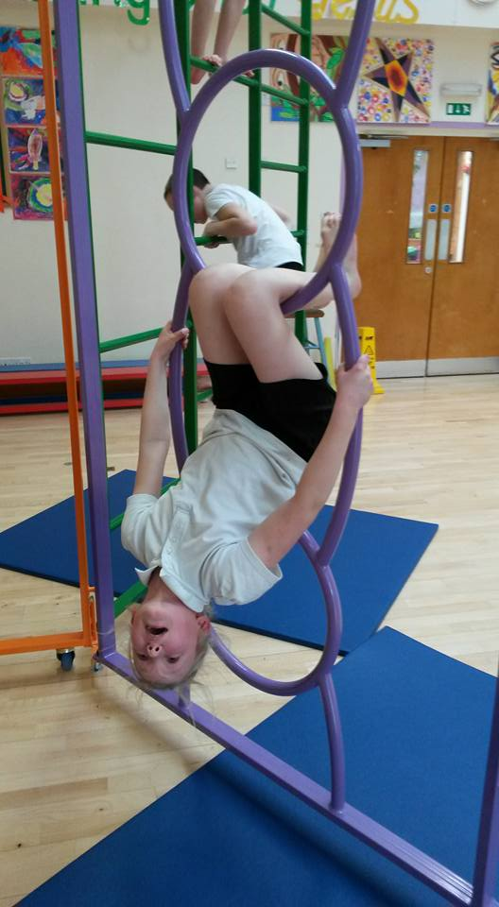

**Next week:**

Monday: St Joseph’s Day Mass in school - 9.15am

Monday: Last Swimming Session Class 5

Wednesday: Reports go home

Wednesday: Group of Class 5 Bowling competition at Ocean

Thursday: Class 2 trip to Powderham

Friday: Red Nose Day.

Friday: Class 4 trip to Buckfast Abbey (please wear school uniform)

Friday: Class 5 and 6 group to take part in Gymnastics competition at ECC.

**Best wishes and thank you for your continued support**

**Mrs Taylor-Bashford**

**New wall bars**

Our new wall bars have arrived. They will make a real difference to the PE learning experiences we can offer the children. As you can see in the pictures they are already proving very popular.

**Headteacher’s Awards:**

**Well done to:** FSU – Elliott,Rian, Yr 2 – Max, Yr 3 – Charlie, Jasmyne, Yr 5 – George, Yr 6 – Nina, Shannon, Alex, Will

**Bronze certificates:** FSU – Rose, Lola, Dean, Amelia, Harry, Yr 1 – Misha, Yr 2 – Elliot, Ben, Yr 5 – George, Samuel, Yr 6 – Adam, Skye

**Silver certificates:** Yr 2 – Max, Yr 5 – Sophia, Yr 6 Nina

**Stars of the Week:** FSU – Dean, Yr 1 – Mason, Yr 2 – Shanel, Yr 3 – Ryan, Yr 4 – Archie, Yr 5 – Alex, Yr 6 – Alana



If you know anyone looking for school places, please let them know as we still have spaces available in some classes. They can contact the Office for more information or to book a tour.

Tel: 01395 264875 email: admin@stjo.uk