 | Nursery | Reception | Year 1 | Year 2 | Year 3 | Year 4 | Year 5 | Year 6
 | Here I am  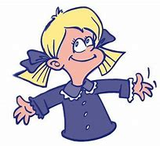  Begin making sense of their own life story using photos | Me and My Family  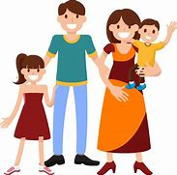  Explore family and the places they have been .Similarities and differences between other families.  People familiar to them | What was life like for people in the past?  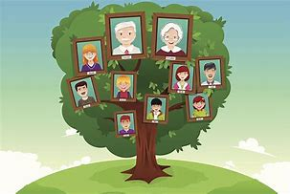  An introduction to the discipline of history with my family tree, and how schools, toys and the way we communicate  have changed over time | Local History – Exmouth Docks  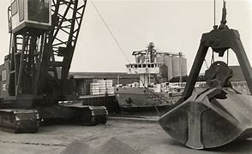  Exploring Exmouth docks and its transformation into the Marina. How have the communities and industries which exist there changed. | European history-  Prehistoric Britain  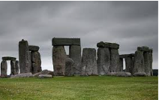  How settlements, food, communities and beliefs changed across the Palaeolithic, Mesolithic, Neolithic, Bronze Age  and Iron Age | North American history-  Ancient Maya  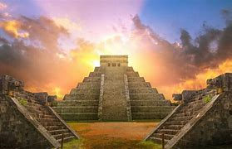  Understanding life for the Ancient Maya, and comparing this with that of the Ancient Greeks and Ancient  Egyptians | European history-  Ancient Rome  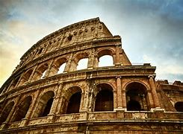  The development of the Roman Empire, how it changed over time, and how these changes affected people  differently | European history: Settlement by Anglo-  Saxons  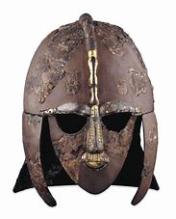  Using artefacts identified at Sutton Hoo to explore what life was like for Anglo-Saxons
Autumn
 | Let’s celebrate  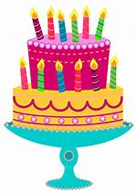  Discuss their celebrations using past tense | Superheroes  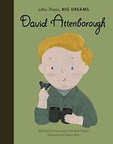  Heroic figure from recent history Heroes in our community | Transport-  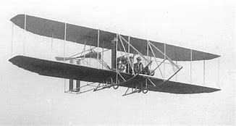  How did people travel in the past?  The development of transport by land, sea, air and space and the roles of key individuals | European history-  The Great Fire of London  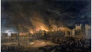  Life in London 1660s, and the causes and effects of the Great Fire of London | African history- Ancient Egypt  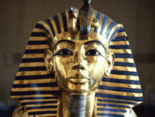  The role of the pharaoh in Ancient Egypt, and examining pyramids, mummification and conquest in the Egyptian empire | Asian history-  Early Islamic Civilisation  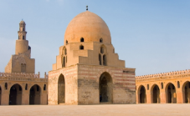  The establishment of Baghdad and the contributions Islamic scholars in the House of Wisdom made to science, maths, medicine and  technology | European history- Roman Empire in Britain  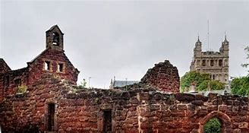  The Roman conquest of Britain, and how the Romans maintained power in Britannia | European history: Viking invasions  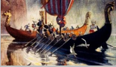  Understanding who the Vikings were and how their reputation has changed over time; making arguments as to whether they deserve a violent reputation
Spring | Nursery | Reception | Year 1 | Year 2 | Year 3 | Year 4 | Year 5 | Year6
 | Let’s explore  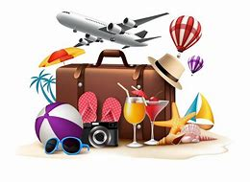  Sharing news about personal experiences using past tense | Green Fingers  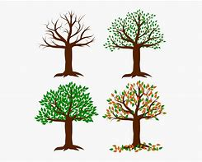  Change in living things (changes in leaves, weather, season) Change in season from Spring to Summer | Homes-  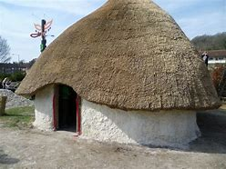  Where did people live in the past?  How homes looked different in the past. | American History – Explorers  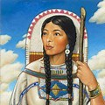  The similarities and differences between the lives of Sacagawea and Michael Collins | 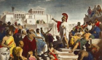  European history-Ancient Greece  The contributions made by the city-states of Ancient Greece, and how these are influence our lives today | 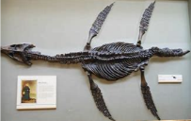  European history. A local study - The Jurassic Coast  The significance of the Jurassic Coastline as a world heritage site and the role of Mary Anning.. | Global history: Quest for knowledge  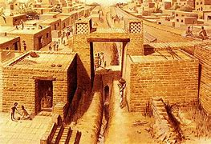  An exploration of a range of civilisations across the world and across time, and how they developed and shared knowledge | Global history: Power, empire and democracy  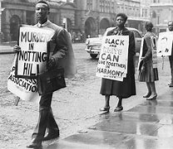  A short introduction to the rise and fall British Empire, and its legacy in Britain from the 1960s to today
Summer |  |  |  |  |  |  | ]

