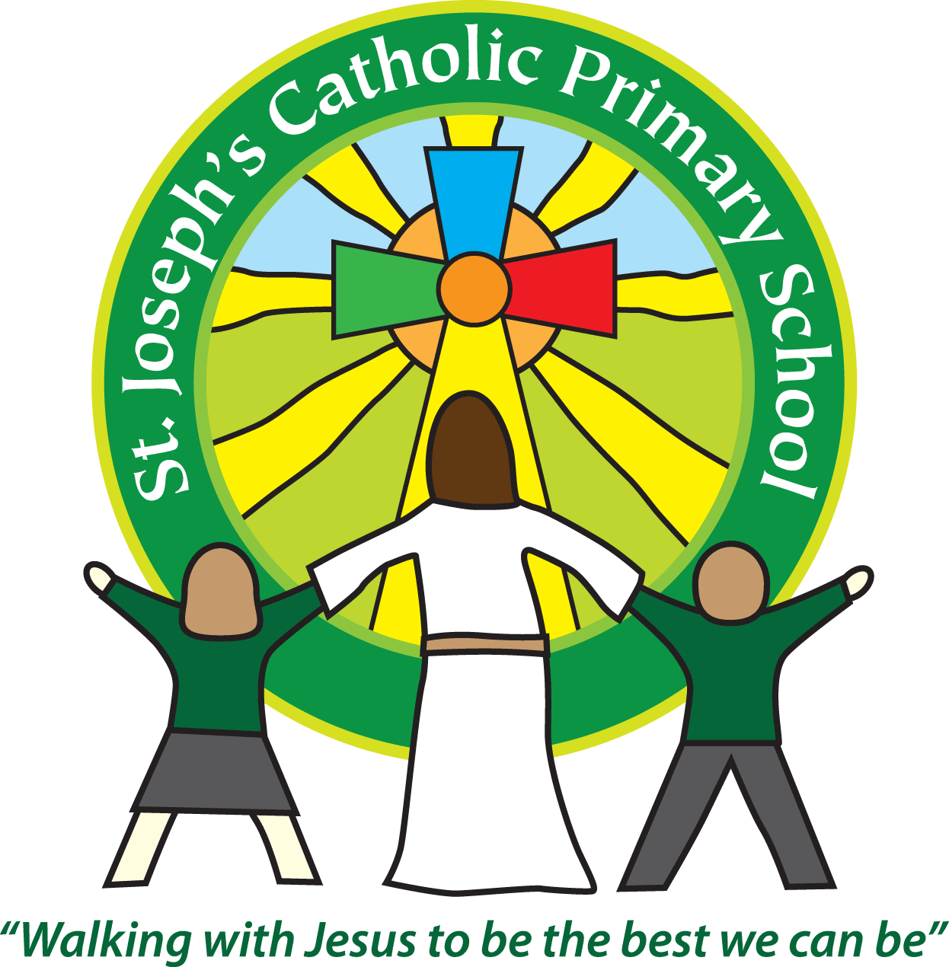
St Joseph’s Catholic Primary School
Year 6 – Autumn term (2nd half)
Welcome back!
This half term our topic continues to be ‘Marvellous Minds’.
Year 6 home learning
Subject | Sent home | Due in | Frequency
Spellings | Thursday | Tuesday | Weekly
Times Tables and related division facts should be practised weekly – children have access to Timetables Rock Stars to help them with this. |  |  | Weekly
Maths/English | Thursday | Tuesday | Weekly
Topic | Thursday | Tuesday | As required
Reading | We expect the children to read at home daily. Books can be changed in school or your child may wish to read a book from home. Please make sure that you regularly read with your child and discuss the books that they are reading. Please note: it is important to question your child about what they have read. eg. How do you think Tess felt when she left the house? Why? These open questions require children to use evidence from the text to support their judgements. It would also be useful if you could ask your child to collect new/unknown words from their book, find their meaning and share them with the class.

Reminders
School lunch and snacks | Now the new school lunch system is in place, please remember that if your child would like a school dinner, it should be ordered before 9am of the day concerned. They can also be block booked ahead if that is more convenient.  We promote healthy eating at school and so lunch boxes should not contain more than one chocolate snack and one packet of crisps.  Children are welcome to bring fresh fruit or vegetables for a snack at break time.  We are a nut free school. We have children with potentially fatal nut allergies in school, therefore no food containing nuts may be sent into school.
Drinks | Your child must have a named water bottle in school every day. Please only send in water; no juice or fizzy is allowed.
Uniform | Please ensure all uniform is clearly named.  Grey trousers or shorts; grey skirt or pinafore dress; black, white or grey socks; black or grey tights; white polo shirt; green logo school sweatshirt or cardigan. Warm weather option – green and white gingham dress (dress with shorts instead of skirt is acceptable).  Hair past shoulder length must be tied back – please use plain hairbands in green, black or white, not brightly coloured bows.  Nail varnish is not allowed. School shoes must be black and no heels, trainers or boots.
PE kit | Green t-shirt with school logo, black shorts, black or navy jogging bottoms and trainers. All kit must be named and in a named bag.  Earrings must be removed or covered with tape for PE lessons.  Watches must be removed for PE.  PE kit must be in school every day.
Bags | Children can have a bag in school but please avoid the large bulky ones as 30 rucksacks take up a lot of room in the class. We would also ask that children don’t bring in pencil cases as we have nowhere to store them and the children get upset if items are lost.
Mornings | School starts promptly at 8.45am.  Your child will be greeted at the class door by an adult. Please only pass on quick messages then, for a longer meeting please make an appointment.  Children and parents arriving after 8.50am will be asked to sign in at the office.
After school | School finishes at 3.15pm. If someone other than yourself is collecting your child please ensure the office has their details. We will not let them leave unless we are sure they are safe.  Yrs 5 and 6 - if your child sometimes walks home alone or with friends please ensure the teacher or office knows that you have given permission for this.
Contact details | Please ensure you contact details and those of other people who may collect your child are always kept up to date. Please see the office asap if you change your phone number or address.

Teaching assistants
Mrs Greenway will be working with us Mon – Thurs mornings.
Specialist teachers
On a Tuesday afternoon, year 6 will continue with music taught by Mrs Nelmes and PE taught by Mrs Turner.
RSHE
You will see from the information on the topic web, we will be starting to look at the topic of puberty this half term. This will involve learning about the changes that happen to both boys’ and girls’ bodies during puberty. If you have any questions about what we will be teaching, please feel free to send an email to admin@stjo.uk which will be passed on to Mrs Jukes or catch one of us after school.
Administrative information
This term we are going to be learning about Light in science and need empty kitchen roll holders and some large cereal boxes – if you have any of these items in your recycling, please send them into school and we will make good use of them! Thank you.
From now on to cut down on paper usage we will only email these class letters out. Please ensure the office has your current email address and let me know if you require a paper copy.
We recognise the importance of passing information between parents and school so I am available at the start and end of the day if you need to pass on any messages. However, if you would like a longer chat please make an appointment with me. This will probably need to take place over the phone in the current situation.
If you are able to support our learning with resources, please let a member of staff know. We value your involvement in your child’s education.

Yours sincerely,
Mrs Jukes and Mrs Monks

