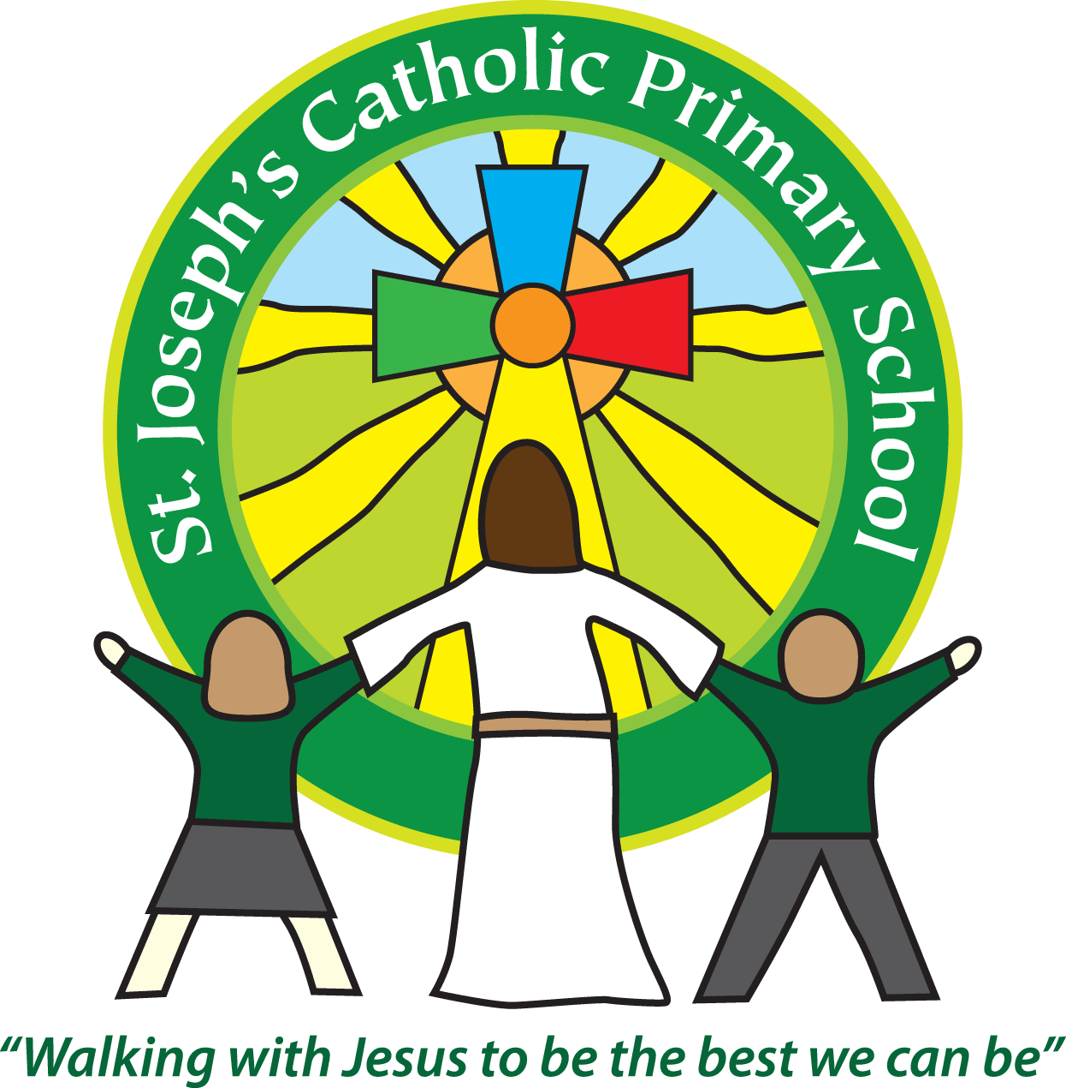
St Joseph’s Christmas Art Creations
Whilst Christmas may seem far away, I’m sure it will be here before we know it!
I’m sure many of you will remember the super cribs the children made last year for the school ‘Crib trail’.
This year we are asking that all the children have a go at creating their own Christmas Art work. These will then be displayed at school for all the parents, parish community and children to see from 1.30pm on Thursday 14th December. The local paper will also be coming to photograph them. Everyone is welcome to come and view the art work during the afternoon and is then invited to stay for our ‘Carols around the Christmas tree’ at 2.30pm.
So the challenge:
All children are asked to design and make their own Christmas model or picture. This could be in the form of a collage, painting, model etc the more creative the better.
I have included some examples below as inspiration!
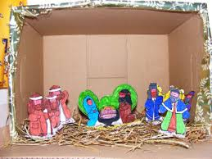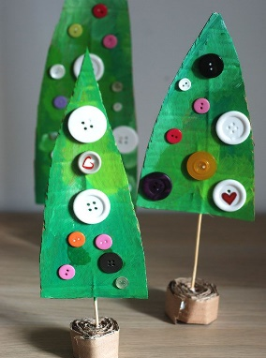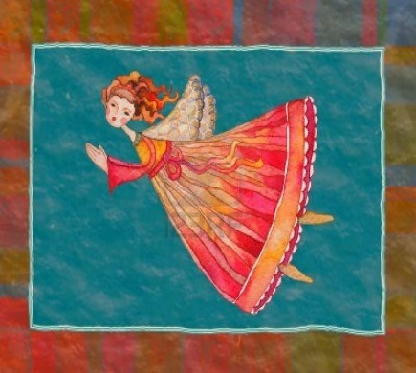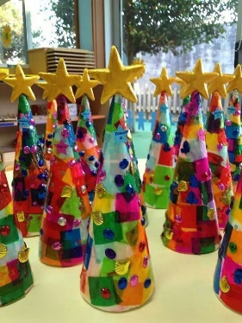
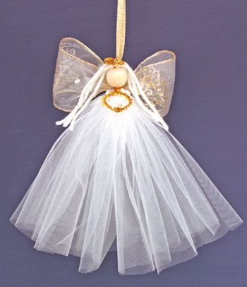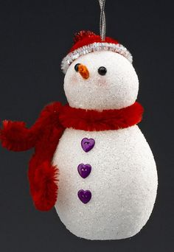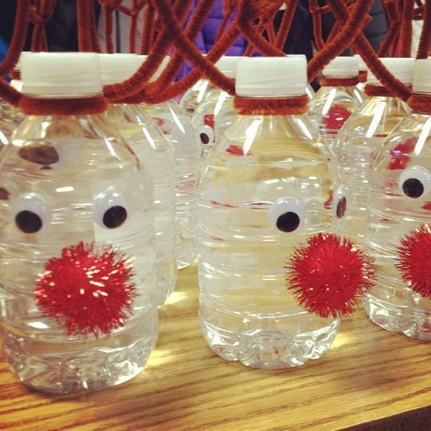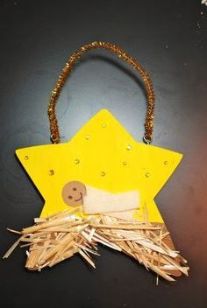
I would be grateful if the children could bring their creation into school during the week of December 4th so there is plenty of time for them to be displayed and enjoyed.
Let the creating commence!
Many thanks
Mrs Taylor-Bashford

