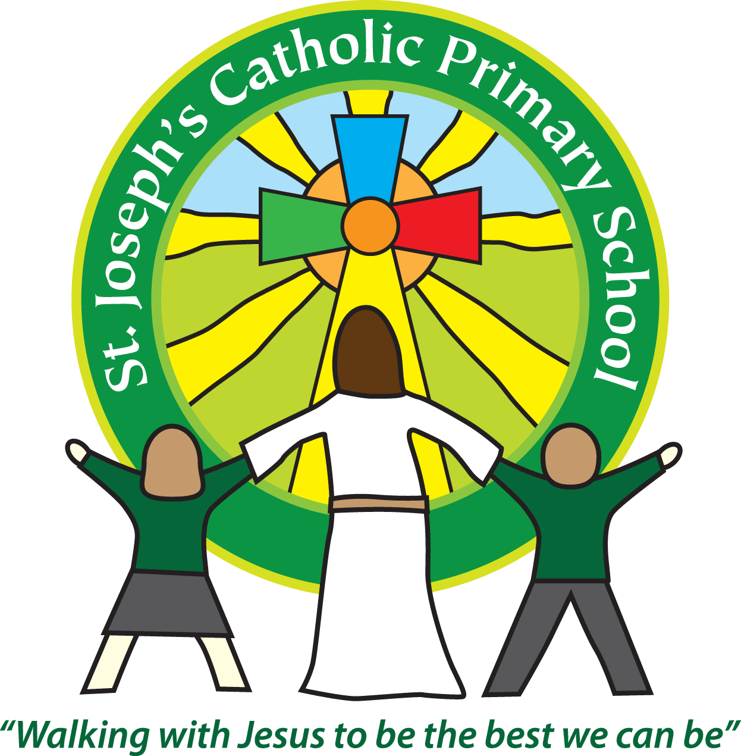 St Joseph’s Clubs Spring 2018
**PLEASE READ THOROUGHLY**
The following clubs will run during the Spring Term. The times / dates will vary so please check the details for each individual club.
Booking
See the table below as booking varies depending on the club provider.
Payment
For fee paying clubs full payment must be made to the club provider (as listed on the club sheet) before the first session or the place will be allocated to another child.
Clothing
Please provide appropriate clothing for clubs, including warm clothing for outdoor activities. Please do not use school PE kit unless absolutely necessary as we need to ensure that this remains at school for use during the school day.
Medical issues
If your child suffers from any medical issues that the club leader needs to be aware of please provide written details.
Contact number for text messaging
Please ensure the number the office has for the first contact on your child’s record is up to date. This will be the number we use for the text messaging service.
If a club is unable to run we will contact you as soon as possible via the text messaging service.
Essential - Safeguarding
If your child cannot attend a session, please let us know by 12pm – at the latest on the day in question. This is to ensure we know for registration and to keep pupils safe.
Collection from clubs - We will only release your child to an adult we have listed for your child on our database. If you wish for your child to be collected by another adult (including other parents) please contact the school office to let us know.
Permission to walk home - It is expected that your child will be collected from the club unless written permission to walk is provided.
Day | Club | Dates running | Time | Classes | Cost | Contact details for booking
Monday | Choir club | Jan: 8th, 15th, 22nd, 29th  Feb: 5th,  Half term  Feb: 19th, 26th  March: 5th, 12th, 19th, 26th | 3.30-4.30pm | 1-6 | £15 per half term | See Mrs Turner or email  aturner@stjo.uk for more details and booking.  Please pay on parent pay or at the office.
 | Spanish Club | Jan: 8th, 15th, 22nd, 29th  Feb: 5th  Half term  Feb: 19th, 26th  March: 5th, 12th, 19th, 26th | 45 mins sessions.  Various times between 3.30-6pm | 1-6 | £5 per session | habloyhablo@gmail.com
 | Soccer Club | Jan: 8th, 15th, 22nd, 29th  Feb: 5th  Half term  Feb: 19th, 26th  March: 5th, 12th, 19th, 26th | 3.30-4.30pm | Rec – yr 6 | £42 per term | https://www.saintssouthwest.co.uk/all-courses/afterschool-club/
Tuesday | Homework club  Please note there is no club on January 16th | Jan: 9th, 23rd, 30th  Feb: 6th  Half term  Feb: 20th, 27th  March: 6th, 13th, 20th, 27th | 3.30-4.30pm | 6 | Free | Mrs Jukes/Mrs Ertle
 | Tennis | Jan: 9th, 16th, 23rd, 30th  Feb: 6th  Half term  Feb: 20th, 27th  March: 6th, 13th, 20th, 27th |  |  | Free
Wednesday | Guitar Club | Jan: 4th, 11th, 18th, 25th  Feb: 1st, 8th,  Half term  Feb: 22nd  March: 1st, 8th, 15th, 22nd, 29th | 12.30-1.00pm | 1-6 | £5 per session | markknightbass@gmail.com  07772905944
 | High 5 Netball Club  Please note there is no club on February 7th. | Jan: 10th, 17th, 24th,31st  Half term  Feb: 21st, 28th  Mar:7th, 14th, 21st, 28th | 3.30pm – 4.30 pm | 3-6 | Free | See Mrs Turner or email  aturner@stjo.uk for more details and booking.
Thursday | Science Club | Jan: 4th, 11th, 18th, 25th  Feb: 1st, 8th,  Half term  Feb: 22nd  March: 1st, 8th, 15th, 22nd, 29th | 3.30-4.15pm | 1-6 | £4.50 per session  £54 total | yates.claire@btopenworld.com
 | Yoga at the Shala | Jan: 11th, 18th,25th  Feb:1st, 8th  Half Term | 3.30 – 4.45 | 1- 6 | £2 per session  £10 total | See Mrs Turner or email  aturner@stjo.uk for more details and booking.  Please pay on parent pay or at the office.
Friday | Knitting Class | Jan: 5th, 12th, 19th, 26th  Feb: 2nd, 9th  Half term  Feb: 23rd  Mar: 2nd, 9th, 16th, 23rd | 12.45 - 1.15pm | 5 & 6 | Free | See Class teacher
 | Running Club | Jan: 12th, 19th, 26th  Feb: 2nd, 9th  Half term  Feb: 23rd  Mar: 2nd, 9th, 16th, 23rd | 3.30 – 4.30pm | 1-6 | Free | See Mrs Turner or email  aturner@stjo.uk for more details and booking.

Music lessons can be arranged through Exmouth Community College and carried out here at St Joseph’s School by one of ECC’s specialist teachers. Please see our Office for more details or ring Paul Stock, Head of Music at ECC – 01395 255627

