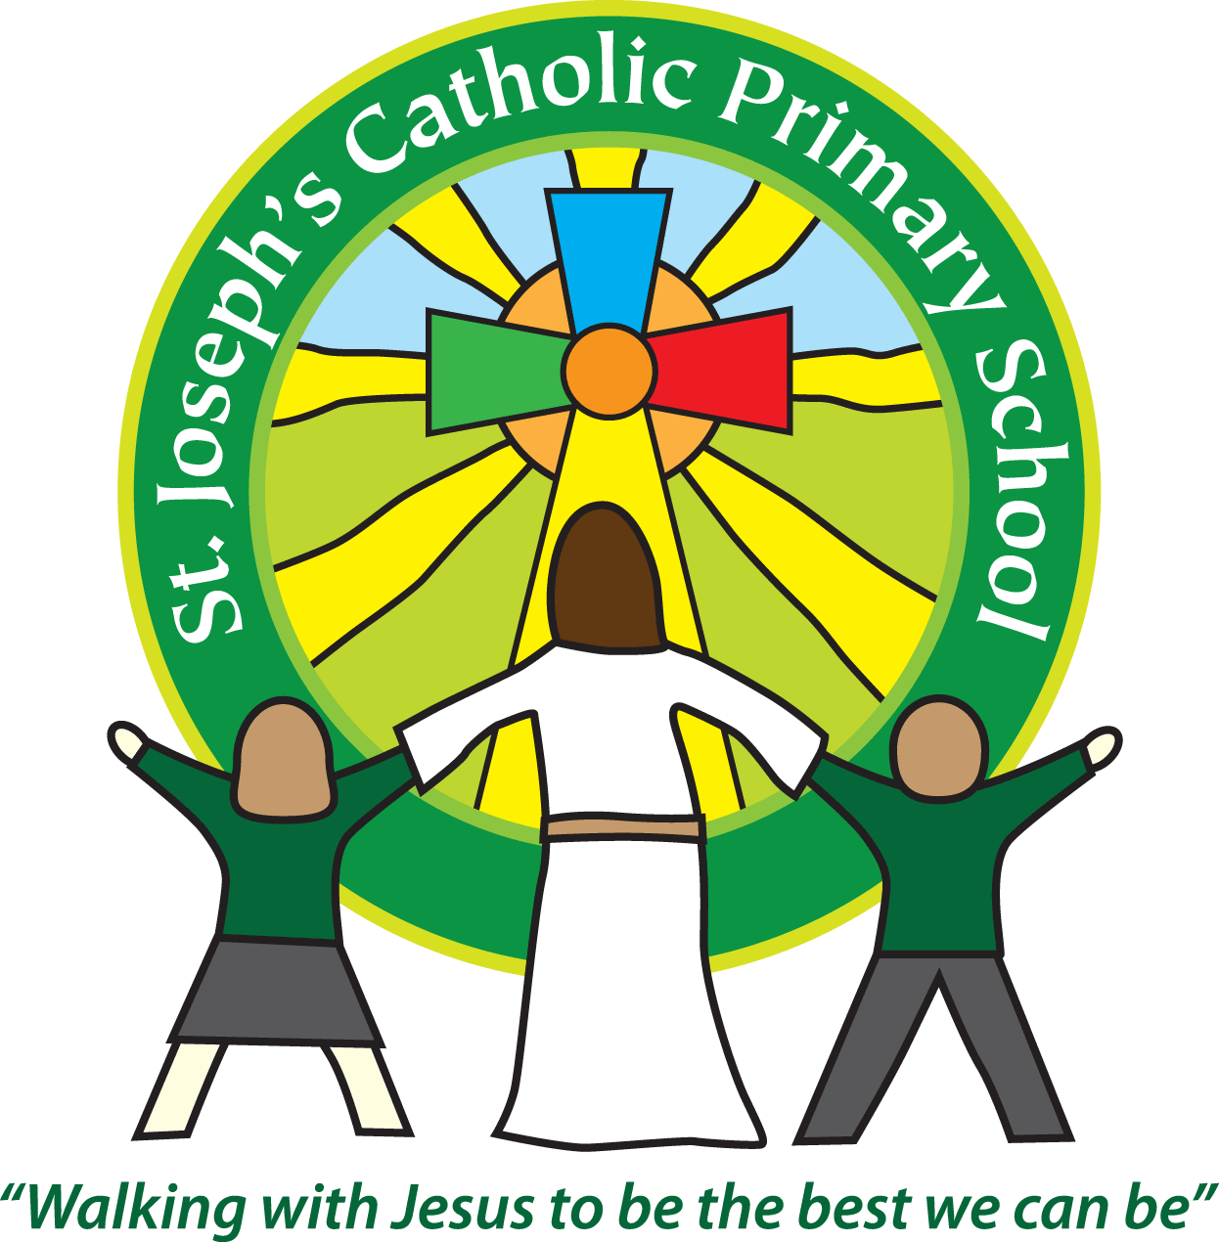
St Joseph’s Catholic Primary School Home Learning Pack
Class: Sycamore Year 2
Please find the suggested timetable. This is just a suggestion and you need to find what works for you and your child as we understand that everyone learns differently. Just to be clear, we are not expecting everyone to do all of the activities and these are only suggestions. We understand that our circumstances are all very different at the moment and that lots of you will be trying to juggle ‘home school’ and your own work as well as caring for elderly neighbours and family. Please only do what you feel you can. We do not want to set anything that causes any worry so please do what you feel. There are some references to resources but they do not need to be printed and can be viewed online and the work can be completed or copied onto paper. Please contact us at admin@stjo.uk and in the subject name it… For (Your Child’s teachers name and Class) if you need any further support. For example; For Miss Rowe, Sycamore Class. This will help us to ensure your request is dealt with quickly.
Suggested Family Home Learning Timetable
This is a guide to help you establish a routine for your children – this is just a suggestion and you will need to adapt it to the needs of your family.
Time | Activity
Before 9.00 | Get up, washed, dressed, make beds and eat breakfast
9.00 – 9.30 | PE with Joe or family walk
9.30 – 9.45 | Drink and get ready for home learning
9.45 – 10.30 | English – writing, spelling or grammar activity from your home learning pack
10.30 – 11.00 | Break time - take a snack and drink outside if you can
11.00 – 11.45 | Maths – choose an activity from your home learning pack
11.45 – 12.30 | Creative time – draw, paint, sew, bake, do a job in the garden, stop-motion animation with lego / plasticine (the list is endless). Have a project that you can do a bit of everyday.
12.30 – 1.15 | Lunch – help to make it AND clear up behind it!
1.15 – 1.30 | Chores – do a job around the house e.g. put laundry away, tidy your room, vacuum or polish
1.30 – 2.00 | Quiet time – shared or independent reading
2.00 – 3.15 | Topic time – science / art / history / geography / music – choose a topic activity from the home learning pack
3.00 – 3.15 | Break time – take a snack and drink outside if you can
3.15 – 3.30 | Reading – enjoy a book together

All the PDF’s and resources will be on the school website under Coronavirus – Home Learning – Sycamore.
Maths |  | Activities | Resources
Day 1 | Can I double and halve? | Start each day with 5 minutes of TTRS.  Introduce words double and halve. What do they mean?  Work through reminders sheets and activities in resource 1.  Whilst working through the activities, if you can, make it as practical as possible with objects and also encourage them to draw a picture to show understanding. What does it look like to double and halve?  Here is an extra challenge if you need it. | Resource Day 1  Counters, counting objects if you have them
Day 2 | Can I find fractions of amounts? | Start each day with 5 minutes of TTRS.  Use reminder sheets.  It is important to recognise the relationship between finding fractions, dividing and times table facts.  Again, alongside today’s activities, if you can show this visually this will help the understanding. The Bar Model is being used to illustrate this today and is really good for understanding it as part of a whole. This is shown on your check your understanding page. | Resource Day 2  Counters, counting objects if you have them
Day 3 | Can I use a numberline to multiply? | Start each day with 5 minutes of TTRS.  Use the reminders to show examples of beadstrings.  When using numberlines for the activities, please follow the model on the Year 2 Calculation Policy under the multiplication section. This shows jumping in these jumps repeatedly.  As an extra challenge – you could use some of the number sentences and write them as a word problem. For examples 2 x 5 =  There were 2 children. They were each given 5 sweets each. How many do they have altogether? | Calculation Policy Year 2  Resource Day 3
Day 4 | Can I divide? | Start each day with 5 minutes of TTRS.  Work through the reminders.  Work through the activities.  Again please refer to our calculation policy under multiplication as we can show it the same way on a numberline. | Calculation Policy Year 2  Resource Day 4
Day 5 | Can I multiply and divide? | Start each day with 5 minutes of TTRS.  Use today to revise anything from the week that you think they might need some extra practice on.  I have provided some suggestions below if you need to move on.  - You could design and make a board game to help you practise your multiplication and division facts.  - You could make a times table song.  - Make up some word stories/problems to match multiplication and division calculations.  - You could present them with a calculation such as 6 x 3 = and you have to show it in as many ways as possible (a bar model, objects, word problem, using the inverse) | Above resources

English |  | Activities | Resources
Day 1 | Can I apply suffixes? | Recap what a suffix is – (it adds onto the end of the word and can change the type of word it is).  Examples of suffixes – ed, est, er, ing, ly, ment  Make some flashcards – Turn them over so they are facing downwards. Pick one at a time and read them. Ask them if they can identify the root word. The root word is the word before the suffix has been added. For example – hopeful the root word is hope. Discuss the meaning of any words that they are unsure of.  Words – lazily, thoughtless, hopeless, hopeful, narrowly, careful, doubtful, payment, enjoyment, mindful, thoughtful, gently.  Then ask your child to organise them in any way that they feel.  They might have organised them by suffix or by word families. Look at different ways you could organise them.  Turn them back over so they are facing down.  Pick three and write them in sentences. Remember capital letters and full stops. | Flashcards
Day 2 | Can I follow rules of suffixes? | Recap suffixes from yesterday. Watch the video below.  https://www.bbc.co.uk/teach/class-clips-video/english-ks2-wonderful-words-suffixes-part-1/zdnd7nb  Today we are going to look at words with the suffixes er and est.  Start with er first.  Look at these root words.  foggy  early  angry  late  dirty  What will happen when you add the suffix. Follow the rule. How does it change the meaning of the word when you add the suffix?  For example - Foggy becomes foggier – the y is replaced by an i.  Repeat the same for est.  big  crazy  friendly  noisy  tiny  pretty  Again look at what happens to the word when you add the suffix. | Video
Day 3 | Can I spell words with suffixes? | Using the est words from yesterday, write them in sentences. Remember to include capital letters and full stops in the correct place. Can you include a conjunction? (when, if, that, because, and, or, but)  biggest  craziest  friendliest  noisiest  tiniest  prettiest | Pencil and paper
Day 4 | Can I make a poster? | Choose one of the rules you have learnt this week for adding suffixes.  Make a poster to explain how to apply the rule.  Remember to make it eye-catching and include some examples of how you apply the rule. | Pencils  Paper  Colouring pencils
Day 5 | Can I practise my handwriting? | Look back at handwriting from last week.  Choose a couple of the letters that you need to practise and focus on those.  Perhaps write them in the air, with paint or use your finger to write them on a hard or soft surface before you write them on paper. | Suggested surfaces – table, cushions, bedding, paint, sand  Paper and a pencil

Suggested Reading Activities
Reading Daily
Please enjoy a bedtime story together each night! Afterwards discuss the main events of the story. Ask: Were there any particular words or phrases that you liked? Why do you like them?
Spellings
Here are a list of this weekly spellings.
- enjoyment
- payment
- biggest
- prettiest
- noisiest
- friendliest
You could quiz them each week, like we do in class if you would like to.

Varied activities of Science, Music, Topic (History, Geography, Art) and R.E
 |  | Activities | Resources
Day 1 | Can I create a food chain? | Watch:  https://www.bbc.co.uk/bitesize/clips/z96r82p  https://www.bbc.co.uk/bitesize/clips/z8hxpv4  Discuss what a food chain is.  Do some research – can you think of any food chains?  Draw them on a piece of paper. | Websites
Day 2 | Can I learn that we are part of a global family? | Discuss term ‘Global Family’ we are all part of God’s family wherever we are in the world.  To be able to work together to make the world a fairer place for everyone we need to be able to speak to everyone. Find out how to say ‘Hello’ in different languages.  This is a very catchy song to help. https://www.youtube.com/watch?v=NAvc-NLVo7U  You could draw people from around the world and draw a speech bubble with how to say hello in a different language. | Website  Paper  Drawing and colouring pencils
Day 3 – Day 5 | Can I find facts out about another European Country?  (mini-project) | Choose either France, Spain or Italy.  Research some facts about this country. You can present your ideas in any way you would like. Here are some suggestions to help you.  - You could make a booklet and include pictures and facts like a non-fiction book.  - You could create a poster with your findings.  - You could create some artefacts.  This mini-project could take you a few days.  Here are some questions that I would like you to find out about your chosen country.  - Use a map – Where is your country? Which continent is it in? How big is the country? What is the name of its capital city?  - What language/s do they speak there?  - What is the population?  - What does their flag look like?  - Is the country known to have any famous landmarks?  - Are there any famous celebrities that come from there?  - Can you name any foods from there?  - What currency do they use?  - Can you find any other interesting facts?  - Can you learn any of their language?  Here are some suggested websites.  https://www.bbc.co.uk/bitesize/topics/zyhp34j/articles/zhw7vk7  https://www.bbc.co.uk/bitesize/clips/zf9vr82  https://www.bbc.co.uk/bitesize/clips/zyk3cdm  https://www.bbc.co.uk/bitesize/clips/zprs34j  https://www.bbc.co.uk/bitesize/clips/zc2kjxs | Websites  Books  Maps

