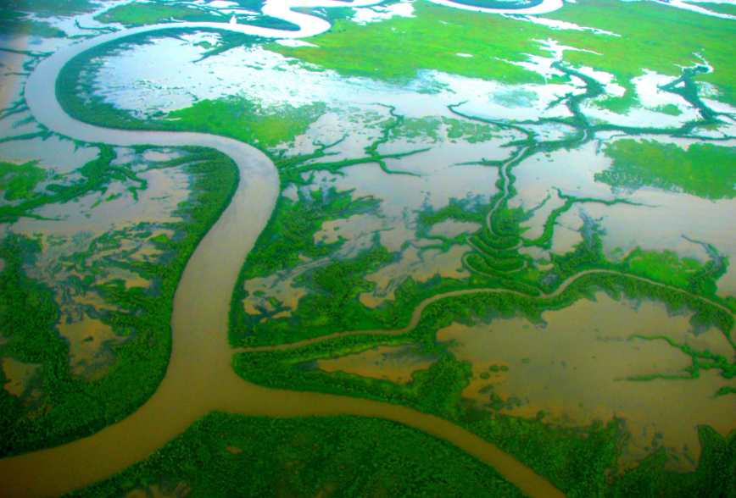Rivers home learning

Belongs to: .
River features
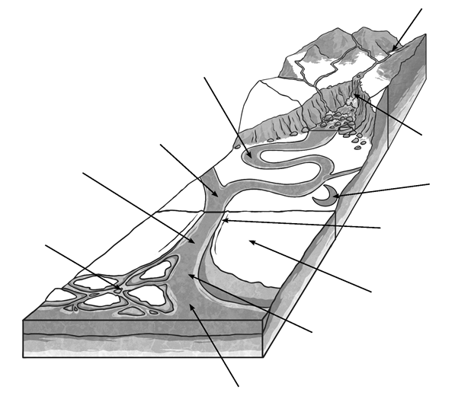

Vocabulary you should know: confluence delta estuary meander mouth source waterfall
New geographical river vocabulary: oxbow lake levee floodplain channel
Can you add any other features to the diagram and label them? You can colour it in, appropriately, when you are finished

United Kingdom Rivers

For each river, identify the area of land in which its source is located, the key towns along its route and the location of its mouth. Use any reliable sources of information that might help you (atlas, Google maps, woodlands junior, BBC etc.).
River Name | Source | Mouth | Key Towns
Shannon
Tamar
Wye
Severn
Thames
Great Ouse
Trent
Tyne
Tweed
Clyde

Describing how a river changes
Create a coloured key to match and show where erosion (washing away of soil) and deposition (dropping of soil) occur in the diagram below. Then tell me what you think is happening at the different parts of the river channel.
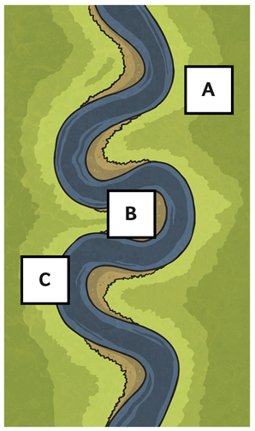How is the river moving or changing at point A?

How is the river moving or changing at point B?

Erosion
Deposition
How is the river moving or changing at point C?

The river flows more slowly at the part so doesn’t have as much energy to carry soil etc. The load is deposited making the channel shallower.
The river flows more quickly; it has more energy and therefore wears away at the side of the river bank, making it widener and deeper.

What are the different uses of rivers?

Group | How they use the river: | Positive effects: | This could lead to… | Negative effects: | This could lead to…
Fishermen
Factory owners
Power generation companies
Tourists
Water sports groups
Debating Dams
Find information out about dams on rivers and support, disagree or be balanced about the statement: ‘Damming a river is not beneficial for the environment’. Research some famous dams from around the world to help you.
 | Benefits | Disadvantages
People
Animals
Plants
Economy
Environment
Other features?
Debating Dams

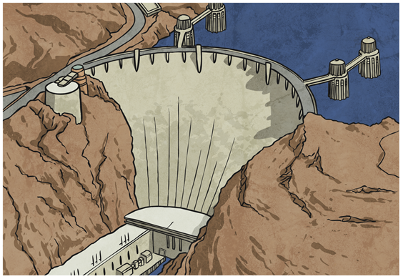

Raging rivers crossword
Down: 2. An ………… is where salt water and fresh water mix. 3. Rivers receive water from small streams called ……… 5. The amount of water that flows along a river every second is known as it’s …………… 6. The place where a river first rises is known as its… 7. A structure that blocks the flow of a river is called a ………… 9. A twist in a river’s course is called a ………

Across: 1. .……………is when a slow-moving river drops its load. 4. The river ………… flows though Egypt. 8. Hydroelectric power is a form of ………… energy. 10. The longest river in the U.K. is the River ……………

River challenges

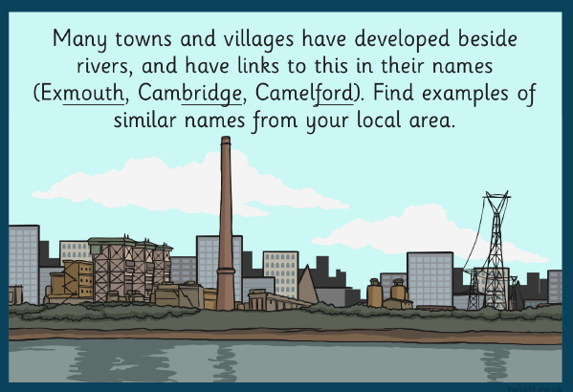

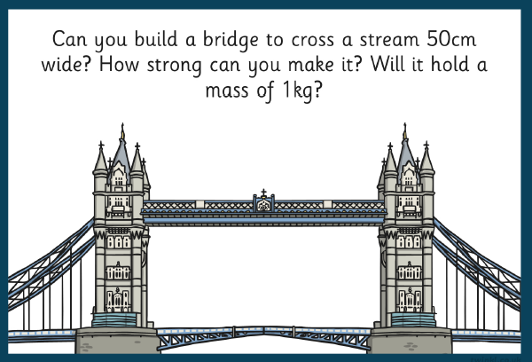

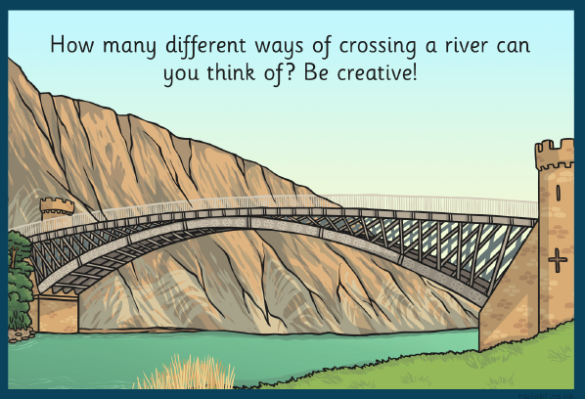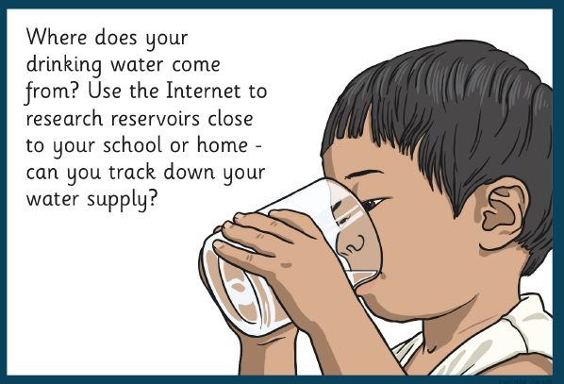

Make a model river
Supplies: - clear plastic bottle - sand - soil - water - small pebbles or stones
Draw a diagram of what you saw:
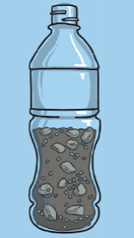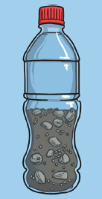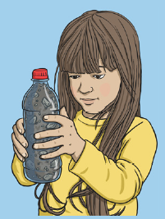
Can you explain why it happened?
3) Now shake your bottle, Watch what happens to the san, soil and stones (the river’s load). Leave your bottle to sit for a few minutes.

1) Put all of the sand, stones and soil into a bottle,
2) Fill the bottle with water and replace the lid tightly.

