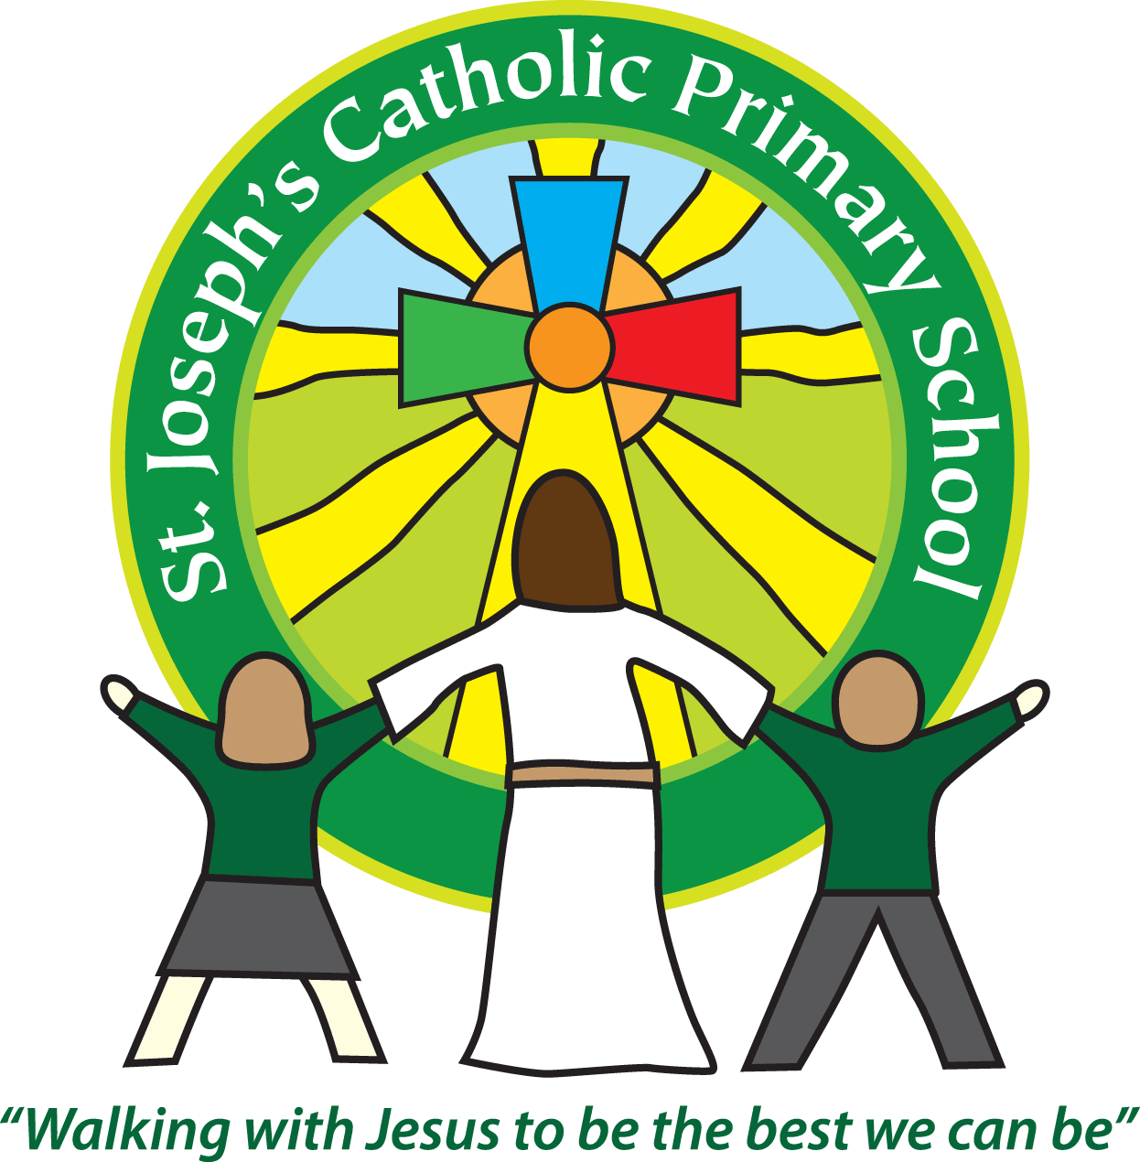St Joseph’s Catholic Primary School
Year 1 – Autumn (1st half)
Welcome to Year 1. We are looking forward to a wonderful year together!
We are currently enjoying getting to know the children. We are taking time to help them settle back into being at school as well as assessing where they are in their learning. Their mental wellbeing and happiness is our number one priority. As part of this we are buddying up with the children in Maple Class. We will read with our buddies each week and it gives each of the children an older friend on the playground at lunch times while they adjust to all the changes.
Today in book bags you will find a login for your child’s Google classroom account as well as a login to use IXL. IXL is an online learning site where the children can practise many different Maths and English skills. We will post homework on Google Classroom every Friday as well as any other updates. It is vital that you check it each week.
This half term our topic is ‘It’s Good to be Me!’
Please see attached our topic overview.
Year 1 home learning
Subject
Reading | Weekly (Thursday or Friday)  (As of 15th September) | We expect the children to read at home daily. Daily practice can really support your child’s progress, even if it is just for five minutes every day. Each week we will continue with the three reading practise sessions, they will then share this with you at home. They will also bring home a book to read for pleasure to share with you. Thank you for your support with this. As part of your reading routine, you can support your child by asking questions about the book. E.g How is Lucy feeling when …….? What do you think will happen next? Can you discuss your favourite words and phrases?
English/Maths/Topic/  Spelling | Friday  (As of 16th September) | Parents often ask about how they could further support learning at home, so we put together a weekly list of ideas. These will be activities that you can choose to use and they will link to what we have been learning in class throughout the week. Homework will be posted every Friday on Google Classroom. Your Google Classroom login will be sent home next week.  This will include spellings which we will be testing the children on each Friday.

Reminders
School lunch and snacks | Year 1 children are entitled to a free school lunch every day. Please see the school website for the menu and now order the meals on Parent Pay. You can send a packed lunch if you prefer. We promote healthy eating at school and so lunch boxes should not contain more than one chocolate snack and one packet of crisps.  Children are welcome to bring fresh fruit or vegetables for a snack at break time.  We are a nut free school. We have children with potentially fatal nut allergies in school, therefore no food containing nuts may be sent into school.
Drinks | Your child must have a named water bottle in school every day. Please only send in water, no juice or fizzy is allowed.
Uniform | Please ensure all uniform is clearly named.  Grey trousers or shorts, grey skirt or pinafore dress, white or grey socks, grey tights, White polo shirt, Green logo school sweatshirt or cardigan. Warm weather option – green and white gingham dress (dress with shorts instead of skirt is acceptable)  Hair past shoulder length must be tied back – please use plain hairbands in green, black or white, not brightly coloured bows.  Nail varnish is not allowed. School shoes must be black and no heels, trainers or boots.
PE kit | Green t-shirt with school logo, black shorts, black or navy jogging bottoms and trainers. Ear rings must be removed or covered with tape for PE lessons.  Watches must be removed for PE.  PE kit must be worn into school on a Wednesday and a Friday.
Bags | Reception, Yr 1 and 2 children must have a book bag in school. This is so books can easily be checked and letters put in. Children can have a bag or rucksack in school but please avoid the large bulky ones as 30 rucksacks take up a lot of room in the class.
Mornings | School starts promptly at 8.55am. Your child will be greeted at the patio gate by an adult. Please only pass on quick messages then, for a longer meeting please make an appointment. Children and parents arriving after 9.00am will be asked to sign in at the office.
After school | School finishes at 3.30pm. If someone other than yourself is collecting your child please ensure the office has their details. We will not let them leave unless we are sure they are safe.
Contact details | Please ensure you contact details and those of other people who may collect your child are always kept up to date. Please see the office asap if you change your phone number or address.

Teaching assistants
The teaching assistant who will be working with your child this half term is Mrs Jones.
Specialist teachers
Mrs Gates will be teaching the children every Friday afternoon and alternate Monday afternoons.
Key dates for this half term
Tuesday 18th October – Tiverton Museum workshop
Wednesday 19th October – Forest School (please bring in old clothes and wellies on that day in a named bag)
We recognise the importance of passing information between parents and school so we are available at the start and end of the day if you need to pass on any messages. However, if you would like a longer chat please make an appointment with us.
Yours sincerely,

Mrs Robertson and Mrs O’Mahony.

