St Joseph’s Catholic Primary School
Exmouth

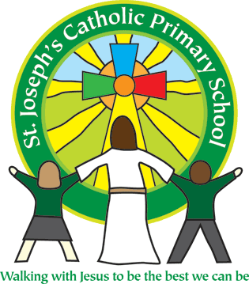



British Values Policy
May 2016

Signed ………………………………………Chair of Committee

Signed …………………………………………… Headteacher

Date ……………………………

British Values
The DfE have recently reinforced the need “to create and enforce a clear and rigorous expectation on all schools to promote the fundamental British values of democracy, the rule of law, individual liberty and mutual respect and tolerance of those with different faiths and beliefs.”
The government set out its definition of British values in the 2011 Prevent Strategy, and these values have been reiterated by the Prime Minister this year. At St Joseph’s these values are reinforced regularly and in the following ways:
Democracy:
The promotion of democracy is extensive within the school. Pupils have the opportunity to have their voices heard through our School Council and pupil questionnaires. Children in each class vote for the children they want to represent them on school Council. Children add tokens to jars to vote for the charity they would like a financial donation to go to, as one of the rewards in our school’s behaviour policy. The pupils suggest and vote in different charities each term. Children are consulted and contribute to the development of school policies, for example our behaviour policy and the school aims.
The Rule of Law:
The importance of Laws, whether they be those that govern the class, the school, or the country, are consistently reinforced throughout regular school days, as well as when dealing with behaviour and through school worship times. Pupils are taught the value and reasons behind laws, that they govern and protect us, the responsibilities that this involves and the consequences when laws are broken. Visits from authorities such as the Police and Fire Service are regular parts of our calendar and help reinforce this message.
Individual Liberty:
Within school, pupils are actively encouraged to make choices, knowing that they are in a safe and supportive environment. As a school we educate and provide boundaries for young pupils to make choices, through provision of a safe environment and empowering education. Pupils are encouraged to know, understand and exercise their rights and personal freedoms and advise how to exercise these safely, for example through our E-Safety and PSHE lessons. Pupils are given the freedom to make choices, for example signing up for extra-curricular clubs, choosing the level of challenge in some lessons and deciding what to present at class assemblies to parents.
Mutual Respect:
As a Catholic School and a member of Plymouth CAST, our ethos is based around core Christian values, including respect. Our Mission Statement ‘Walking with Jesus to be the best we can be’ is firmly based on the value of respect, which permeates all aspects of school life, including our school development plan and behaviour policy. This is supported by our acts of worship, our team points system based on courtesy and consideration and displays in the main hall.
Tolerance of those of Different Faiths and Beliefs:
This is achieved through enhancing pupils understanding of their place in a culturally diverse society and by giving them opportunities to experience such diversity. Worship times and discussions involving prejudices and prejudice-based bullying have been followed and supported by learning in RE and PSHE. Members of different faiths or religions are encouraged to share their knowledge to enhance learning within classes and the school. Every class has a school visit to a different place of worship annually. We are currently involved in a partnership project with a school in Sri Lanka, which gives pupils the opportunity to learn about other cultures. We use opportunities such as The Olympics and World Cups to study other countries.

