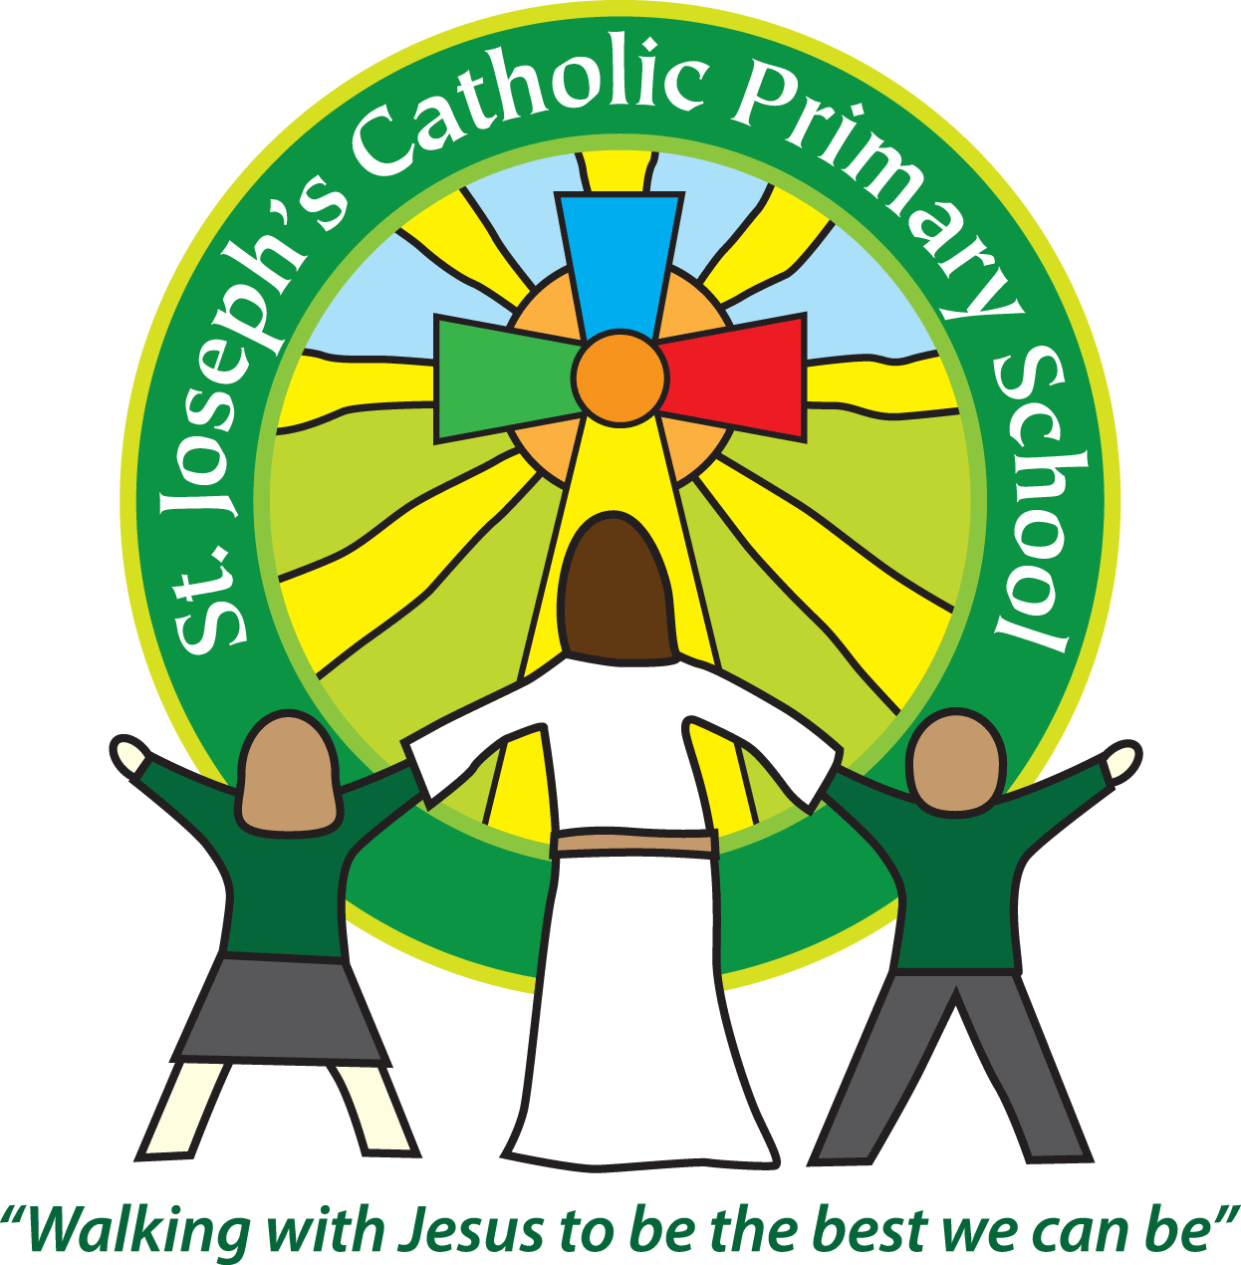
St Joseph’s Catholic Primary School
Regents Gate
Long Causeway
Exmouth
Devon
EX8 1TA

Executive Headteacher: Mrs R Pattison
Acting Head: Mrs N Taylor-Bashford

Tel: 01395 264875

Data for Year 2 children 2015-2016

- Children are teacher assessed against the national interim standards.
- Children took the national test in reading and maths. The Grammar and Spelling test was withdrawn nationally.

The results shown for the Year 2 children are shown below:

 | Children who have achieved the expected standard (Teacher Assessment) | SATs Test
Reading | 59.3% | 61%
Mathematics | 66.7% | 64%
Writing | 51.9% | No test

