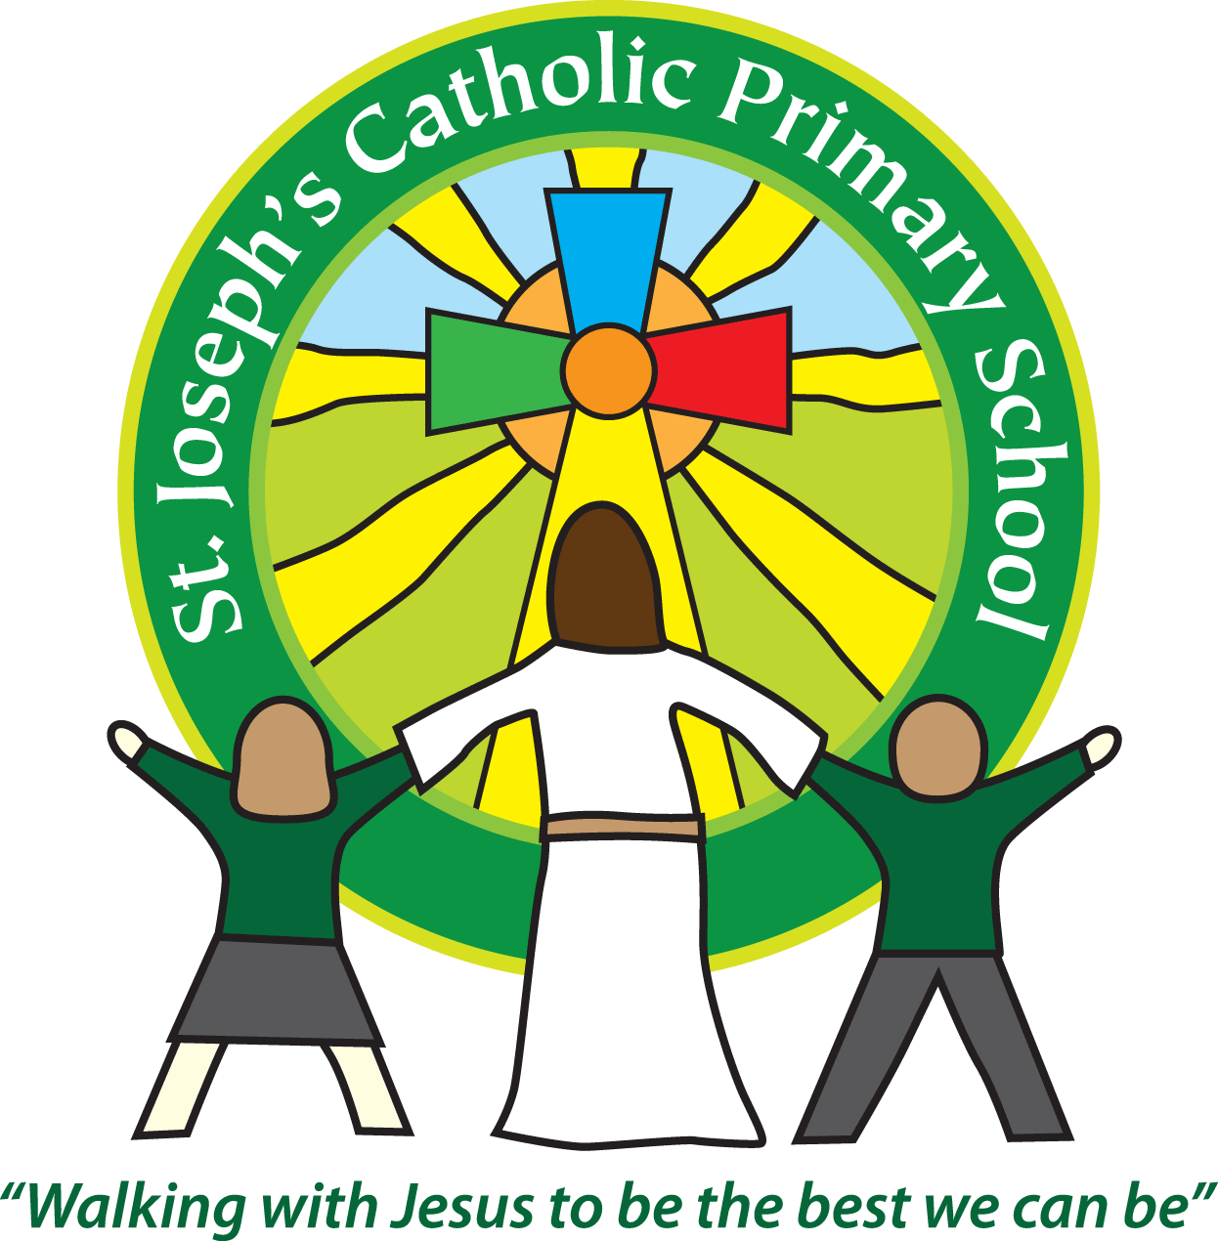

St Joseph’s Catholic Primary School

Newsletter

February 9th 2017

**Dear all,**

I can’t believe we have come to half-term already. We are now half way through the academic year and the time is flying by! The children have been busy learning and many visitors have commented on the ‘buzz of learning, enthusiasm and good behaviour of children’ which has been great to hear.

**Internet safety day**

On Tuesday it was Internet safety day and we started the day with a whole school assembly looking at the importance of keeping ourselves safe online. Each class was then assigned a task to do with an area of Internet safety e.g. cyberbullying. The classes then went off and designed posters or made films about their chosen task. The results will be put on the website under the E-Safety tab for everyone to view and we will have a follow up assembly next half term. The children learnt a lot from the day and hopefully they will remember this and be aware of the possible dangers online.

In school we are always looking at ways of supporting our children e.g. teaching them about appropriate behaviour and running assemblies and workshops. I wanted to share with you a useful website:

<http://www.anti-bullyingalliance.org.uk/advice/parents-carers/>

It gives lots of information for children and parents about cyberbullying, what to do if you are worried your child is being bullied as well as information if you are worried your child is bullying someone else.

The Childline website also has lots of information:

<https://www.childline.org.uk/info-advice/bullying-abuse-safety/types-bullying/online-bullying/>

As always if you have any concerns please speak to your children’s class teacher and then if necessary either myself or one of the SENCOs – Mrs Keeping or Mrs Evans

**Bishop Mark’s visit**

Bishop Mark spent an afternoon in school and he visited all the classes. He enjoyed meeting all of them and the children got to ask him lots of questions. He also had a chance to meet all the Holy Communion class after school and talk to them about what they have been doing in the sessions. There are photos on the website of the Bishop with the children for you to view.

**Non-Pupil Day**

Just a reminder that tomorrow – Friday 10th is a non-pupil day.

**Week following half term:**

Monday 20th February: Class 5 swimming

Tuesday: Dental survey 5yr olds only.

Tuesday: Yr 5 Parent activity session 2.15pm-3.15pm

Wednesday: FSU Parent activity session 9.00-10.00am

Wednesday: Yr 4 Parent activity session 2.15-3.15pm

Thursday: Yr 6 Parent activity session

I hope you all have a very happy, safe and relaxing half term.

**Best wishes and thank you for your continued support**

**Mrs Taylor-Bashford**



**Headteacher’s Awards:**

**Well done to:** Yr 1 - Brooke

**Stars of the Week and certificates:** will be done the week after half-term

If you know anyone looking for school places, please let them know as we still have spaces available in some classes. They can contact the Office for more information or to book a tour.

Tel: 01395 264875 email: admin@stjo.uk