Hello Rowan Class,
We hope you are all well. We just wanted to write a quick note to say that we are really missing being your teachers! We hope you are all keeping safe and enjoying being with your families.
Mrs Robertson…
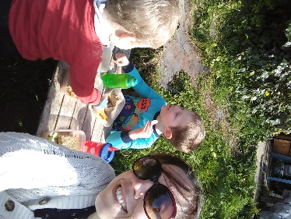  I am being full time Mummy to my two boys George and Henry. They both have their birthdays in April. | 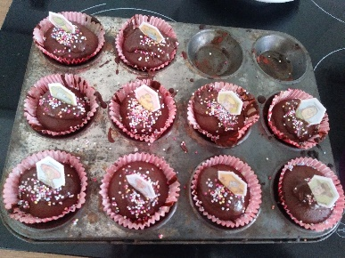  We have enjoyed baking some yummy cakes! | 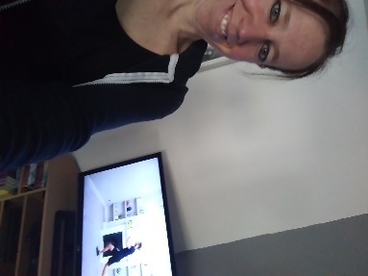  I have been trying to keep fit by doing PE with Joe Wicks each morning. | 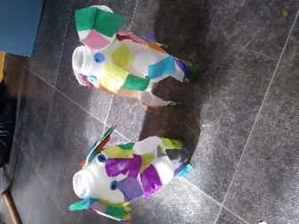  We have been doing lots of craft. We read Elmer by David McKee and made our own patchwork elephants.
Mrs Boatman . . .
As a mummy too, I am spending lots of time doing home learning with my little girl, Keira. We have also found a super youtube art channel ‘Art for Kids Hub’ which teaches you how to draw!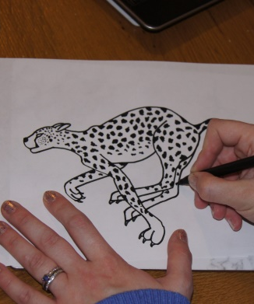 | When we are having a break from learning, we cuddle our pet dog Luna and teach her different tricks like sit, lie down and roll over! | I have been trying to challenge myself and exercise my brain by learning how to play the piano.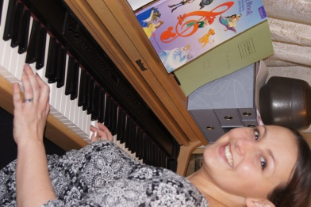 | To keep our bodies healthy, we all have a go on the trampoline- even Luna the dog!
We hope that the time you spend with your family will be a special time you will all cherish and we look forward to seeing what you get up to with your school learning and life-learning! We would love to hear what you have been up to. Please send us an email, or write a letter to the school and stay in touch!

