PE @ St Jos

Year 6 Boys Winners of the Vernon Griffiths Memorial Shield

Sports Report 2018 - 19
Our aim at St Josephs is to have every child developing a love of PE and sport. This year more children have participated in clubs and represented the school than last year. In KS2, where the main opportunity exists in our school sports partnership to compete, 88% of the children from year 3 to year 6 participated in at least one event. This has been achieved with the help of our incredible staff, who have embraced opportunities for the children to work in teams in a variety of sports and competitions and festivals. Our children’s understanding of invasion games continues to develop as they practice offensive and defensive attacks. We are also developing fantastic skills and a deeper understanding of strategy in striking and fielding games. Super team effort in the year 576 Rounders and in PE lessons, Dartmoor 3 ball is a real hit!! This year our year 1 and 2s have enjoyed Turner Variety Ball.
Dartmoor School Sports Partnership (DSSP) have facilitated a variety of sports festivals and competitions. As a school we attended with sometimes 2 teams to all the events our own school calendar enabled us to.
This year we have attended:
Cross Country at Bicton Arena Year 3-6
Cross country team Years 3 - 6
East Devon Cross Country Finals Year 5&6 Boys team
Quick Sticks Hockey Year 5&6 Festival
Quick Sticks Hockey Year 5&6 Competition
Indoor Athletics Year 5&6
High 5 Netball Year 5&6 Competition
Exeter City 6 a-side Football at Exeter University
Aesthetics Festival Years 1 &2
Dance Festival Years 3&4
Sport for All Send Festival
Sports Hall Athletics Year 3&4
Rounders Competition Year %&6
Invitation Tennis at the Tennis Centre
Boys Football Year 3&4 at Withycombe School
Boys Football Year 6 Vernon Griffiths’ Memorial Shield

At all these South Dartmoor School Sports Partnership (SDSSP) events our teams showed great sportsmanship and worked together to achieve great team effort. We are so proud of our teams.

Probably one of our greatest successes in sport this year is the popularity and consistent attendance at the Running Club. We have over 60 children on the register for the club and most weeks over 40-50 enjoy running focused activities. This club has continued to grow this year. It would not run without the support of a band of loyal parents. (Indigo’s mum, Thomas’s and Ella’s mum, Elizabeth and Emily’s dad. And many more who step in each week on our rota. We are clocking uo the Kilometres each week – the children love their termly tallies of distances and laps.

The SDSPP supported us in the development of our gymnastic teaching last year and this has continued this year with whole school inset on large apparatus. The children love to use the large equipment and all staff are growing in confidence to use it with the children. The partnership has also delivered a dance inset and we hope to work with this to produce a dance performance in the next academic year.
Winning is not everything but it was fantastic to see the year 6 boys win the Vernon Griffiths’ Memorial Shield at Withycombe school in July. The boys have competed at several football events over the last 2 years, (Beach Football, Otterton School Competition, Exeter City 6 a side) but never won or got into a final. It was their day and able assisted by Coach Rob and Coach Stu they brought the shield back to school. An excellent way to end their time at St Josephs.

Fitter Future has been running in the school for the last year, a computer based daily fitness platform. This has not flourished this year and keen to capture the children’s interest in running a couple of classes have tried the Daily Mile. We will look to develop this this next academic year.
We also had success at the cross country with our Year 6 boys team gaining a place in the East Devon final. We had a high placed runner also in the year 3&4 boy’s race, Jack Tidball coming 3rd. Many of the children achieved higher places than the previous year.
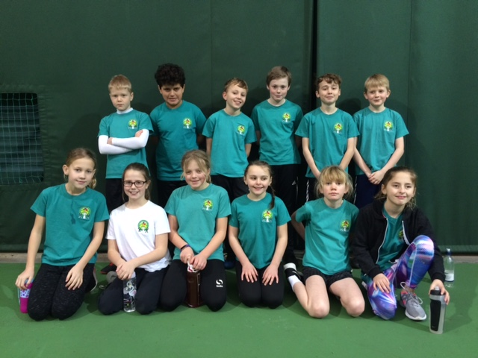
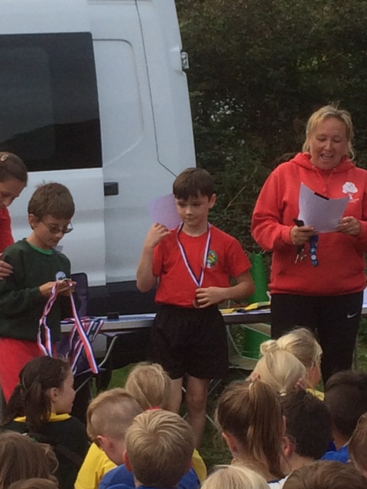
Jack’s 3rd place Cross country win

Year 5 Indoor Athletics

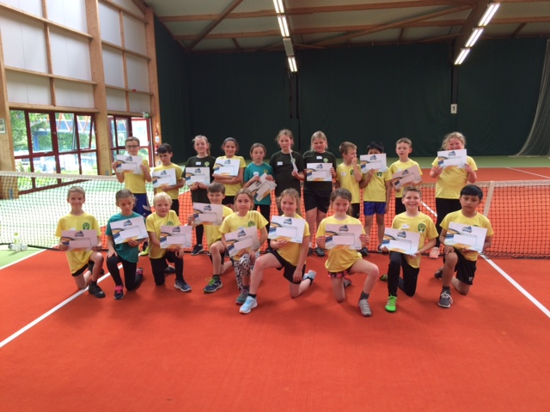
Invited Tennis Event

