 | Nursery | Reception | Year 1 | Year 2 | Year 3 | Year 4 | Year 5 | Year 6
 | We belong here!  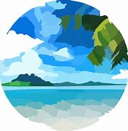  Explore the outdoor area of school (local)  How is our local area special? | All About Me  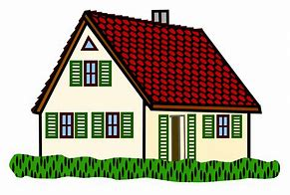  Navigating around our  classrooms, outside areas and school  Discuss their homes and what is near their homes  What is their home like? Make comparisons of different homes | 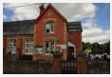  Home Sweet Home- What is it like to live here? | Wonderful Weather – What is weather? | 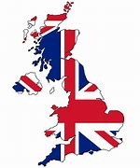  United Kingdom – What is in the UK and how is its South West unique? | South America – Where is Brazil?  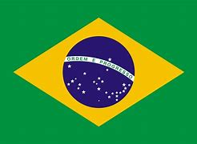 | Trade and Economics– Where do our food and resources come from?  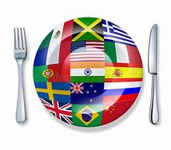 | Our Environment – How can we improve the world we live in?
Autumn |  | + | Locating our school in our local area, and  identifying local physical and human features on a map and during fieldwork | Studying the human and physical geography of  the local area with an introduction to scale and fieldwork | Locating the UK, Great Britain and the British  Isles, and regions and counties; identifying human and physical features across the UK and in one region | Locating lines of longitude and latitude;  understanding Brazil’s physical features and climate, and its human settlements | Understandingthe distribution of the world’s natural  resources and these are traded between places across the world | Recognising the importance of renewable energy and reducing waste, and the actions that humans can take to improve the environment
 | Spring on the farm  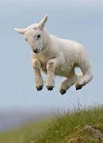 | Spring has Sprung  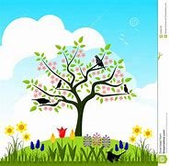 | You’re Great Britain – What makes Britain great? | Hot and Cold Deserts – What is climate?  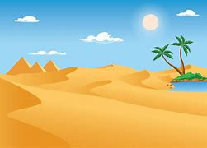 | 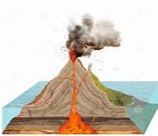  Mountains and Volcanoes – is there life in these environments? | 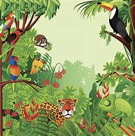  Rainforests –Where are they and what makes them so vital? | 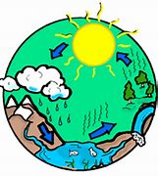  Investigating Water – How does water help and hinder life? | On The Move – Why do people relocate to other countries?  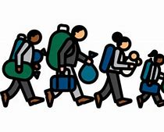
 |  |  |  | Locating hot and cold deserts, and identifying common physical and human features
Spring | Exploring how things work on a  farm (Human  feature)  Nursery | Study features of the local environment. Compare places using Google  Earth- how are they similar or different? Use bee-bots on simple maps. Use directional language.  Reception | Locating our local area in the UK; identifying the four countries of the UK; some key human and physical features  Year 1 | Year 2 | Understanding the structure of the Earth; how fold mountains and volcanoes are formed; and the impacts they can have on human settlement using case studies of Etna and La  Soufriere  Year 3 | Understanding the key features of a rainforest ecosystem, the contributions they make to the world and threats they face (using Amazon Rainforest)  Year 4 | Understanding the water cycle and the distribution of the world’s water; considering land use along rivers Danube,  Mississippi, and Severn  Year 5 | Understanding push and pull factors in migration from the Northern Triangle to the USA, and Syria to countries in Europe; understanding the benefits of migration to  the UK  Year6
 | Travel  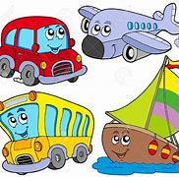  Explore Ways to travel – car/train…  Differences in places.  Explore sea side area (physical feature)  Bee Bot on a seaside mat | Let’s Explore  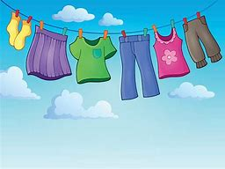  Change in living things, comment on the weather, culture, clothing and houses  Explore the natural world through hands-on experience | Kenya – What is it like to live in Kenya compared to Exmouth?  Understanding where we live on the global scale; locating continents and comparing the human and physical features of an area in the UK with an area in Kenya | 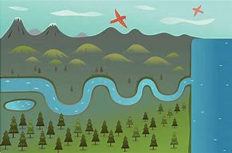  Rivers, Seas and Oceans –How do they connect?  Locating the seas around the UK and oceans of the world. Identifying physical and human features around rivers and coastal areas | 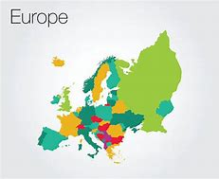  Europe – What does life look like across our continent?  Comparing the human  and physical features of the Alps, Dartmoor, Exmouth and the Amalfi Coast, and exploring the impact of tourism in these areas | The Angry Earth – Why and where do earthquakes occur?  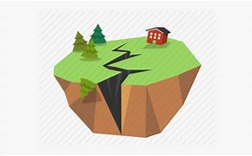  Understanding why earthquakes take place and what effects they had in Haiti and Japan | 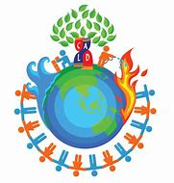  Climate Across the World – How do we keep the vital balance?  Understanding time zones, climate zones, biomes, and vegetation belts, and the effects of global warming | 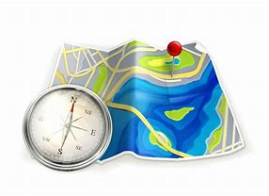  I am a Geographer  Posing questions,  completing fieldwork and presenting a geographical investigation
Summer |  |  |  |  |  |  | ]

