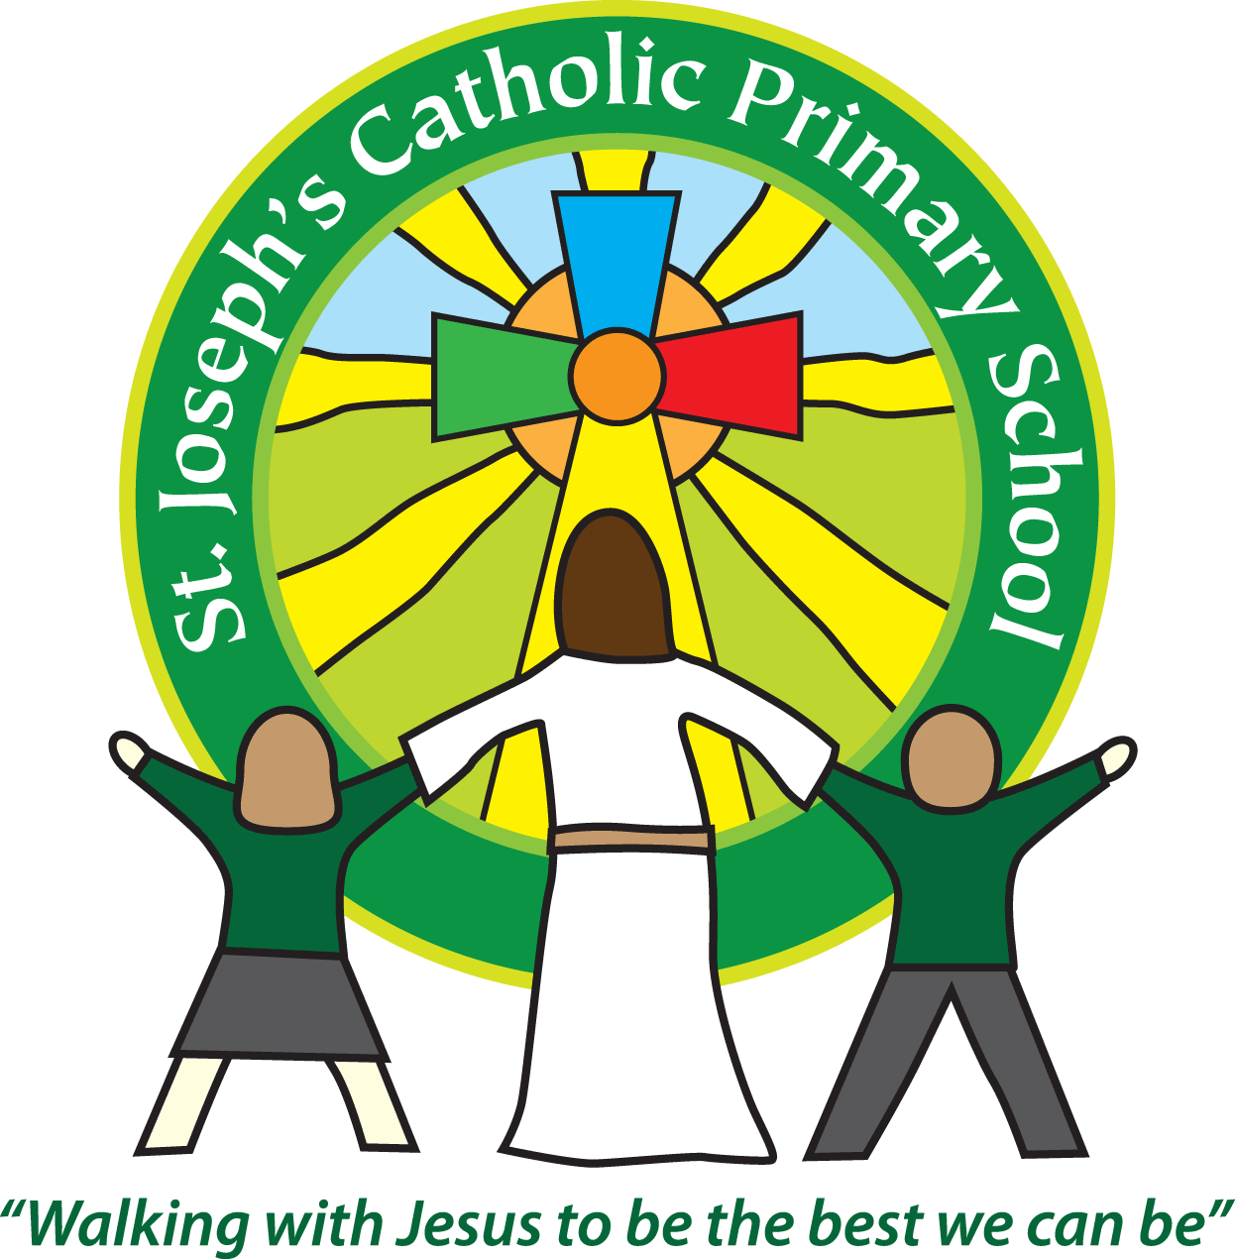St Joseph’s Catholic Primary School
Year 1 – Spring (1st half)
Welcome back!
This half term our topic is ‘It’s Good to be Me.’
Please see attached our topic overview.
Year 1 home learning
Subject | Sent home | Due in | Frequency
Common exception words | Friday | Thursday | Weekly
English | Friday | Thursday | Weekly
Maths | Friday | Thursday | Weekly
Topic | Friday | Thursday | As required
Reading | We expect the children to read at home daily. Daily practice can really support your child’s progress, even if it is just for five minutes every day. Thank you for your support with this. Books can be changed each day. As part of your reading routine, you can support your child by asking questions about the book. E.g How is Lucy feeling when …….? What do you think will happen next? Can you discuss your favourite words and phrases?  It would be useful if you could ask your child to collect new/unknown words from their book, find their meaning and share them with the class. We have a magpie board in class which we can add these to.
Reminders
School lunch and snacks | Year 1 children are entitled to a free school lunch every day. Please see the school website for the menu and order on ParentPay. You can send a packed lunch if you prefer.  We promote healthy eating at school and so lunch boxes should not contain more than one chocolate snack and one packet of crisps.  Children are welcome to bring fresh fruit or vegetables for a snack at break time.  We are a nut free school. We have children with potentially fatal nut allergies in school, therefore no food containing nuts may be sent into school.
Drinks | Your child must have a named water bottle in school every day. Please only send in water, no juice or fizzy is allowed.
Uniform | Please ensure all uniform is clearly named.  Grey trousers or shorts, Grey skirt or pinafore dress, Black, white or grey socks, Black or grey tights, White polo shirt, Green logo school sweatshirt or cardigan. Warm weather option – green and white gingham dress (dress with shorts instead of skirt is acceptable)  Hair past shoulder length must be tied back – please use plain hairbands in green, black or white, not brightly coloured bows.  Nail varnish is not allowed. School shoes must be black and no heels, trainers or boots.
PE kit | Green t-shirt with school logo, black shorts, jogging bottoms and trainers. All kit must be named and in a named bag.  Ear rings must be removed or covered with tape for PE lessons.  Watches must be removed for PE.  PE kit must be in school every day.  Due to the cold weather this term, if children could include jogging bottoms.
Bags | Reception, Yr 1 and 2 children must have a book bag in school. This is so books can easily be checked and letters put in.  Children can have a bag or rucksack in school but please avoid the large bulky ones as 30 rucksacks take up a lot of room in the class.
Mornings | School starts promptly at 8.55am.  Your child will be greeted at the class door by an adult. Please only pass on quick messages then, for a longer meeting please make an appointment.  Children and parents arriving after 9.00am will be asked to sign in at the office.
After school | School finishes at 3.30pm. if someone other than yourself is collecting your child please ensure the office has their details. We will not let them leave unless we are sure they are safe.
Contact details | Please ensure you contact details and those of other people who may collect your child are always kept up to date. Please see the office asap if you change your phone number or address.

Teaching assistants
The teaching assistants who may be working with your child this half term are Mrs Kerr and Miss Christopher.
Specialist teachers
On a Wednesday afternoon, Year 1 will have music taught by Miss Christopher and PE taught by Mrs Turner.
Key dates for this half term
Space Cats Theatre Production – Thursday 23rd January
Parents Evening – Week beginning 27th January (Day and times will be sent out separately).
Parent Activity session – Wednesday 5th February.
We recognise the importance of passing information between parents and school so I am available at the start and end of the day if you need to pass on any messages. However, if you would like a longer chat please make an appointment with me.
If you are able to support our learning with resources or would like to help in class, please let a member of staff know. We value your involvement in your child’s education.

Yours sincerely,

Mrs Robertson and Mrs Finn

