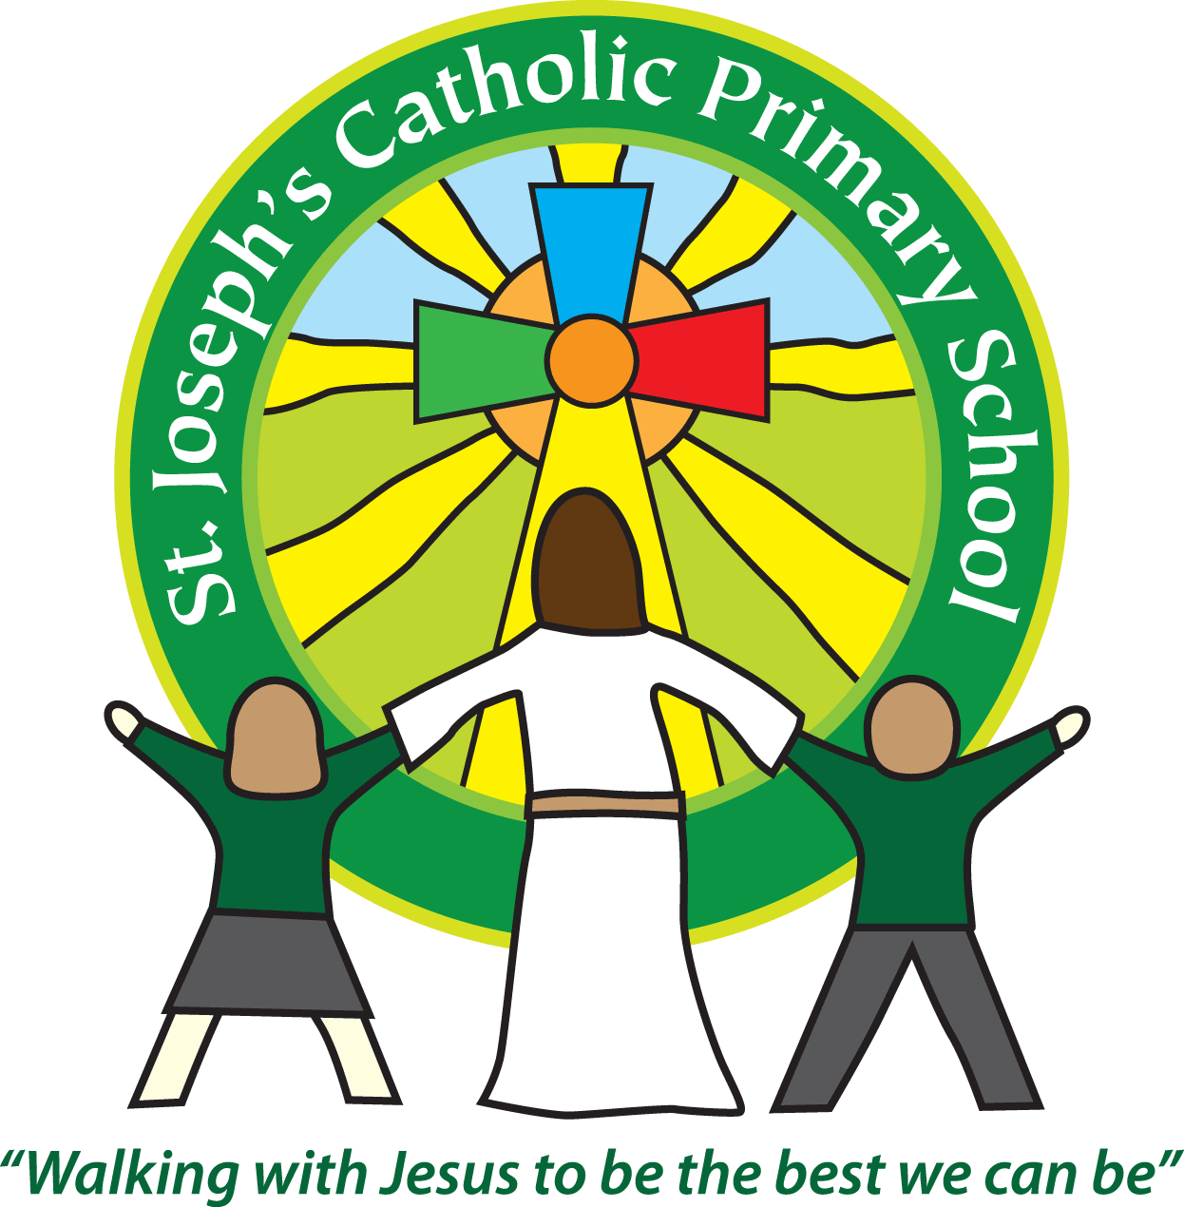

St Joseph’s Catholic Primary School

Newsletter

April 28th 2017

**Dear all,**

The children have had a super week. It was lovely seeing some children in Yr 1 dressing up as an African school child and interviewing each other on Tuesday. They had fantastic knowledge of what it might be like being a child at school in Africa. Class 3 and 4 are also hopefully having an exciting day today at the Lyme Regis Fossil festival today. I’m looking forward to hearing all about it next week!

**Thank you**

I would like to say a huge thank you to Adele & Mike (Archie & Theo’s parents) for paying for the Class 4 trip to Eden as well as the lovely hoodies. Also thank you to Adele and Debs (Alfie’s mum) for going to help and Mr Edmunds and Mrs Howard for organising and going on the trip. Finally thank you to Rav and Jo (Rafa and Felix’s parents) for providing money for ice-creams! The children had a wonderful time and made many happy memories.

**Music**

In our music sessions with Mrs Nelmes this term, we have two exciting events to focus on. The first is a live stream into the classroom of the 'Secrets and Codes' concert by the Bournemouth Symphony Orchestra, during which we will be performing two specially-commissioned pieces by resident composer James Redwood alongside the orchestra. One piece focuses on body percussion and the other is a choral work which includes the use of Makaton sign language. The second event is our participation in the Exmouth Festival Schools Concert on 26th May, where our fantastic school choir will be singing alongside some of the other schools which Primary Music & Education works with. Mrs Nelmes will be sending home more details about this once they have been released.

**Photos:**

Please add to your diary dates that on Wednesday June 21st it will be class photos.

**Next week:**

Wednesday 3rd May Class 5 Magdalen residential

Thursday 4th May: Class 3 parent activity session 9.10am

Thursday 4th May: KS1 Football event 4pm

I hope you all have a lovely and hopefully sunny bank holiday weekend, and if you have time take a look at our exciting new website design.

**Best wishes and thank you for your continued support**

**Mrs Taylor-Bashford**

**Well done to:**

**Headteacher’s Awards:** Yr 1 – Theo, Mason, Yr 3 – Olivia, Jasmyne

**Bronze certificates:** FSU - Maddison

**Silver certificates:** FSU – Alfie, Yr 1 - Theo

**Stars of the Week:** FSU - Amelia, Yr 1 - Ollie , Yr 2 –Jasmine, Y5 –Kai, Yr 6 –Selkie

If you know anyone looking for school places, please let them know as we still have spaces available in some classes. They can contact the Office for more information or to book a tour.

Tel: 01395 264875 email: admin@stjo.uk