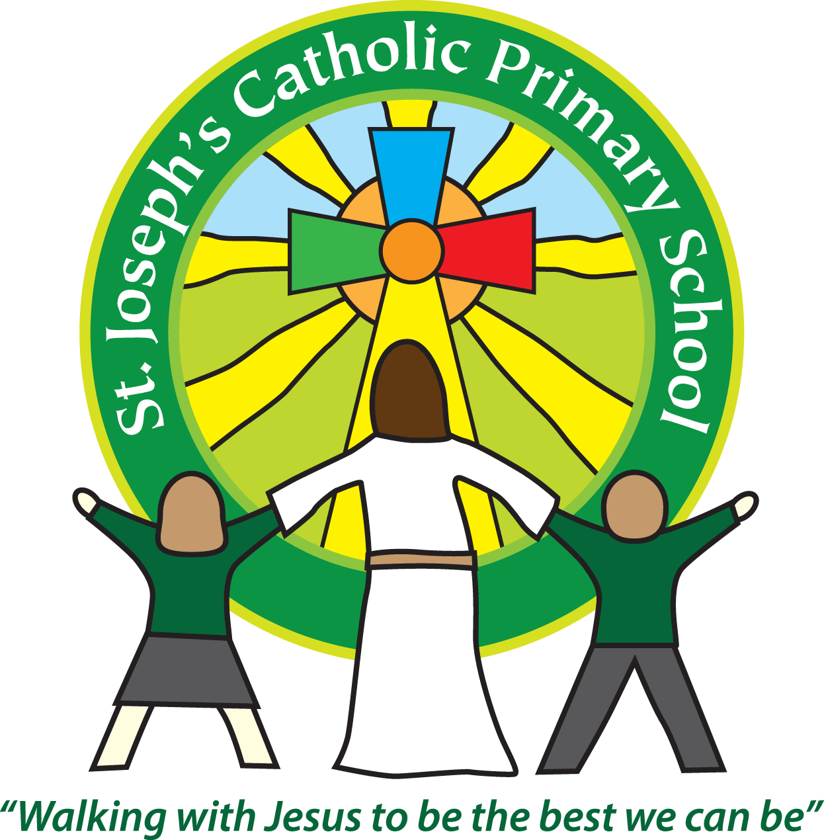

St Joseph’s Catholic

Primary School

Newsletter

June 10th 2016

**Dear all,**

What an exciting week it has been at St Joseph’s!

We had a visitor to do a KS2, ICT assembly. This changed from online safety to the new technology of today and the future. The children were very excited about the Virtual Reality Headset that was brought in! The online safety assembly has been rescheduled for a later date.

We have had the FSU and Yr 5/6 parent activity sessions. Luckily the weather held for both, so everyone could enjoy the activities outside. Particularly well done to the FSU parents for joining in with finding bugs, den building and using the mud kitchen!

Unfortunately, the weather did not hold off for our Yr 5/6 trip to the Jurassic coast this morning and they were forced to head back early due to the rain and over 50% of the children not having a waterproof. This was a real shame as it had all been carefully planned and would have been a fantastic learning experience.

Whilst they were out, the rest of the school meet a Gospel choir from Tennessee, America. There were about 30 choir singers and they held a workshop for the Year 3s and a group from Year 4. They taught them a gospel song which they then performed in assembly. It was fantastic!

Then this afternoon will be the Queen’s tea party and parade. Unfortunately the weather looks like it will have to be indoors but I’m sure it won’t dampen the children’s (or staff’s!) enthusiasm. Thank you very much to everyone for the fantastic array of cakes that you sent in – the children are looking so excited!

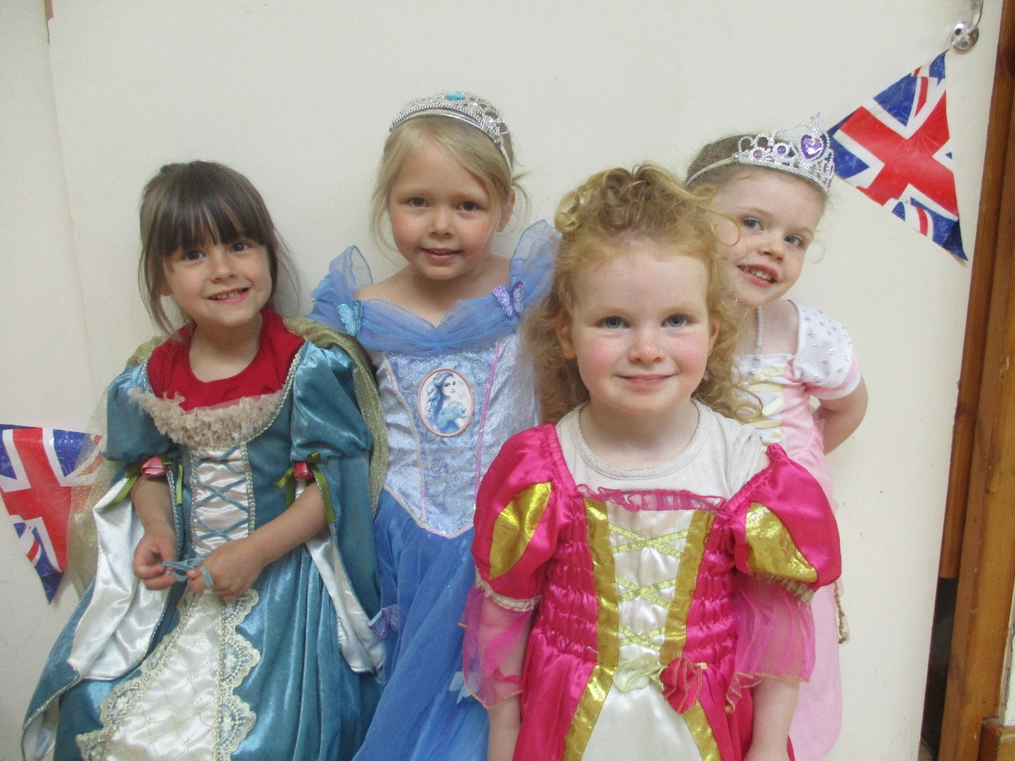 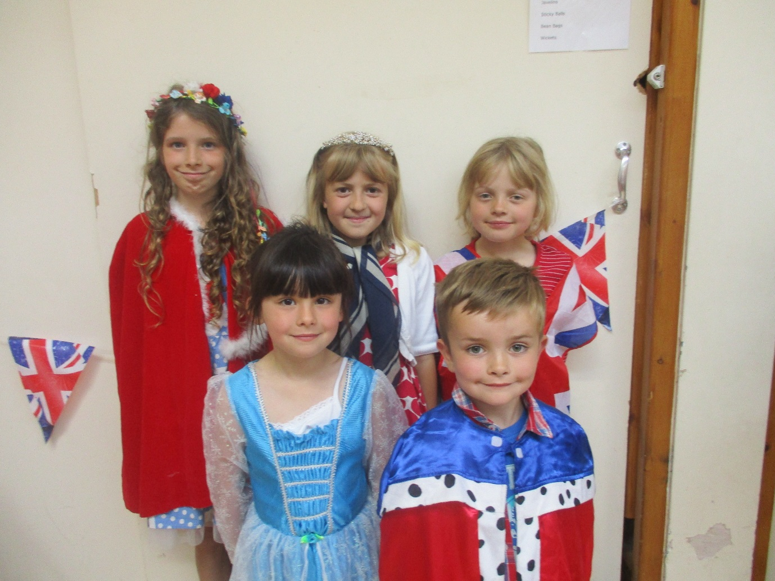 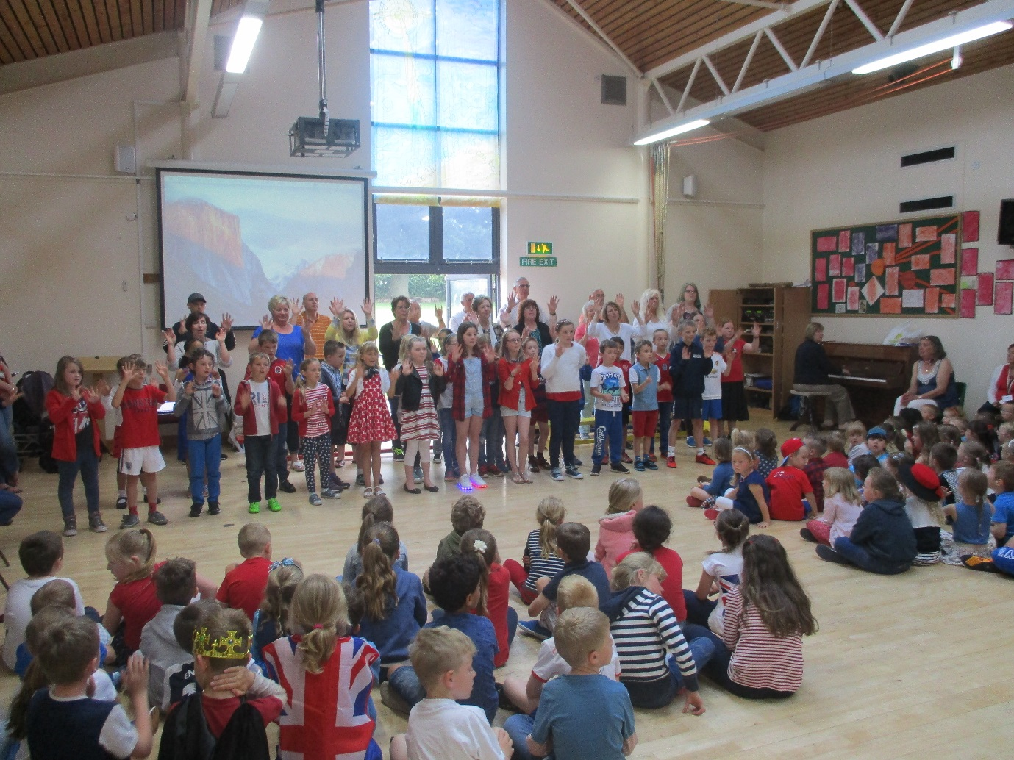

Thank you also to Jules Allen for taking the photos of the children in the regal outfit and all the other staff and PTA who have helped with bits today.

A reminder that from September, the PE t-shirts will be plain white. If your child still fits into their coloured shirt they are welcome to continue wearing that until the time you need to buy a new one.

**Best wishes & thank you for your continued support**

**Mrs Taylor-Bashford**

**Headteacher’s Awards:** Well done to: Amelie F2, Shanel Yr 1, Hannah Yr 3, Archie Yr 3, Madison Yr 3, Jessie Yr 6, Kaela Yr 6, Devon Yr 6, Jessie Yr 6, Elizabeth Yr 6 & Maisie Yr 6

**Bronze certificates:** Well done to: Jack Yr 4, Bethany Yr 4 and Devon Yr 6

**Stars of week & Gospel Values Awards:** will be added next weekdue to the Gospel choir today.





